UNITED STATES
SECURITIES AND EXCHANGE COMMISSION
Washington, D.C. 20549
SCHEDULE 14A
Proxy Statement Pursuant to Section 14(a) of the
Securities Exchange Act of 1934 (Amendment No. )

Filed by the Registrant x Filed by a party other than the Registrant o
Check the appropriate box:
o Preliminary Proxy Statement
o Confidential, for Use of the Commission Only (as permitted by Rule 14a–6(e)(2))
x Definitive Proxy Statement
o Definitive Additional Materials
o Soliciting Material under §240.14a–12
BLOOMIN’ BRANDS, INC.
(Exact name of registrant as specified in its charter)
(Name of Person(s) Filing Proxy Statement, if other than the Registrant)
Payment of Filing Fee (Check the appropriate box):
x No fee required
o Fee computed on table below per Exchange Act Rules 14a–6(i)(1) and 0–11
(1) Title of each class of securities to which transaction applies:
_______________________________________________________________________________________________
(2) Aggregate number of securities to which transaction applies:
_______________________________________________________________________________________________
(3) Per unit price or other underlying value of transaction computed pursuant to Exchange Act Rule 0–11 (set forth the amount on which the filing fee is calculated and state how it was determined):
_______________________________________________________________________________________________
(4) Proposed maximum aggregate value of transaction:
_______________________________________________________________________________________________
(5) Total fee paid:
_______________________________________________________________________________________________
o Fee paid previously with preliminary materials.
o Check box if any part of the fee is offset as provided by Exchange Act Rule 0–11(a)(2) and identify the filing for which the offsetting fee was paid previously. Identify the previous filing by registration statement number, or the Form or Schedule and the date of its filing.
(1) Amount Previously Paid:
_______________________________________________________________________________________________
(2) Form, Schedule or Registration Statement No.:
_______________________________________________________________________________________________
(3) Filing Party:
_______________________________________________________________________________________________
(4) Date Filed:
_______________________________________________________________________________________________



Table of Contents

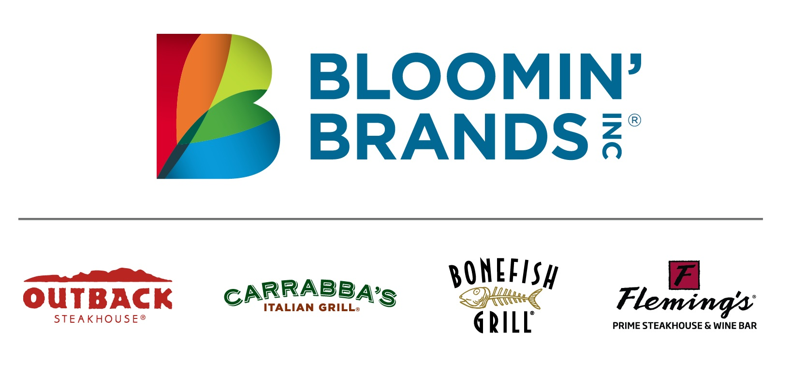
Bloomin’ Brands, Inc.
2202 North West Shore Boulevard, Suite 500
Tampa, Florida 33607
March 4, 2024

Dear Bloomin’ Brands Stockholder:

You are cordially invited to attend the Annual Meeting of Stockholders of Bloomin’ Brands, Inc. on Tuesday, April 23, 2024, at 8:00 a.m. (EDT), at Corporate Center One, 2202 North West Shore Boulevard, 4th Floor, Tampa, Florida 33607. The purpose of the meeting is detailed in the Notice of Annual Meeting of Stockholders and the Proxy Statement.
To provide you with the information you need to make an informed vote, most of our stockholders will receive our proxy materials over the internet. Your vote is important regardless of the number of shares you own, and we encourage you to vote on the internet whether or not you plan to attend the meeting. Alternatively, you may vote by telephone or, if you received the proxy materials in the mail, by completing, signing, dating, and returning the paper proxy card in the enclosed prepaid and addressed envelope.
If you plan to attend the annual meeting, please bring photo identification as well as your notice, admission ticket from your proxy card, or a current statement of ownership from a bank, broker or other third party confirming ownership.
Thank you for considering the matters presented in the proxy statement, and please vote as soon as you are able.
On behalf of the Board of Directors and Bloomin’ Brands’ management, thank you for your support.
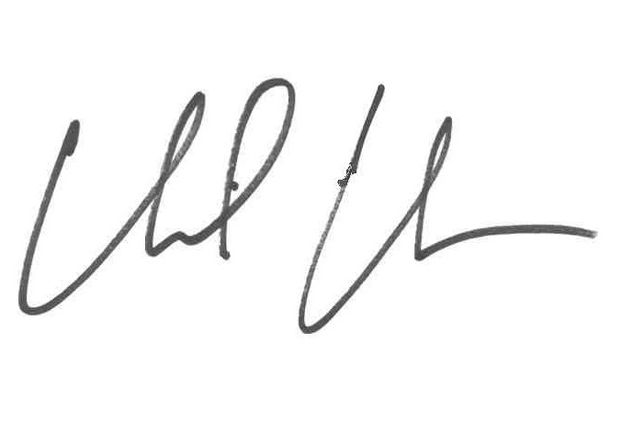
David Deno, Chief Executive Officer

Table of Contents

BLOOMIN’ BRANDS, INC.
2202 North West Shore Boulevard, Suite 500
Tampa, Florida 33607

NOTICE OF ANNUAL MEETING OF STOCKHOLDERS
To Be Held April 23, 2024

The Annual Meeting of Stockholders of Bloomin’ Brands, Inc. (the “Company”) will be held at Corporate Center One, 2202 North West Shore Boulevard, 4th Floor, Tampa, Florida 33607 on Tuesday, April 23, 2024, at 8:00 a.m. (EDT) for the following purposes:

1.To elect ten members to the Company’s Board of Directors (the “Board” or “Board of Directors”), each for a one-year term expiring in 2025

2.To ratify the appointment of PricewaterhouseCoopers LLP as the Company’s independent registered certified public accounting firm for the fiscal year ending December 29, 2024

3.To approve, on a non-binding advisory basis, the compensation of the Company’s named executive officers

4.To vote on a stockholder proposal regarding stockholder right to act by written consent

The foregoing items of business are more fully described in the accompanying proxy statement. The record date for determining those stockholders entitled to notice of, and to vote at, the annual meeting and at any adjournments or postponements thereof is February 28, 2024.

Whether or not you plan to attend the annual meeting, please vote as soon as possible. As an alternative to voting at the annual meeting, you may vote via the internet, by telephone or, if you receive a paper proxy card in the mail, by mailing a completed proxy card. For detailed information regarding voting instructions, please refer to the section entitled “Voting via the Internet, by Telephone or by Mail” on page 2 of the proxy statement. You may revoke a previously delivered proxy at any time prior to the annual meeting. If you are a registered holder and decide to attend the annual meeting and wish to change your proxy vote, you may do so automatically by voting at the annual meeting.
BY ORDER OF THE BOARD OF DIRECTORS
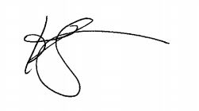
Kelly Lefferts, Secretary
Tampa, Florida
March 4, 2024

Important notice regarding the availability of proxy materials for the Annual Meeting of Stockholders to be held on April 23, 2024:

This notice of annual meeting of stockholders, the accompanying proxy statement, and our 2023 annual report to stockholders are available at www.edocumentview.com/BLMN.

Table of Contents

TABLE OF CONTENTS
 |  |  |  |  |  | Page No.
 |  |  | PROXY STATEMENT FOR ANNUAL MEETING OF STOCKHOLDERS |  |  | 1
 |  |  | PURPOSE OF MEETING |  |  | 1
 |  |  | VOTING |  |  | 1
 |  |  | Voting Rights |  |  | 1
 |  |  | Recommendations of the Board of Directors |  |  | 2
 |  |  | Voting via the Internet, by Telephone or by Mail |  |  | 2
 |  |  | Electronic Delivery |  |  | 3
 |  |  | Changing or Revoking Your Proxy |  |  | 3
 |  |  | Admission to the Annual Meeting |  |  | 3
 |  |  | PROPOSAL NO. 1 - ELECTION OF DIRECTORS |  |  | 5
 |  |  | Nominees for Election at this Annual Meeting |  |  | 5
 |  |  | Recommendation of the Board of Directors |  |  | 15
 |  |  | Board Overview |  |  | 16
 |  |  | Board Committees and Meetings |  |  | 18
 |  |  | Independent Directors |  |  | 20
 |  |  | Arrangements or Understandings Regarding Service as a Director |  |  | 21
 |  |  | Nominees for the Board of Directors |  |  | 21
 |  |  | Board Leadership Structure |  |  | 22
 |  |  | Board’s Role in Risk Oversight |  |  | 22
 |  |  | Code of Conduct |  |  | 23
 |  |  | Stockholder Communications with the Board of Directors |  |  | 23
 |  |  | Director Compensation |  |  | 23
 |  |  | PROPOSAL NO. 2 - RATIFICATION OF INDEPENDENT REGISTERED CERTIFIED PUBLIC ACCOUNTING FIRM |  |  | 25
 |  |  | General |  |  | 25
 |  |  | Principal Accountant Fees and Services |  |  | 25
 |  |  | Policy on Audit Committee Pre-Approval of Audit and Permissible Non-Audit Services of Independent Auditor |  |  | 26
 |  |  | Recommendation of the Board of Directors |  |  | 26
 |  |  | PROPOSAL NO. 3 - ADVISORY VOTE ON EXECUTIVE COMPENSATION |  |  | 27
 |  |  | General |  |  | 27
 |  |  | Recommendation of the Board of Directors |  |  | 27
 |  |  | PROPOSAL NO. 4 - STOCKHOLDER PROPOSAL REGARDING STOCKHOLDER RIGHT TO ACT BY WRITTEN CONSENT |  |  | 28
 |  |  | Proposal 4 - Shareholder Right to Act by Written Consent |  |  | 29
 |  |  | Statement of the Board of Directors in Opposition to the Stockholder Proposal |  |  | 29
 |  |  | Recommendation of the Board of Directors |  |  | 30
 |  |  | OWNERSHIP OF SECURITIES |  |  | 31
 |  |  | Delinquent Section 16(a) Reports |  |  | 32
 |  |  | EXECUTIVE COMPENSATION AND RELATED INFORMATION |  |  | 34
 |  |  | Compensation Discussion and Analysis |  |  | 34
 |  |  | Compensation Committee Report |  |  | 46
 |  |  | Compensation Committee Interlocks and Insider Participation |  |  | 46
 |  |  | Compensation-Related Risk |  |  | 46
 |  |  | Summary Compensation Table |  |  | 47
 |  |  | Grants of Plan-Based Awards for 2023 |  |  | 48

Table of Contents

 |  |  | Outstanding Equity Awards at 2023 Year-End |  |  | 49
 |  |  | Option Exercises and Stock Vested for Fiscal 2023 |  |  | 50
 |  |  | Nonqualified Defined Contribution and Other Nonqualified Deferred Compensation Plans |  |  | 51
 |  |  | Potential Payments Upon Termination or Change in Control |  |  | 51
 |  |  | Pay vs. Performance |  |  | 56
 |  |  | CEO Pay Ratio |  |  | 59
 |  |  | CERTAIN RELATIONSHIPS AND RELATED PARTY TRANSACTIONS |  |  | 60
 |  |  | AUDIT COMMITTEE REPORT |  |  | 60
 |  |  | STOCKHOLDER PROPOSALS FOR 2025 ANNUAL MEETING OF STOCKHOLDERS |  |  | 61
 |  |  | PROXY SOLICITATION AND COSTS |  |  | 61
 |  |  | STOCKHOLDERS SHARING THE SAME ADDRESS |  |  | 61
 |  |  | FORM 10-K |  |  | 62
 |  |  | OTHER MATTERS |  |  | 63
 |  |  | APPENDIX A - INCENTIVE COMPENSATION METRICS NON-GAAP RECONCILIATIONS |  |  | 64
 |  |  | APPENDIX B - NON-GAAP RECONCILIATIONS |  |  | 65

Table of Contents

BLOOMIN’ BRANDS, INC.
2202 North West Shore Boulevard, Suite 500
Tampa, Florida 33607

PROXY STATEMENT
FOR
ANNUAL MEETING OF STOCKHOLDERS

These proxy materials are provided in connection with the solicitation of proxies by the Board of Directors of Bloomin’ Brands, Inc., a Delaware corporation (“Bloomin’ Brands,” “Company,” “we,” “us,” or “our”), for the Annual Meeting of Stockholders to be held at 8:00 a.m. (EDT) on Tuesday, April 23, 2024, at the principal executive offices of the Company at Corporate Center One, 2202 North West Shore Boulevard, 4th Floor, Tampa, Florida 33607, and at any adjournments or postponements of the annual meeting. These proxy materials are first being distributed or otherwise sent to stockholders on or about March 4, 2024.

PURPOSE OF MEETING
The proposals to be considered and acted upon at the annual meeting are:

1.To elect ten members to the Company’s Board, each for a one-year term expiring in 2025

2.To ratify the appointment of PricewaterhouseCoopers LLP as the Company’s independent registered certified public accounting firm for the fiscal year ending December 29, 2024

3.To approve, on a non-binding advisory basis, the compensation of the Company’s named executive officers

4.To vote on a stockholder proposal regarding stockholder right to act by written consent

Each proposal is described in more detail in this proxy statement.

VOTING

Voting Rights
Only stockholders of record of Bloomin’ Brands common stock on February 28, 2024, the record date, will be entitled to vote at the annual meeting. Each holder of record will be entitled to one vote on each matter for each share of common stock held on the record date. On the record date, there were 87,070,573 shares of our common stock outstanding.

A majority of the outstanding shares of common stock must be present or represented by proxy at the annual meeting in order to have a quorum for the annual meeting. Abstentions and “broker non-votes” will be treated as shares present for the purpose of determining the presence of a quorum for the transaction of business at the annual meeting. A “broker non-vote” occurs when a bank, broker or other nominee holding shares for a beneficial owner submits a proxy for the annual meeting without voting on a particular proposal, because the bank, broker or other nominee has not received instructions from the beneficial owner and does not have discretionary voting power with respect to that proposal. A bank, broker or other nominee may exercise its discretionary voting power with respect to the ratification of the appointment of PricewaterhouseCoopers LLP as our independent registered certified public accounting firm (“Independent Auditor”) for the fiscal year ending December 29, 2024 (Proposal 2), but does not have discretion to vote with respect to the election of directors (Proposal 1), the non-binding advisory approval of the compensation of the Bloomin’ Brands named executive officers (Proposal 3), or the stockholder proposal regarding stockholder right to act by written consent (Proposal 4).

1
Table of Contents

A majority of votes cast at the annual meeting is required to elect directors in uncontested elections (Proposal 1). A “majority of votes cast” means that the number of shares voted “FOR” a nominee must exceed the number of votes cast “AGAINST” the nominee in order for such nominee to be elected as a director at the annual meeting. Any incumbent director who receives fewer “FOR” votes than “AGAINST” votes is required to offer his or her irrevocable resignation. Our Nominating and Corporate Governance Committee will consider the offer of resignation and make a recommendation to the Board as to whether to accept or reject the resignation of such incumbent director. The Board will then act on the resignation, taking into account the committee’s recommendation, and publicly disclose (by filing a Form 8-K or other appropriate disclosure with the Securities and Exchange Commission) its decision regarding the resignation and the rationale for its decision within a period of 90 days following certification of the election results.

Proposals 2, 3, and 4 require the approval of the holders of a majority of votes properly cast on the proposal. Abstentions and broker non-votes have no effect on the determination of whether a director nominee or any proposal has received a majority of the votes cast. Proposals 2 (ratification of the appointment of Independent Auditor), 3 (advisory approval of the compensation of the named executive officers), and 4 (stockholder proposal regarding stockholder written consent) are not binding on the Company or the Board. The Board or the appropriate committee will review and consider the results of the votes on these proposals.

If the persons present or represented by proxy at the annual meeting constitute the holders of less than a majority of the outstanding shares of common stock as of the record date, the annual meeting may be adjourned to a subsequent date for the purpose of obtaining a quorum.

Recommendations of the Board of Directors
The Bloomin’ Brands Board of Directors recommends that you vote:

•FOR each of the nominees to the Board of Directors, each for a one-year term expiring in 2025 (Proposal 1)

•FOR ratification of the appointment of PricewaterhouseCoopers LLP as our independent registered certified public accounting firm for the fiscal year ending December 29, 2024 (Proposal 2)

•FOR the non-binding advisory approval of the compensation of our named executive officers (Proposal 3)

•AGAINST the stockholder proposal regarding stockholder right to act by written consent (Proposal 4)

Voting via the Internet, by Telephone or by Mail
Registered Holders

If you are a “registered holder” (meaning your shares are registered in your name with our transfer agent, Computershare Trust Company, N.A. (“Computershare”)), then you may vote either at the annual meeting or by proxy. If you decide to vote by proxy, you may vote via the internet, by telephone or by mail and your shares will be voted at the annual meeting in the manner you direct. For those registered holders who receive a paper proxy card, instructions for voting via the internet or by telephone are set forth on the proxy card or such holders can complete, sign, date and return the mailed proxy card in the prepaid and addressed envelope that was enclosed with the proxy materials. For those stockholders who receive a Notice of Internet Availability of Proxy Materials, the Notice of Internet Availability of Proxy Materials provides information on how to access your proxy card, which contains instructions on how to vote via the internet or by telephone or receive a paper proxy card to vote by mail.

If you return a signed proxy card on which no directions are specified, your shares will be voted FOR all director nominees, FOR Proposals 2 and 3, and AGAINST Proposal 4.

2
Table of Contents

Beneficial Holders
If, like most stockholders, you are a beneficial owner of shares held in “street name” (meaning a broker, trustee, bank, or other nominee holds shares on your behalf), and you wish to vote your shares at the annual meeting, you must follow the procedures provided by the nominee that holds your shares for obtaining a legal proxy to vote such shares at the annual meeting, as well as the registration instructions provided below under “Admission to the Annual Meeting.” Alternatively, you may provide voting instructions to the nominee that holds your shares by completing, signing and returning the voting instruction form that the nominee provides to you, or by using telephone or internet voting arrangements described on the voting instruction form, the Notice of Internet Availability of Proxy Materials or other materials that the nominee provides to you.

If you do not provide voting instructions to your nominee, the nominee will not vote your shares on the election of directors (Proposal 1), the non-binding advisory approval of the compensation of our named executive officers (Proposal 3), or the stockholder proposal regarding stockholder written consent (Proposal 4). However, your nominee will be able to exercise its discretionary voting power with respect to the ratification of the appointment of PricewaterhouseCoopers LLP as our Independent Auditor for the fiscal year ending December 29, 2024 (Proposal 2) and would be able to cause your shares to be counted as present at the annual meeting for purposes of determining a quorum.

Electronic Delivery
Stockholders who have elected to receive our 2024 proxy statement and 2023 annual report to stockholders electronically will be receiving an email on or about March 4, 2024, with information on how to access stockholder information and instructions for voting.

If you received your Notice of Internet Availability of Proxy Materials or all of your annual meeting materials by mail, we encourage you to sign up to receive your stockholder communications electronically. Email delivery benefits the environment and reduces printing and mailing costs. With electronic delivery, you will be notified by email when the annual report on Form 10-K and proxy statement are available on the internet, and you can submit your stockholder votes online. Your electronic delivery enrollment will be effective until you cancel it. If you are a registered holder, visit www-us.computershare.com/Investor to create a login and to enroll. If you hold your Bloomin’ Brands stock through a bank, broker or other nominee, please refer to the information provided by that entity for instructions on how to elect to view future proxy statements and annual reports over the internet and how to change your elections.

Changing or Revoking Your Proxy
You may revoke or change a previously delivered proxy at any time before the annual meeting by delivering another proxy with a later date, by voting again via the internet or by telephone, or by delivering written notice of revocation of your proxy to our Corporate Secretary at our principal executive offices before the beginning of the annual meeting. You may also revoke your proxy by attending the annual meeting and voting, although attendance at the annual meeting will not, in and of itself, revoke a valid proxy that was previously delivered. If you hold shares in “street name,” you must contact the nominee that holds the shares on your behalf to revoke any prior voting instructions. You also may revoke any prior voting instructions by voting at the annual meeting if you obtain a legal proxy as described above.

Admission to the Annual Meeting
The annual meeting will be at 8:00 a.m. (EDT) on Tuesday, April 23, 2024 at our Restaurant Support Center located at 2202 North West Shore Boulevard, 4th Floor, Tampa, Florida 33607. You are entitled to participate in the annual meeting only if you were a stockholder of record of the Company or beneficial holder of our common shares as of the close of business on February 28, 2024, the record date.

3
Table of Contents

You will need a valid government-issued photo identification and either an admission ticket or proof of ownership of our common stock as of February 28, 2024, to enter the meeting. If you are a registered owner, your Notice of Internet Availability of Proxy Materials will be your admission ticket. If you received the proxy statement and annual report by mail, you will find an admission ticket attached to the proxy card sent to you. If you plan to attend the annual meeting, please bring the ticket with you for admission to the annual meeting. If your shares are held in the name of a bank, broker or other nominee, you will need proof of ownership to be admitted to the annual meeting. A recent brokerage statement or letter from a bank or broker is an example of proof of ownership.

In accordance with our bylaws, a list of all stockholders entitled to vote at the annual meeting, the address of each such stockholder and the number of shares registered in the name of such stockholder, will be available for review during the annual meeting by stockholders at the Restaurant Support Center.

4
Table of Contents

PROPOSAL NO. 1

ELECTION OF DIRECTORS

Nominees for Election at this Annual Meeting
Our Board of Directors currently has 11 directors. As of the 2024 annual meeting, the size of the Board will be reduced to ten directors. David R. Fitzjohn’s term ends as of the annual meeting, and he is not standing for re-election. This decision was not as a result of any disagreement with the Board or with the Company’s management. At this annual meeting, stockholders will consider the election of ten directors for one-year terms ending in 2025. All were nominated at the recommendation of our Nominating and Corporate Governance Committee and all have previously served on the Board. Commencing with this annual meeting, each director will stand for election every year.

Proxies may not be voted for a greater number of persons than the number of nominees named. The proxy holders intend to vote all proxies received by them for the nominees unless otherwise instructed. In the event any nominee is unable or declines to serve as a director at the time of the meeting, the proxies will be voted for a nominee, if any, who may be designated by the Board to fill the vacancy. As of the date of this proxy statement, the Board is not aware that any nominee is unable or will decline to serve as a director.

The following provides information regarding the business experience and qualifications of each of the nominees:
5
Table of Contents

 |  |  |  |  |  | Key Skills and Experience:  •Executive Leadership: As the CEO of Bloomin’ Brands since 2019, responsible for developing and executing the Company’s long-term objectives, growth strategies and initiatives for its portfolio of casual and fine-dining brands. Previously served as CFO and Chief Administrative Officer at Bloomin’ Brands, President of Asia and CFO at Best Buy International, and CFO and COO at Yum! Brands, building deep public company executive experience in these roles.  •Casual Dining: Extensive industry experience with nearly four decades of service at iconic restaurant companies, including Bloomin’ Brands, Yum! Brands and Burger King Corporation.  •Finance: Significant financial expertise across business analytics and global strategy, as well as all areas of financial planning and reporting, including accounting services, corporate tax, treasury and investor relations through CFO and finance roles at Bloomin’ Brands, Best Buy International, Yum! Brands and Burger King Corporation.  •Logistics and Supply Chain: Gained skills in overseeing and optimizing global supply chains through role as Chief Administrative Officer at Bloomin’ Brands and COO at Yum! Brands.  •International: Strong international experience earned as President of Asia for Best Buy International, in addition to leadership roles overseeing Bloomin’ Brands’ international expansion.  Career Highlights:  •Bloomin’ Brands (since 2012)  •CEO (since 2019)  •CFO and Chief Administrative Officer (2012-2019)  •President of Asia and Chief Financial Officer (International Division), Best Buy (2009 – 2012)  •Yum! Brands (1997 – 2006)  •COO (2004 – 2006)  •CFO (1999 – 2005)  •CFO (International Division) (1997 – 1999)  •Various roles, including CFO of Pizza Hut, PepsiCo, Inc. (1991 – 1997)  •Various financial roles, Burger King Corporation (1983 – 1991)  Other Public Company Boards:  •Krispy Kreme (since 2016)  •Brinker International (2011 – 2012)  Education:  •BA, Economics and Political Science, Macalester College  •MBA, University of Michigan
David J. Deno

Chief Executive Officer, Bloomin’ Brands

Director since: 2019

Age: 66

6
Table of Contents

 |  |  |  |  |  | Key Skills and Experience:  •Casual Dining: Brings over 30 years of leadership experience in restaurant industry, including direct operational oversight of Olive Garden and LongHorn Steakhouse. Deeply familiar with unique aspects of casual dining consumer landscape and value creation opportunities with proven record of driving growth and profitability.  •Executive Leadership: As COO of Darden Restaurants, helped identify and drive significant operational and organizational turnaround initiatives at company during his tenure.  Career Highlights:  •Darden Restaurants (2007 – 2020)  •EVP, COO (2018 – 2020)  •EVP, Darden (2016 – 2018)  •President, Olive Garden (2013 – 2018)  •Rare Hospitality International Inc. (1998 – 2013) (acquired by Darden Restaurants in 2007)  •President, LongHorn Steakhouse (2003 – 2013)  •SVP of Operations, LongHorn Steakhouse (2001 – 2003)  •VP of Operations, The Capital Grille (2000 – 2001)  •Regional VP of Operations North, LongHorn Steakhouse (1998 – 2000)  Education:  •BS, Hotel and Restaurant Management, Michigan State University
David George

Retired Chief Operating Officer, Darden Restaurants

Independent Director since: 2024

Committees:
•Operating (Chair)
•Compensation

Age: 68
7
Table of Contents

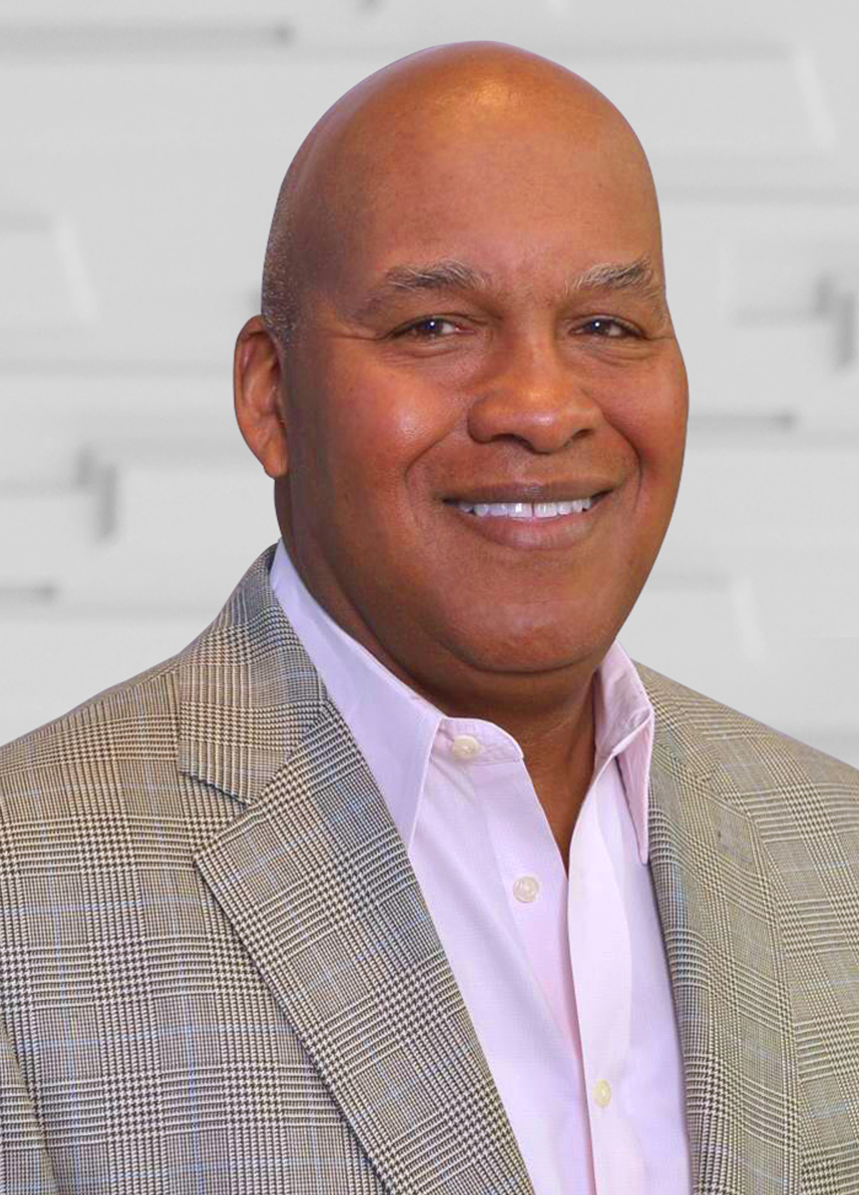 |  |  |  |  |  | Key Skills and Experience:  •Executive Leadership: Held top leadership roles at some of the largest companies in the world, including Walmart Inc., Dollar General Corporation, Safeway, Inc. and PepsiCo, Inc. As Senior Advisor to New Mountain Capital, LLC, a manager of private equity funds based in New York, has also served on the boards of several portfolio companies.  •Consumer and Retail: Spent 40 years leading consumer product companies and retailers, including Walmart Inc. and Dollar General Corporation, where his efforts led to significant new store openings and improved same-store results, as well as Safeway, Inc. and PepsiCo, Inc.  •Finance: Through his role at New Mountain Capital, LLC, has gained significant experience overseeing financial profiles of various portfolio companies. As President and CEO of the Global Procurement division at Walmart Inc, directed efforts of purchasing offices in 28 countries. In various roles at PepsiCo, Inc., including VP of Sales for Pepsi Cola, General Manager of Pepsi Cola Bottling and COO of Worldwide Operations for PepsiCo Foods, had key role in financial strategy and planning decisions.  •Logistics and Supply Chain: Gained deep knowledge regarding food manufacturing, distribution and supply chain operations throughout career. Implemented programs to improve the company’s factory sourcing while President and CEO of the Global Procurement division at Walmart Inc. As Senior Vice President of Supply Chain Operations at Safeway, Inc., led the manufacturing, distribution and private-label operations for the $30bn grocer.  •Business Development and Marketing: As General Manager of Pepsi Cola Bottling, oversaw strategy and activities for Marketing and Development teams.  •Human Resources/Talent Management: As Chief People Officer at Walmart Inc., was responsible for all human resources planning for the Company’s 1.5 million associates worldwide, including recruitment, training and executive development, succession planning, implementation of human resource technology and all diversity initiatives.  Career Highlights:  •Senior Advisor and Board member for several of the firm’s private portfolio companies, New Mountain Capital, LLC, a manager of private equity funds (since 2008)  •Walmart Inc. (2004 – 2008)  •President and CEO of Global Procurement Division (2006 – 2008)  •EVP and Chief People Officer (2004 – 2006)  •President and COO, Dollar General Corporation (2003 – 2004)  •Senior Vice President, Supply Chain Operations, Safeway, Inc. (1997 – 2003)  •Various executive roles, PepsiCo, Inc. (1981 – 1998)  •Consultant, McKinsey & Company (1979 – 1981)  Other Public Company Boards:  •John Bean Technologies Corporation (since 2020)  •Assurant, Inc. (since 2009)  •Snyder's-Lance, Inc. (2015 – 2018)  Education:  •BA, Economics, Harvard University  •MBA, Harvard Business School
Lawrence V. Jackson

Senior Advisor,
New Mountain Capital

Independent Director since: 2020

Committees:
•Nominating and Corporate Governance (Chair)
•Audit

Age: 70
8
Table of Contents

 |  |  |  |  |  | Key Skills and Experience:  •Finance: Deep expertise gained while at Ernst & Young LLP. Advised companies on the finance, accounting and reporting impacts of their business transformations, including mergers and acquisitions, dispositions and IT systems, and regularly collaborated with their merchandising and operations personnel in addressing the financial implications of their operational initiatives.  •Accounting and Auditing: Significant experience acquired as the lead audit partner for consumer businesses, resulting in expertise in accounting and auditing standards.  •Risk Management: Proven expert in risk management and compliance standards while advising multiple public companies at Ernst & Young LLP.  •Executive Leadership: Held various market-facing leadership roles in Ernst & Young LLP’s Consumer sector during last 20 years of tenure and served as Managing Partner of the Columbus office for five years, overseeing client engagement and quality reviews in addition to personnel and staffing management, training and thought leadership.  •Consumer and Retail: Spent nearly 40 years in various audit and assurance positions, focusing on all sectors of consumer products and retail.  •ESG: Advised companies on environmental, social and corporate governance (“ESG”) assessments, reporting and governance frameworks.  Career Highlights:  •Ernst & Young LLP (1984 – 2021)  •Senior Partner, Financial Accounting Advisory Services (2015 – 2021)  •Various audit and assurance positions (1984 – 2015)  Education:  •BA, Accounting and Business Management, University of St. Thomas  •Certified Public Accountant
Julie Kunkel

Former Senior Partner, Financial Accounting Advisory Services,
Ernst & Young LLP

Independent Director since: 2022

Committees:
•Audit

Age: 61
9
Table of Contents

 |  |  |  |  |  | Key Skills and Experience:  •Cybersecurity: As EVP and Chief Information Officer at Saia, Inc., a public logistics company, leads data privacy and NIST-based cybersecurity programs through training, process changes and technology.  •Information Technology and Digital: Deep technology acumen and proven track record transforming IT systems and cultures and ensuring IT solutions and data-driven decisions become competitive tools to enable and advance an organization’s strategic objectives. Significant experience in designing and implementing solutions focused on the customer experience, productivity and asset utilization.  •Logistics and Supply Chain: In current role at a public logistics company, leads IT teams to develop and deliver enterprise-wide solutions. Co-developed modern machine learning-based decision support and real-time traffic routing applications to replace legacy supply chain planning and city delivery solutions. While at The Coca-Cola Company, held advisory and governance roles with franchise bottler boards and helped implement end-to-end ERP solutions, including order-to-cash, forecasting, manufacturing, warehousing and route planning. Prior to that, led ERP value realization engagements at mid-market and global companies across multiple industries as CEO and Founder of AceTrack, Inc., a boutique consultancy.  •Executive Leadership: Proven leader at a publicly-traded company, having enacted transformative change and delivered impressive financial results, operating margin improvements and debt reduction.  •Business Development and Marketing: Extensive business development experience having founded and led AceTrack, Inc., including overseeing a multi-million dollar RFP to select a managed service provider for The Coca-Cola Company. In addition, six years of software sales and business development experience as a sales manager and sales executive at QAD.  •Consumer and Retail: Through a nine-year tenure at The Coca-Cola Company, gained expertise in consumer product sales and manufacturing. Oversaw the rollout of solutions for Trade Promotion Management, mobile sales force and Direct Store Delivery to convenience stores.  •Innovation and Culture: At Saia, Inc., transformed IT culture and technology to enable business growth through digital innovation. At The Coca-Cola Company, introduced customer-centric innovative solutions for better product ordering and sales force automation.  Career Highlights:  •Executive Vice President and Chief Information Officer, Saia, Inc. (since 2017)  •The Coca-Cola Company / CONA (Coke One North America) (2008 – 2017)  •Director, Enterprise Architecture, CONA Services (2016 – 2017)  •Director of Technology Strategy, CONA (2013 – 2016)  •Director of Application Development and Infrastructure (2008 – 2013)  •CEO and Founder, AceTrack, Inc. (2000 – 2008)  •Sales Manager, Sales Executive, Consultant and Application Developer, QAD (1989 – 1998)  Education:  •BS, Chemical Engineering, Indian Institute of Technology
Rohit Lal

Executive Vice President and Chief Information Officer, Saia, Inc.

Independent Director since: 2023

Committees:
•Audit

Age: 63
10
Table of Contents

 |  |  |  |  |  | Key Skills and Experience:  •Executive Leadership: Proven strategic and operational leadership capabilities having held multiple broad-based roles at Google, including current role leading the Americas for YouTube, Visible World (now owned by Comcast), where she was President and developed the Company into a leading technology platform for addressable video advertising, and McKinsey & Company, where she helped lead the Global Media & Entertainment and Sales & Marketing practices.  •Business Development and Marketing: Has more than 25 years of digital media sales and marketing experience, including tenure as Managing Director of Ads Marketing at Google, during which time she led Google’s communications and market development for clients and partners across products worldwide. Additionally, she was an advisor to CROs and CMOs throughout her tenure at McKinsey & Company and helped develop key thought leadership for the firm.  •Consumer and Retail: Deep understanding of evolving consumer interests and behavior based on 13 years at Google and YouTube, including leadership of initiatives driving retail media and e-commerce solutions. Regular advisor to CMOs and CEOs on best practices to drive consumer results across the purchase funnel.  •Information Technology and Digital: Significant digital transformation expertise from her roles at Visible World and Google, ranging from sales and marketing to operations and culture.  •Innovation and Culture: Writes and speaks frequently as a C-suite advisor on how to step-change innovation and culture to succeed in a rapidly evolving landscape.  •Human Resources and Talent Management: Led numerous talent management initiatives at McKinsey & Company, Visible World and Google to improve recruiting, performance management, employee engagement, and diversity and inclusion.  Career Highlights:  •Google (since 2011)  •Vice President, Americas, YouTube (since 2021)  •Vice President, Agency and Brand Solutions (2017 – 2021)  •Vice President, Agency Solutions (2014 – 2017)  •Managing Director, Ads Marketing (2011 – 2014)  •President, Visible World (2005 – 2011)  •Associate Partner, McKinsey & Company (1999 – 2005)  Other Public Company Boards:  •Braze, Inc. (since 2019)  Education:  •BA, Economics, Harvard University  •MBA, Harvard Business School
Tara Walpert Levy

Vice President, Americas, YouTube

Independent Director since: 2013

Committees:
•Compensation (Chair)

Age: 50
11
Table of Contents

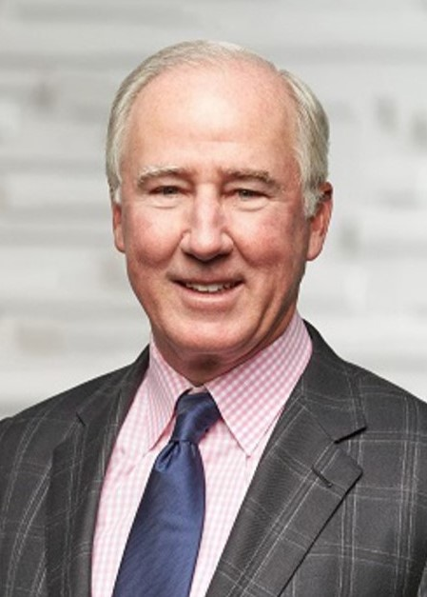 |  |  |  |  |  | Key Skills and Experience:  •Finance: Accomplished financial executive with large-cap public company experience. Gained substantial expertise in corporate finance, financial reporting and financial management from executive roles at Staples, Inc., experience as a Director for various public companies, and career as a certified public accountant and Partner at Ernst & Young LLP.  •Accounting and Auditing: Significant knowledge of auditing, accounting, governance and executive compensation through his 20-year career at Ernst & Young LLP and 15-year tenure as CFO of Staples, Inc.  •Risk Management: Gained expertise in risk management advising companies on appropriate controls during tenure at Ernst & Young LLP in addition to overseeing IT protocols and initiatives through role as Chief Administrative Officer at Staples, Inc.  •Executive Leadership: Over 45 years in leadership and management roles of increasing responsibility.  •Consumer and Retail: 35+ years of extensive experience during service in various roles at Staples, Inc., a multinational office supply retailer, as well as service on several retail public company boards including Chico’s FAS, Burlington Stores, Inc., and The Michael’s Companies, Inc.  •International: Through role as Chief Administrative Officer at Staples, Inc., helped oversee the Company’s international operations.  •Human Resources and Talent Management: Experience overseeing the human resources initiatives of public companies as Chair of Chico’s Human Resources, Compensation and Benefits Committee and previously as Chair of Burlington’s Compensation Committee.  Career Highlights:  •Staples, Inc. (1996 – 2012)  •Vice Chairman (2006 – 2012)  •CFO (1996 – 2012)  •Chief Administrative Officer (1997 – 2006)  •Executive Vice President (1996 – 2006)  •Partner, Ernst & Young LLP, holding roles in its National Office Accounting and Auditing groups (1975 – 1996)  Other Public Company Boards:  •Chico's FAS (since 2007)  •Burlington Stores, Inc. (since 2013, appointed Chair in 2020)  •The Michael’s Companies, Inc. (2013 - 2021)  •Zipcar, Inc. (2010 – 2012)  Education:  •BA, English, College of the Holy Cross  •MBA, Northeastern University  •Certified Public Accountant
John J. Mahoney

Former Chief Financial Officer and Retired Vice Chairman, Staples, Inc.

Independent Director since: 2012

Committees:
•Audit (Chair)
•Operating

Age: 72
12
Table of Contents

 |  |  |  |  |  | Key Skills and Experience:  •Finance: Extensive expertise in financial planning and analysis, including current position as CFO of Urban Outfitters, Inc. where she oversees finance, accounting, tax, business development and strategy and loss prevention.  •Accounting and Auditing: Significant knowledge of financial reporting, accounting and auditing through nearly two decades of experience in financial roles at publicly traded companies.  •Executive Leadership: Served in key leadership roles in finance organizations at large public companies, including General Motors, Campbell Soup Company and currently Urban Outfitters, Inc.  •Business Development and Marketing: Serving in various roles at Urban Outfitters, Inc. concentrating on financial planning and business analysis, long-range planning and business development for the Company's global consumer brands including Urban Outfitters, Anthropologie, Free People, BHLDN, Terrain, Menus & Venues and Nuuly.  •Consumer and Retail: Over 27 years in roles of increasing responsibility at major retail and consumer products organizations driving top line growth and financial returns, including several in the food and beverage sector.  Career Highlights:  •Urban Outfitters, Inc. (since 2013)  •CFO (since 2020)  •Executive Director, Corporate Development & Finance (2013 – 2020)  •Various financial roles including Assistant Treasurer, Campbell Soup Company (2004 – 2013)  •North America Finance Director, Godiva Chocolatier (2000 – 2004)  •Manager, Finance, General Motors (1996 – 2000)  Education:  •BS, Accounting and Decision Sciences, The Wharton School of the University of Pennsylvania  •MBA, Finance, The Wharton School of the University of Pennsylvania
Melanie Marein-Efron

Chief Financial Officer,
Urban Outfitters, Inc.

Independent Director since: 2022

Committees:
•Compensation

Age: 54
13
Table of Contents

 |  |  |  |  |  | Key Skills and Experience:  •Executive Leadership: Leadership roles over the majority of career have had significant focus on all aspects of operations, including sales, merchandising, marketing, supply chain management, services and new business initiatives.  •Business Development and Marketing: Expertise in digital marketing over 35+ year career including various roles at Best Buy Co. leading merchandising and marketing efforts. At Best Buy Co., gained additional significant business development experience through the launch of partnerships with leading consumer brands to create the within-store Magnolia and Pacific Kitchen & Home concepts and leading the evolution of Best Buy’s private-label, fitness devices and connected home products.  •Logistics and Supply Chain: Significant experience through close involvement in vendor engagement throughout tenure at Best Buy Co., assisting with negotiating master agreements and pricing for billions of dollars of goods purchased from vendors each year. As Chief Operating Officer, directly oversaw the logistics and distribution teams, including the massive upgrade in automated technology in the distribution centers.  •Real Estate: Experience directly managing large real estate portfolios, including leading Best Buy Co.’s real estate committee and directly overseeing its real estate, capital and maintenance planning for new stores, renovations, relocations and vacated locations involving ~200 real estate transactions per year.  •Consumer and Retail: An extensive career at large retail companies including Best Buy Co. and Good Guys, an audio-video specialty retailer that operated 79 stores in the western United States.  •Human Resources and Talent Management: As Chief Operating Officer of Best Buy Co., led complete overhaul in operating model of the Company’s 5,000+ corporate roles to support talent and development plans and had deep involvement in all decisions related to compensation, job grades and benefits for Company’s ~100,000 global employees.  •Information Technology and Digital: Proven ability to advance consumer-facing digital strategy having directly overseen Best Buy Co.’s ecommerce platform as Chief Operating Officer, including all aspects of development, product release and specific online customer demand generation.  Career Highlights:  •Best Buy Co. (2004 – 2021)  •President and Chief Operating Officer (2019 – 2021)  •Chief Operating Officer, U.S. Business (2018 – 2019)  •Senior Executive Vice President and Chief Merchandising and Marketing Officer (2014 – 2018)  •Senior Vice President and President of the Home Business Group (2013 – 2014)  •Senior Vice President of Merchandising (2008 – 2013)  •Vice President and General Merchandise Manager (2004 – 2007)  •Good Guys (1997 – 2004)  •Vice President and General Merchandise Manager (2002 – 2004)  •Senior Category Management (1997 – 2002)  •Various positions, Future Shop (1988 - 1997)  Other Public Company Boards:  •Vizio Holding Corp. (since 2023)  •Petco Health and Wellness Company, Inc., Lead Independent Director (since 2021)  Education:  •Engineering and Commerce, University of Calgary
R. Michael Mohan

Chairman of the Board

Former President and Chief Operating Officer, Best Buy
Co.

Independent Director since: 2017

Chairman since: 2023

Committees:
•Compensation
•Nominating and Corporate Governance
•Operating

Age: 56
14
Table of Contents

 |  |  |  |  |  | Key Skills and Experience:  •Finance: Brings valuable financial and investment acumen as a Partner at Starboard Value. In previous roles at Casablanca Capital, Mill Road Capital and Prentice Capital Management, gained expertise evaluating and executing opportunities for long-term investments to drive growth and profitability.  •Executive Leadership: As a Partner at Starboard Value, actively engages with management teams and boards of directors of publicly traded U.S. companies to identify and execute on opportunities to unlock value for the benefit of shareholders.  •Casual Dining: Helped lead prior Starboard investments in Darden Restaurants and Papa John’s with a focus on driving operational improvements.  •Real Estate: Gained experience advising companies in managing large or complex real estate footprints, including at Darden through REIT spin to create Four Corners Property Trust.  •ESG: Brings expertise in key corporate governance matters and sustainability initiatives to inform best-in-class processes, including through prior role as member of Acacia Research Corporation’s Board of Directors and service on its Nominating, Governance & Sustainability Committee.  Career Highlights:  •Partner, Starboard Value LP (since 2011)  •Investment Analyst, Casablanca Capital (2010 – 2011)  •Investment Analyst, Mill Road Capital (2009 – 2010)  •Investment Analyst, Prentice Capital Management (2006 – 2009)  •Investment Banking Analyst, Rothschild Inc. (2004 – 2006)  Other Public Company Boards:  •Acacia Research Corporation (2019 – 2024)  Education:  •AB, Philosophy, Princeton University  •MBA, Columbia Business School
Jonathan Sagal

Partner, Starboard Value LP

Independent Director since: 2024

Committees:
•Nominating and Corporate Governance
•Operating

Age: 42

Recommendation of the Board of Directors
The Board of Directors recommends that stockholders vote FOR each of the nominees to the Board.

15
Table of Contents

Board Overview
Our Board is currently comprised of 11 individuals selected on the basis of numerous criteria, including business experience, industry knowledge and other fields of significant knowledge, good character, sound judgement, integrity, and diversity. We view the effectiveness of our Board through both an individual and collective lens and believe that our Board is optimized to support and guide the Company.

Board Snapshot

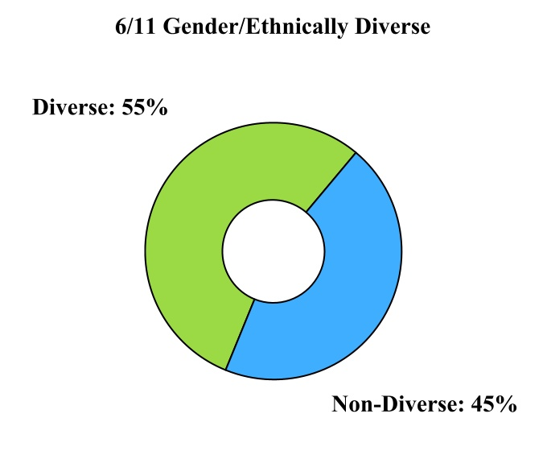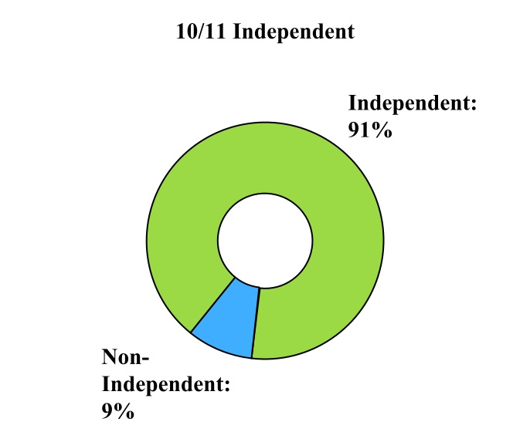
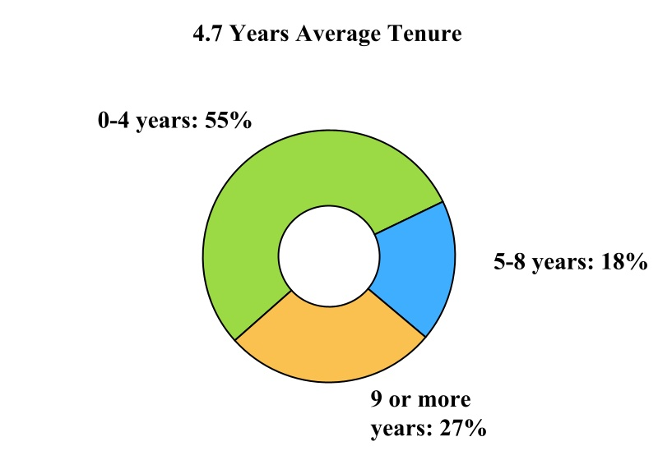

Note: The information above is based on Board composition as of March 4, 2024. The Board size will be reduced to ten directors as of the 2024 annual meeting. The term of David R. Fitzjohn, an independent director, ends as of the 2024 annual meeting, and he is not standing for re-election.

16
Table of Contents

Board Diversity Matrix
BOARD DIVERSITY MATRIX (AS OF MARCH 4, 2024)(1)(2)
BOARD SIZE:
Total number of directors |  |  |  |  |  | 11(1)
GENDER IDENTITY: |  |  |  |  |  | FEMALE |  |  |  |  |  | MALE |  |  |  |  |  | NON- BINARY |  |  |  |  |  | DID NOT DISCLOSE GENDER
Number of directors based on gender identity |  |  |  |  |  | 3 |  |  |  |  |  | 8 |  |  |  |  |  | — |  |  |  |  |  | —
Number of directors who identity in any of the categories below:
African American or Black |  |  |  |  |  | — |  |  |  |  |  | 1 |  |  |  |  |  | — |  |  |  |  |  | —
Alaskan Native and Native American |  |  |  |  |  | — |  |  |  |  |  | — |  |  |  |  |  | — |  |  |  |  |  | —
Asian |  |  |  |  |  | — |  |  |  |  |  | 1 |  |  |  |  |  | — |  |  |  |  |  | —
Hispanic or Latinx |  |  |  |  |  | — |  |  |  |  |  | — |  |  |  |  |  | — |  |  |  |  |  | —
Native Hawaiian or Pacific Islander |  |  |  |  |  | — |  |  |  |  |  | — |  |  |  |  |  | — |  |  |  |  |  | —
White |  |  |  |  |  | 3 |  |  |  |  |  | 5 |  |  |  |  |  | — |  |  |  |  |  | —
Two or More Races or Ethnicities |  |  |  |  |  | — |  |  |  |  |  | 1 |  |  |  |  |  | — |  |  |  |  |  | —
LGBTQ+ |  |  |  |  |  | —
Did Not Disclose Demographic Background |  |  |  |  |  | —
_________________
(1)As of the 2024 annual meeting, the size of the Board will be reduced to ten directors. David R. Fitzjohn’s term ends as of the 2024 annual meeting, and he is not standing for re-election.
(2)To see our Board Diversity Matrix as of March 6, 2023, please see the 2023 proxy statement filed with the SEC on that date.

Board Skills Matrix
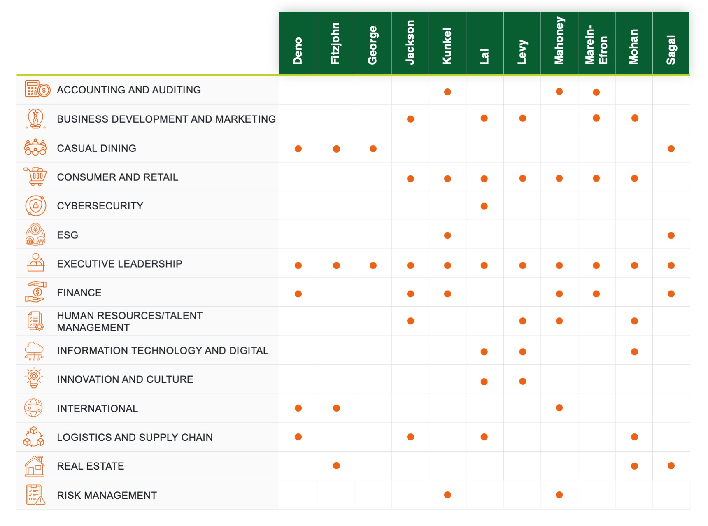

17
Table of Contents

Board Committees and Meetings
During our fiscal year ended December 31, 2023, the Board of Directors held 16 meetings. During fiscal 2023, each incumbent director attended at least 75% of the aggregate of (i) the total number of Board meetings (held during the period for which he or she has been a director) and (ii) the total number of meetings held by all Board committees on which he or she served (during the period that he or she served). Directors are strongly encouraged to attend the annual meeting of stockholders. All of our directors who were then on the Board of Directors attended our 2023 annual meeting of stockholders.

We have three standing committees: the Audit Committee; the Compensation Committee; and the Nominating and Corporate Governance Committee. Each of these committees has a written charter approved by the Board of Directors. A copy of each charter can be found by clicking on “Governance—Governance Documents” in the “Investors” section of our website, www.bloominbrands.com.

Under our Corporate Governance Guidelines, committee members may serve a maximum of five one-year terms, which enables committee members to rotate periodically to different committees. In addition, committee chairs may serve a maximum of five one-year terms as chair (which may be in addition to prior service as a committee member) in order to facilitate the rotation of committee chairs while preserving experienced leadership. Upon reaching the completion of the fifth one-year term, the committee member or committee chair, as the case may be, must tender his or her resignation to the Board, to be effective immediately at the end of such director’s then-current term.

Under the rules of the NASDAQ Stock Market (“NASDAQ”), our Board of Directors must consist of a majority of directors who meet NASDAQ’s independence requirements (“Independent Directors”) and the Audit, Compensation, and Nominating and Corporate Governance Committees must be composed entirely of Independent Directors. See “Independent Directors” for additional information regarding these independence requirements and our satisfaction of these requirements.

The members and chairs of these committees, as of the date of this proxy statement, are identified in the following table:
DIRECTOR |  |  |  |  |  | AUDIT COMMITTEE |  |  |  |  |  | COMPENSATION COMMITTEE |  |  |  |  |  | NOMINATING AND CORPORATE GOVERNANCE COMMITTEE
David R. Fitzjohn |  |  |  |  |  |  |  |  |  |  |  |  |  |  |  |  |  | X
David George (1) |  |  |  |  |  |  |  |  |  |  |  | X
Lawrence V. Jackson |  |  |  |  |  | X |  |  |  |  |  |  |  |  |  |  |  | Chair
Julie Kunkel |  |  |  |  |  | X
Rohit Lal |  |  |  |  |  | X
Tara Walpert Levy |  |  |  |  |  |  |  |  |  |  |  | Chair
John J. Mahoney (1) |  |  |  |  |  | Chair
Melanie Marein-Efron |  |  |  |  |  |  |  |  |  |  |  | X
R. Michael Mohan (1) |  |  |  |  |  |  |  |  |  |  |  | X |  |  |  |  |  | X
Jonathan Sagal (1) |  |  |  |  |  |  |  |  |  |  |  |  |  |  |  |  |  | X
_________________
(1)Under the terms of the Starboard Agreement (defined below), in January 2024, the Board formed an Operating Committee consisting of Messrs. George (Chair), Mahoney, Mohan and Sagal.
18
Table of Contents

Audit Committee
The purposes of the Audit Committee are set forth in the Audit Committee charter and are primarily to assist the Board of Directors in overseeing:

•the integrity and overall quality of our financial statements

•the effectiveness of our internal control over financial reporting

•our compliance with legal and regulatory requirements

•the Independent Auditor’s qualifications and independence

•the evaluation of enterprise risk issues

•the performance of our internal audit function and Independent Auditor

•the Company’s identification, assessment, and management of cybersecurity and data privacy risks

The Audit Committee is also responsible for the appointment, compensation and oversight of the Independent Auditor, as well as the selection and replacement of the lead audit partner of the Independent Auditor.

The Audit Committee reviews and discusses with management and the Independent Auditor mandatory filings and financial information to be included in our audited financial statements, results and performance, including the quality of the accounting principles, the clarity of the disclosures in the financial statements and the adequacy and effectiveness of internal controls. The Audit Committee also reviews earnings press releases.

The Audit Committee reviews significant reports to management prepared by the Company’s internal audit team and management’s responses and discusses with management and the Independent Auditor the internal audit team’s responsibilities, activities, organizational structure and independence, staffing, qualifications and budget. The Audit Committee also meets regularly with our internal audit team to review and discuss the internal audit scope, plan and results of internal audit activities.

The Audit Committee also reviews and discusses with management, the internal audit team and the Independent Auditor enterprise risk issues, including cybersecurity and data privacy, and the steps management has taken to monitor and control such risk exposures. The Audit Committee receives and evaluates quarterly updates from our head of information security and Chief Technology Officer regarding the Company’s cybersecurity program and actions taken to manage cybersecurity risk. The topics cover the following, on an as-needed basis: risk identification and management strategies, consumer data protection, security programs, ongoing risk mitigation activities, and results of third-party assessments and testing.

Mr. Mahoney and Ms. Kunkel were each determined by our Board of Directors to be an “audit committee financial expert” within the meaning of Item 407 of Regulation S-K and are independent within the meaning of the NASDAQ listing rules for audit committee members. All of the members meet the requirements for audit committee members under applicable NASDAQ rules regarding the ability to read and understand financial statements.

The Audit Committee held nine meetings during fiscal 2023.

Compensation Committee
The purposes of the Compensation Committee are set forth in the Compensation Committee charter and are primarily to:

•oversee our executive compensation policies and practices
19
Table of Contents

•discharge the responsibilities of our Board relating to executive compensation of our Chief Executive Officer (“CEO”) and our other executive officers

•review and approve certain compensation and employee benefit plans, policies and programs; and exercise discretion in the administration of such programs

•produce, approve and recommend to our Board for its approval reports on compensation matters required to be included in our annual proxy statement or annual report, in accordance with applicable rules and regulations

For additional description of the Compensation Committee’s processes and procedures for consideration and determination of executive officer compensation, see “Compensation Discussion and Analysis” within “Executive Compensation and Related Information.”

The Compensation Committee held seven meetings during fiscal 2023.

Nominating and Corporate Governance Committee

The purposes of the Nominating and Corporate Governance Committee are set forth in the Nominating and Corporate Governance Committee charter and are primarily to:

•identify and evaluate individuals qualified to become members of our Board and to recommend to our Board the director nominees for each annual meeting of stockholders or to recommend persons to fill vacancies on the Board

•review and recommend to our Board committee structure, membership, and operations, including oversight regarding the rotation of committee members

•develop and recommend to our Board a set of corporate governance guidelines

•oversee the annual performance evaluation of our Board, each committee of the Board, and each individual director, plus an even more in-depth performance review of each of the foregoing led by an outside consultant periodically

•advise the Board regarding director succession planning

•review and assess the effectiveness of the Company’s environmental, social and governance policies, goals and programs, and make recommendations to the Board based on such review and assessment

The Nominating and Corporate Governance Committee held seven meetings during fiscal 2023.

Independent Directors
Under our Corporate Governance Guidelines, an “independent” director is one who meets the qualification requirements for being independent under applicable laws and the corporate governance listing standards of NASDAQ. The Nominating and Corporate Governance Committee evaluates the relationships of each director and director nominee and makes a recommendation to the Board of Directors as to whether to make an affirmative determination that such director or director nominee is independent. Upon recommendation of the Nominating and Corporate Governance Committee, the Board of Directors has affirmatively determined that: (a) Messrs. Fitzjohn, George, Jackson, Lal, Mahoney, Mohan, and Sagal and Mses. Kunkel, Levy and Marein-Efron are independent under the criteria established by NASDAQ for director independence; (b) Ms. Kunkel and Messrs. Jackson, Lal, and Mahoney are independent under the criteria established by NASDAQ for audit committee membership; and (c) Messrs. George and Mohan and Mses. Levy and Marein-Efron are independent under the criteria established by NASDAQ for compensation committee membership.

20
Table of Contents

Arrangements or Understandings Regarding Service as a Director
Messrs. George and Sagal (the “Starboard Nominees”) were appointed by the Board on January 2, 2024 pursuant to an agreement that we entered into on January 2, 2024 (the “Starboard Agreement”) with Starboard Value LP and certain of its affiliates (collectively, “Starboard”). Messrs. George and Sagal were nominated for re-election at the 2024 annual meeting, each for a one-year term expiring at the 2025 annual meeting. In addition, pursuant to the Starboard Agreement, the Company formed an Operating Committee of the Board. Mr. George has been appointed to serve as Chair of the Operating Committee and as a member of the Compensation Committee. Mr. Sagal (along with current directors R. Michael Mohan and John J. Mahoney) has been appointed as a member of the Operating Committee, and he has also been appointed as a member of the Nominating and Corporate Governance Committee. The Starboard Agreement contains customary standstill provisions and voting commitments. If, during the standstill period, either Starboard Nominee becomes unavailable to serve as a director, Starboard retains the right to identify a successor, who must be reasonably satisfactory to the Nominating and Corporate Governance Committee. The Starboard Agreement is more fully described in the Company’s Current Report on Form 8-K filed with the Securities and Exchange Commission (“SEC”) on January 2, 2024.

None of our other directors or nominees have any agreements or arrangements with any other person or entity in connection with the director’s or nominee’s candidacy or service on our Board.

Nominees for the Board of Directors
Our Corporate Governance Guidelines provide that nominees for director shall be selected on the basis of their business experience, qualifications, attributes and skills, such as relevant industry knowledge; specific experience with technology, accounting, finance, leadership, strategic planning and international markets; independence; judgment; integrity; the ability to commit sufficient time and attention to the activities of the Board; diversity of occupational and personal backgrounds on the Board; the absence of potential conflicts with our interests; and such other criteria as may be established by the Board from time to time. These criteria are considered in the context of an assessment of the operation and goals of the Board as a whole. In addition, the Board considers, in light of our business, each director nominee’s experience, qualifications, attributes and skills that are identified in the biographical information contained under “Proposal 1—Election of Directors,” and believes that the collective business experience, industry knowledge and other fields of significant knowledge, good character, sound judgment, integrity and diversity of our current Board provides appropriate support and guidance to our Company.

Under our Corporate Governance Guidelines, no incumbent director may stand for re-election to the Board of Directors after reaching the age of 72. Any director who has reached the age of 72 must tender his or her resignation, to be effective immediately at the end of such director’s then-current term. However, the Board may, upon recommendation of the Nominating and Corporate Governance Committee, reject such resignation. Any director whose resignation is rejected by the Board must again tender his or her resignation at the end of his or her then-current term and at the end of any extended term. Mr. Mahoney tendered his resignation to the Board pursuant to the Board’s tenure policy. However, the Board opted to reject this resignation and to nominate him for re-election as a director at the annual meeting in light of the skills he contributes to the Board and its Audit Committee, to serve for a one-year term expiring in 2025.

In recommending candidates for election to the Board of Directors, the Nominating and Corporate Governance Committee considers nominees recommended by directors, officers, employees and others, using the same criteria to evaluate all candidates. The Nominating and Corporate Governance Committee reviews each candidate’s qualifications, including whether a candidate possesses any of the specific qualities and skills desirable in certain members of the Board of Directors. Evaluations of candidates generally involve a review of background materials, internal discussions and interviews with selected candidates as appropriate. Upon selection of a qualified candidate, the Nominating and Corporate Governance Committee recommends the candidate for consideration by the full Board of Directors. The Nominating and Corporate Governance Committee may engage consultants or third-party search firms to assist in identifying and evaluating potential nominees.

21
Table of Contents

The Nominating and Corporate Governance Committee will also consider nominees for election to the Board of Directors submitted by stockholders using substantially the same criteria it applies to recommendations by directors, officers, employees and others. To recommend a prospective nominee for the Nominating and Corporate Governance Committee’s consideration, submit the candidate’s name and qualifications to our Corporate Secretary in writing to the following address: Bloomin’ Brands, Inc., Attention: Nominating and Corporate Governance Committee, 2202 North West Shore Boulevard, Suite 500, Tampa, Florida 33607.

Board Leadership Structure
Under our Corporate Governance Guidelines, the Board of Directors has established a policy that provides it with the flexibility and discretion to select its Chairman at any time, based on what it believes to be in the best interest of the Company and its stockholders. The policy further provides that the same person may serve as both Chairman of the Board and CEO, or the Board may choose to have an independent or Executive Chairman. If the offices of Chairman of the Board and CEO are held by the same person, or if the Chairman of the Board is not otherwise independent, the independent directors may annually elect (by majority vote) a Lead Independent Director.

Our Corporate Governance Guidelines provide that the Chairman of the Board will serve for a term of five years. Upon reaching five years, the Chairman must tender his or her resignation as Chairman, to be effective immediately at the end of such five-year term. The Board may, upon recommendation of the Nominating and Corporate Governance Committee, reject such resignation. If the resignation is rejected by the Board, the Chairman must again tender his or her resignation at the end of any extended term. These limitations, and the term limits and mandatory retirement age discussed above, do not apply to the Company’s Chief Executive Officer, who may serve on the Board until his or her resignation, removal or retirement as Chief Executive Officer.

In addition, various other corporate governance measures also contribute to a high degree of independent oversight of the Company’s management, including holding regular executive sessions; all continuing directors (other than Mr. Deno) and all of the Board committee members being independent under the NASDAQ standards; and the Board and each committee conducting annual self-assessments to ensure that they are functioning effectively.

Mr. Mohan was appointed Chairman of the Board on August 28, 2023, when James Craigie stepped down from his role as Chairman and retired as a director of the Board. Mr. Craigie’s retirement from the Board was not due to a disagreement with the Board or with the Company’s management. As Chairman, Mr. Mohan calls and presides at meetings of the independent directors as well as the Board; establishes, in consultation with the CEO, the agenda for each Board meeting; and is available for consultation and communication with major stockholders. The Board periodically reviews its leadership structure to ensure that it continues to meet our needs in light of all relevant facts and circumstances at that time. The Board believes the current leadership structure, with an independent Chairman of the Board, is appropriate at this time and will promote continued effective decision-making.

Board’s Role in Risk Oversight
It is management’s responsibility to manage risk and bring material risks to the attention of the Board of Directors. The Board of Directors administers its risk oversight role by reviewing strategic, financial and execution risks and exposures associated with the annual plan and multi-year plans; cybersecurity, major litigation and other matters that may present material risk to our operations, plans, prospects or reputation; acquisitions and divestitures; and succession planning for the Chief Executive Officer position and other senior management positions. This oversight role is performed both by the Board of Directors and through the committees, who provide regular reports to the Board of Directors. The Audit Committee reviews risks associated with financial and accounting matters, including financial reporting, accounting, disclosure, internal controls over financial reporting, ethics and compliance programs, organizational culture, compliance with law and protecting against and responding to breaches of our data security. The Compensation Committee reviews risks related to executive compensation and the design of compensation programs, plans and arrangements.

22
Table of Contents

Code of Conduct
We have adopted a written Code of Conduct that applies to our directors, officers and employees, including our principal executive officer, principal financial officer, principal accounting officer and controller, and other persons performing similar functions. A copy of the Code of Conduct can be found by clicking on “Governance—Governance Documents” in the “Investors” section of our website, www.bloominbrands.com.

Stockholder Communications with the Board of Directors
Stockholders may communicate with the Board of Directors through our Corporate Secretary by writing to the following address: Bloomin’ Brands, Inc., Attention: Board of Directors, 2202 North West Shore Boulevard, Suite 500, Tampa, Florida 33607 (we encourage you to send a copy via email to CorporateSecretary@bloominbrands.com). Our Corporate Secretary will forward all appropriate correspondence to the Board of Directors.

Director Compensation
Our Compensation Committee periodically reviews the competitiveness of our Board of Directors Compensation Plan applicable to non-employee directors. Directors who are also our employees do not receive additional compensation for serving on the Board. Shares for equity awards pursuant to the Board of Directors Compensation Plan are issued from our stockholder-approved equity compensation plan in effect at the time of award (currently the Bloomin’ Brands, Inc. 2020 Omnibus Incentive Compensation Plan) and pursuant to which we are authorized to grant shares of our common stock and share-based awards to directors.

Based on the results of a competitive analysis, supported by the Compensation Committee’s independent compensation consultant Frederic W. Cook & Co. (“FW Cook”), the Compensation Committee approved a $5,000 increase to the board members’ current annual cash retainer (outlined below); approved a $5,000 increase to the additional cash retainer amount for Compensation Committee leadership and a $10,000 increase to the additional cash retainer amount for Nominating and Corporate Governance Committee leadership (outlined below); and approved a $5,000 increase to the annual grant for both the Non-Executive Chair and other Board members, with such increases effective starting with the 2023 annual board member grants. These increases were made to maintain competitiveness of our directors’ compensation levels relative to our peer group.

Annual board member grants vest in full on the date of the first annual meeting of stockholders following the grant date, which aligns the grants with the Director’s one-year elected term (expiring at the next annual stockholders’ meeting). The Board of Directors Compensation Plan for fiscal year 2023, which has been in effect since August 7, 2013 and was last amended April 17, 2023, includes the following compensation components for services rendered by our non-employee directors effective April 17, 2023:

•Annual cash retainer of $95,000

•Additional annual cash retainer of $60,000 for serving as non-executive Chairman

•Additional annual cash retainer of $50,000 for serving as the Lead Independent Director, if applicable

•Additional annual cash retainer of $30,000 for serving as chair and $15,000 for serving as a member (other than the chair) of the Audit Committee

•Additional annual cash retainer of $30,000 for serving as chair and $12,500 for serving as a member (other than the chair) of the Compensation Committee

•Additional annual cash retainer of $30,000 for serving as chair and $10,000 for serving as a member (other than the chair) of the Nominating and Corporate Governance Committee

23
Table of Contents

•Annual grant of Bloomin’ Brands restricted stock units (“RSUs”) having a fair market value, based on the closing price of the underlying common stock, of $155,000 (or $220,000 for the non-executive Chairman) on the date of our annual meeting of stockholders, which awards will vest in full on the date of the first annual meeting of stockholders following the grant date as explained above.

If a non-employee director is elected at any time other than at our annual meeting of stockholders, such director will receive an initial grant of restricted stock units having a fair market value, based on the closing price of the underlying common stock on the grant date, of $155,000 on the date of the first Board of Directors meeting that such director attends, prorated for the number of months that such director will serve on the Board from and including the month of the director’s first Board meeting as a director through the month of our next annual meeting of stockholders, rounded to the nearest $100 and vesting in full at the first annual meeting of stockholders following the grant date.

The Board of Directors adopted a Stock Ownership Guidelines Policy for directors, executive officers and members of our executive leadership team. Mr. Deno and all non-employee directors are required to accumulate shares of our common stock through direct purchases or retention of equity incentives (the “Stock Ownership Requirement”) equal to six times base salary for Mr. Deno, and five times the annual retainer for all non-employee directors. The Stock Ownership Requirement must be met by the later of December 17, 2019 or the fifth anniversary of the director’s or executive officer’s initial election or appointment, as applicable. Mr. Deno and all non-employee Directors have met their ownership requirement or are on track to meet their requirement before their respective deadlines.

The following table summarizes the amounts earned and paid to non-employee directors during fiscal year 2023:
 |  |  |  |  |  | FEES EARNED OR PAID IN CASH |  |  |  |  |  | STOCK AWARDS (1) |  |  |  |  |  |  |  |  |  |  |  | OTHER COMPENSATION |  |  |  |  |  | TOTAL
NAME |  |  |  |  |  | ($) |  |  |  |  |  | ($) |  |  |  |  |  |  |  |  |  |  |  | ($) |  |  |  |  |  | ($)
James R. Craigie (2) |  |  |  |  |  | 123,125 |  |  |  |  |  | 220,002 |  |  |  |  |  |  |  |  |  |  |  | — |  |  |  |  |  | 343,127
David R. Fitzjohn |  |  |  |  |  | 102,500 |  |  |  |  |  | 155,021 |  |  |  |  |  |  |  |  |  |  |  | — |  |  |  |  |  | 257,521
John P. Gainor, Jr. (3) |  |  |  |  |  | 117,500 |  |  |  |  |  | 155,021 |  |  |  |  |  |  |  |  |  |  |  | — |  |  |  |  |  | 272,521
Lawrence V. Jackson |  |  |  |  |  | 117,500 |  |  |  |  |  | 155,021 |  |  |  |  |  |  |  |  |  |  |  | — |  |  |  |  |  | 272,521
Julie Kunkel |  |  |  |  |  | 107,500 |  |  |  |  |  | 155,021 |  |  |  |  |  |  |  |  |  |  |  | — |  |  |  |  |  | 262,521
Rohit Lal (4) |  |  |  |  |  | 32,527 |  |  |  |  |  | 90,405 |  |  |  |  |  |  |  |  |  |  |  | — |  |  |  |  |  | 122,932
Tara Walpert Levy |  |  |  |  |  | 105,000 |  |  |  |  |  | 155,021 |  |  |  |  |  |  |  |  |  |  |  | — |  |  |  |  |  | 260,021
John J. Mahoney |  |  |  |  |  | 122,500 |  |  |  |  |  | 155,021 |  |  |  |  |  |  |  |  |  |  |  | — |  |  |  |  |  | 277,521
Melanie Marein-Efron |  |  |  |  |  | 107,500 |  |  |  |  |  | 155,021 |  |  |  |  |  |  |  |  |  |  |  | — |  |  |  |  |  | 262,521
R. Michael Mohan |  |  |  |  |  | 143,043 |  |  |  |  |  | 192,933 |  |  |  |  |  |  |  |  |  |  |  | — |  |  |  |  |  | 335,976
Elizabeth A. Smith (5) |  |  |  |  |  | 45,000 |  |  |  |  |  | — |  |  |  |  |  |  |  |  |  |  |  | — |  |  |  |  |  | 45,000
__________________
(1)Represents RSUs, which vest in full on the date of the first annual meeting of stockholders following the grant date. The amounts represent the full aggregate grant date fair values computed in accordance with Financial Accounting Standards Board (“FASB”) Accounting Standards Codification (“ASC”) Topic 718. The grant date fair market value based on the closing price of the underlying common stock is $155,000 for all directors other than Mr. Craigie and $220,000 for Mr. Craigie. Mr. Mohan received a prorated grant upon becoming chair in August 2023 and Mr. Lal received a prorated grant upon joining the Board in October 2023. As of December 31, 2023, the non-employee directors listed above held the following aggregate number of unvested RSUs: Mr. Craigie, 0 shares; Mr. Fitzjohn, 8,270 shares; Mr. Gainor, 0 shares; Mr. Jackson, 8,270 shares; Ms. Kunkel, 6,508 shares; Mr. Lal 4,018 shares; Ms. Levy, 8,270 shares; Mr. Mahoney, 8,270 shares; Ms. Marein-Efron, 6,508 shares; Mr. Mohan, 9,955 shares; and Ms. Smith, 0 shares. As of December 31, 2023, Ms. Smith held 120,589 vested stock options.
(2)Mr. Craigie stepped down as Chairman and retired from the Board on August 28, 2023. His retirement from the Board was not due to any disagreement with the Company.
(3)Mr. Gainor resigned as a member of the Board effective November 13, 2023, due to to other personal and professional commitments and not due to any disagreement with the Company.
(4)Mr. Lal joined the Board in October 2023.
(5)Ms. Smith’s term as a non-independent director ended as of the 2023 annual meeting, and she did not stand for re-election. Her decision was not a result of any disagreement with the Company.

24
Table of Contents

PROPOSAL NO. 2

RATIFICATION OF INDEPENDENT REGISTERED CERTIFIED PUBLIC ACCOUNTING FIRM

General
We are asking our stockholders to ratify the Audit Committee’s appointment of PricewaterhouseCoopers LLP as our Independent Auditor for the fiscal year ending December 29, 2024. The Company believes that the choice of PricewaterhouseCoopers LLP as the Independent Auditor is in the best interests of the Company and its stockholders. In the event the stockholders do not ratify the appointment, the Audit Committee will reconsider this appointment. Even if the appointment is ratified, the Audit Committee, in its discretion, may direct the appointment of a different Independent Auditor at any time during the year if the Audit Committee determines that such a change would be in the best interests of the Company and its stockholders.

PricewaterhouseCoopers LLP has audited the Bloomin’ Brands consolidated financial statements annually since we were formed and the financial statements of our predecessor since 1998. Representatives of PricewaterhouseCoopers LLP are expected to be present at the annual meeting and will have the opportunity to make a statement if they so desire. It is also expected that those representatives will be available to respond to appropriate questions.

The Audit Committee is directly responsible for the appointment, compensation and oversight of the Independent Auditor and annually reviews the firm’s qualifications and work quality. In the course of these reviews, the Audit Committee considers, among other things:

•the firm’s historical and recent plans and performance on our audit

•the firm’s capability and expertise in handling the breadth and complexity of our operations

•external data on audit quality and performance, including Public Company Accounting Oversight Board reports on the firm and its peer firms

•the firm’s independence and objectivity

•the appropriateness of the firm’s fees for audit and non-audit services, including any effect these fees may have on independence

•the quality and candor of the firm’s communications with the committee and management

•the firm’s tenure as our Independent Auditor, including the benefits of having a long-tenured auditor and controls and processes that help safeguard the firm’s independence

Principal Accountant Fees and Services
The following is a summary of the fees billed to us by PricewaterhouseCoopers LLP for professional services rendered for the fiscal years ended December 31, 2023 and December 25, 2022 (dollars in thousands):
FEE CATEGORY |  |  |  |  |  | 2023 |  |  |  |  |  | 2022
Audit Fees |  |  |  |  |  | $ | 1,790 |  |  |  |  | $ | 1,666
Audit-Related Fees |  |  |  |  |  | 51 |  |  |  |  |  | 12
Tax Fees |  |  |  |  |  | 136 |  |  |  |  |  | 158
All Other Fees |  |  |  |  |  | 2 |  |  |  |  |  | 5
Total Fees |  |  |  |  |  | $ | 1,979 |  |  |  |  | $ | 1,841

25
Table of Contents

Audit Fees. The aggregate audit fees (inclusive of out-of-pocket expenses) billed by PricewaterhouseCoopers LLP were for professional services rendered for the audits of our consolidated and subsidiary financial statements and services that are normally provided by the independent registered certified public accountants in connection with statutory and regulatory filings or engagements. These fees represent work for the fiscal years ended December 31, 2023 and December 25, 2022, including audited consolidated financial statements presented in our Annual Reports on Form 10-K and the review of the financial statements presented in our Quarterly Reports on Form 10-Q. In addition, services rendered included additional audit services associated with our interest rate swap agreements during the fiscal year ended December 31, 2023 and the repurchase of our convertible notes during the fiscal year ended December 25, 2022.

Audit-Related Fees. The aggregate audit-related fees billed by PricewaterhouseCoopers LLP were for assurance and related services that are reasonably related to the performance of the audit or review of our consolidated financial statements and are not reported under “Audit Fees.” These services comprised of an evaluation of our Brazil subsidiary’s operational maturity during the fiscal year ended December 31, 2023 and consents and review of documents in connection with our franchise disclosure documents during the fiscal years ended December 31, 2023 and December 25, 2022.

Tax Fees. The aggregate tax fees (inclusive of out-of-pocket expenses) billed by PricewaterhouseCoopers LLP were for professional services for tax compliance, tax advice and tax planning. These services included assistance regarding U.S. tax consulting and Brazil tax compliance during the fiscal years ended December 31, 2023 and December 25, 2022.
All Other Fees. The aggregate of all other fees billed by PricewaterhouseCoopers LLP were for products and services other than the services reported above. These services included annual subscription licenses for disclosure review and accounting research tools, which we license from PricewaterhouseCoopers LLP, during the fiscal years ended December 31, 2023 and December 25, 2022.

Policy on Audit Committee Pre-Approval of Audit and Permissible Non-Audit Services of Independent Auditor
The Audit Committee has established a policy requiring its pre-approval of all audit and permissible non-audit services (including the fees and terms thereof) provided by our Independent Auditor. The policy provides for the general pre-approval of specific types of services within specific cost limits for each such service on an annual basis. The policy requires specific pre-approval of all other permitted services. The Chairman of the Audit Committee has the authority to address requests for pre-approval of services between Audit Committee meetings, and the Chairman must report any pre-approval decisions to the Audit Committee at its next scheduled meeting.

Recommendation of the Board of Directors
The Board of Directors recommends that the stockholders vote FOR ratification of the appointment of PricewaterhouseCoopers LLP to serve as our independent registered certified public accounting firm for the fiscal year ending December 29, 2024.

26
Table of Contents

PROPOSAL NO. 3

ADVISORY VOTE ON EXECUTIVE COMPENSATION

General
We provide our stockholders with the opportunity to vote to approve, on a non-binding, advisory basis, the compensation of our named executive officers as disclosed in this proxy statement in accordance with section 14A of the Securities Exchange Act, as amended (“Exchange Act”). This vote is referred to as a “say-on-pay” vote.

The Compensation Discussion and Analysis beginning on page 34 and the compensation tables beginning on page 47 of this proxy statement describe our executive compensation program and the compensation of our named executive officers for 2023. The Board of Directors is asking stockholders to cast an advisory vote indicating their approval of that compensation by voting FOR the following resolution:

“RESOLVED, that the stockholders of Bloomin’ Brands APPROVE, on an advisory basis, the compensation paid to its named executive officers, as disclosed pursuant to the compensation disclosure rules of the Securities and Exchange Commission, including the Compensation Discussion and Analysis, compensation tables and narrative discussion.”

As described in detail in the Compensation Discussion and Analysis, we have a total compensation approach focused on performance-based incentive compensation that seeks to drive a pay for performance culture and:

•attract and retain qualified executives in today’s highly competitive market

•motivate and reward executives whose knowledge, skills and performance are critical to the success of the business

•provide a competitive compensation package that aligns management and stockholder interests by tying a significant portion of an executive’s cash compensation and long-term compensation to the achievement of annual performance goals

•ensure internal equity among the executive officers by recognizing the contributions each executive makes to the success of Bloomin’ Brands

As further described in the Compensation Discussion and Analysis, the Compensation Committee regularly reviews our executive compensation program to maintain a strong connection between compensation and the aspects of our performance that our executive officers can impact and that are likely to have an effect on stockholder value.

The vote on this “say-on-pay” proposal is advisory, which means that the vote will not be binding on Bloomin’ Brands, the Board of Directors or the Compensation Committee. The Compensation Committee will review and consider the results of the vote on this proposal in connection with its regular evaluations of our executive compensation program. As the Board of Directors has currently determined to hold this vote each year, the next “say-on-pay” vote will be held at the 2025 Annual Meeting of Stockholders.

Recommendation of the Board of Directors
The Board of Directors recommends that the stockholders vote FOR the advisory approval of the compensation of our named executive officers.

27
Table of Contents

PROPOSAL NO. 4

STOCKHOLDER PROPOSAL REGARDING STOCKHOLDER
RIGHT TO ACT BY WRITTEN CONSENT

We have received notice of the intention of stockholder Kenneth Steiner to present the following proposal at the annual meeting. In accordance with federal securities regulations, the text of the stockholder proposal and supporting statement appears below exactly as received, other than minor formatting changes. The contents of the proposal or supporting statement are the sole responsibility of the proponent, and we are not responsible for the content of the proposal or any inaccuracies it may contain. The Company will promptly provide the address of the proponent and the number of shares owned by him upon request directed to the Company’s Corporate Secretary.

As explained below, the Board of Directors does not support the adoption of this proposal and asks stockholders to consider its response following the proponent’s statement below. If the proposal is properly presented at the annual meeting, the Board recommends you vote AGAINST this proposal.

Proposal 4 — Shareholder Right to Act by Written Consent



Shareholders request that our board of directors take such steps as may be necessary to permit written consent by the shareholders entitled to cast the minimum number of votes that would be necessary to authorize an action at a meeting at which all shareholders entitled to vote thereon were present and voting. This includes shareholder ability to initiate any appropriate topic for written consent.

It is important for shareholders to have a right to act by written consent due to the current restricted right for shareholders to call for a special shareholder meeting. All Bloomin’ Brands shares not owned for one continuous year are prohibited from participating in calling for a special shareholder meeting.

Thus the shareholders who own the 25% of all BLMN shares outstanding that are needed to call for a special shareholder meeting could determine that they own 40% of all shares outstanding when the length of their BLMN stock ownership is factored out. A potential in-practice requirement to own 40% of all shares outstanding to call for a special shareholder meeting is not much of a right. Thus it is reasonable that shareholders have the related right to act by written consent to help make up for the current restricted shareholder right to call for a special shareholder meeting.

Please vote yes:
Shareholder Right to Act by Written Consent — Proposal 4

28
Table of Contents

Statement of the Board of Directors in Opposition to the Stockholder Proposal
The Board has carefully considered this stockholder proposal and believes it is not in the best interests of the Company and our stockholders for the reasons outlined below. Accordingly, the Board unanimously recommends that stockholders vote AGAINST this Proposal No. 4 for the following reasons:

•The Company has an ongoing commitment to accountability and responsiveness to stockholders, as evidenced by its recent implementation of numerous enhanced corporate governance best practices and policies.
•The Company believes all stockholders should have an opportunity to hear about and express their views on important stockholder proposals.
•Stockholders can already advance thoughts and concerns through annual and special meetings, which require advance notice and dissemination of complete information about proposed actions, encouraging a fully informed discussion and consideration of the merits of proposed actions, making a written consent process inferior and redundant.

The Company believes all stockholders should have an opportunity to hear about and express their views on important stockholder proposals.

Action by written consent may deprive smaller stockholders of the critical opportunity to assess, discuss, deliberate, and vote on pending actions by allowing large holders to take quick action by written consent. Further, a simple majority written consent provision could enable a group of stockholders (including special interest investors and those who accumulate a short-term voting position, including through the borrowing of shares) to approve their own proposed actions. This scenario could be especially challenging considering that action by written consent could result in duplicative or even contradictory written consents being discussed simultaneously by separate groups of stockholders interested in advancing their own agendas. The proposal would permit these stockholders to bypass our existing procedural protections by circumventing the important deliberative process of a stockholder meeting. Most significantly, the Board and management would not have the opportunity to consider the merits of the proposed action and provide their recommendation for stockholder consideration. Accordingly, stockholder action by written consent could be used to pursue individual agendas or significant corporate actions that neither enhance long-term stockholder value nor advance the interests of stockholders as a whole.

Stockholders can already advance thoughts and concerns through annual and special meetings, which require advance notice and dissemination of complete information about proposed actions, encouraging a fully informed discussion and consideration of the merits of proposed actions, making a written consent process inferior and redundant.

Stockholders have the right to propose business at our annual meetings under SEC Rule 14a-8 (the provision the proponent used to bring this proposal). Further, in 2023, the Company amended its Certificate of Incorporation (the “Charter”) to enable stockholders to request a special meeting of stockholders, provided that such stockholders have otherwise complied in full with the requirements of the Company’s bylaws, including the requirement that such shares have been “owned” continuously by such stockholders for at least one year prior to the date of the stockholder special meeting request. Thus, stockholders who are able to demonstrate a modest level of support for their concerns can call for a special meeting of stockholders. The Board believes that these mechanisms are preferable to permitting simple majority written consent because they provide all stockholders with the opportunity to be involved in important Company business through an orderly, well-defined process, and thus render the ability to act by simple majority written consent unnecessary.

The Company has an ongoing commitment to accountability and responsiveness to stockholders, as evidenced by its recent implementation of numerous enhanced corporate governance best practices and policies.

In addition to stockholders’ right to call special meetings and participate in the Company’s annual meetings to voice their concerns and ask questions, as explained above, the Company continues its phased approach to evolve other corporate governance policies and practices to further enhance the Board’s accountability and responsiveness to
29
Table of Contents

stockholder concerns. As part of this multi-year process, the Company has taken the following actions after deliberate consideration and engagement with its stockholders: declassification of the board, an effort that will be completed at the 2024 annual meeting; elimination of super majority provisions from the Company’s organizational documents, which was completed in 2022; annual election of directors; majority voting in uncontested director elections; annual say-on-pay vote; no stockholder rights plan (“poison pill”); a board refreshment policy and significant board refreshment, with three new board members appointed since October (Messrs. Lal, George and Sagal). The Company engages with stockholders on an ongoing basis through its strong investor relations activities, which encourages active stockholder engagement and promotes discussions between management and stockholders around Company strategy and performance, executive compensation, and corporate responsibility matters. For example, the Company engaged with stockholders prior to proposing the amendment to its Charter that was approved in 2023 to implement the right of stockholders to call a special meeting.

In conclusion, it is the Company’s position that the proposal is not in the best interest of the Company or its stockholders because it may result in the disenfranchisement of minority stockholders who would see their right to participate in corporate governance diminished, it would reduce corporate due process and transparency, and undermine existing minority stockholder protections. Finally, the Company already has strong corporate governance practices that ensure ongoing communications with stockholders and responsiveness and transparency in the management of Company affairs.

Recommendation of the Board of Directors
The Board of Directors recommends that the stockholders vote AGAINST this stockholder proposal.

30
Table of Contents

OWNERSHIP OF SECURITIES

The following table describes the beneficial ownership of Bloomin’ Brands, Inc. common stock as of February 13, 2024 (except as noted) by each person known to us to beneficially own more than 5% of our common stock, each director, and each named executive officer listed in the “Summary Compensation Table,” and all current directors and executive officers as a group. The number of shares of common stock outstanding used in calculating the percentage for each listed person includes the shares of common stock underlying options and restricted stock units beneficially owned by that person that are exercisable or will be settled within 60 days following February 13, 2024. The beneficial ownership percentages reflected in the table below are based on 86,588,803 shares of our common stock outstanding as of February 13, 2024.

Except as otherwise indicated in a footnote, all of the beneficial owners listed have, to our knowledge, sole voting, dispositive and investment power with respect to the shares of common stock listed as being owned by them. Unless otherwise indicated in a footnote, the address for each individual listed below is c/o Bloomin’ Brands, Inc., 2202 North West Shore Boulevard, Suite 500, Tampa, Florida 33607.
NAME OF BENEFICIAL OWNER |  |  |  |  |  | AMOUNT AND NATURE OF BENEFICIAL OWNERSHIP |  |  |  |  |  | PERCENT OF CLASS (COMMON STOCK)
Five Percent Stockholders:
BlackRock Inc. (1)  50 Hudson Yards  New York, NY 10001 |  |  |  |  |  | 13,524,987 |  |  |  |  |  | 15.62 |  | %
The Vanguard Group (2)  100 Vanguard Blvd.  Malvern, PA 19355 |  |  |  |  |  | 12,425,332 |  |  |  |  |  | 14.35 |  | %
Starboard Value LP (3)  777 Third Avenue, 18th Floor  New York, NY 10017 |  |  |  |  |  | 8,441,000 |  |  |  |  |  | 9.75 |  | %
Directors and Named Executive Officers:
David J. Deno (4) |  |  |  |  |  | 1,408,044 |  |  |  |  |  | 1.61 |  | %
David R. Fitzjohn (5) |  |  |  |  |  | 37,335 |  |  |  |  |  | *
David George (5) |  |  |  |  |  | 1,196 |  |  |  |  |  | *
Lawrence V. Jackson (5) |  |  |  |  |  | 20,344 |  |  |  |  |  | *
Julie Kunkel (5) |  |  |  |  |  | 5,142 |  |  |  |  |  | *
Rohit Lal (5) |  |  |  |  |  | — |  |  |  |  |  | *
Kelly M. Lefferts (6) |  |  |  |  |  | 116,450 |  |  |  |  |  | *
Tara Walpert Levy (5) |  |  |  |  |  | 55,725 |  |  |  |  |  | *
John J. Mahoney (5) |  |  |  |  |  | 63,683 |  |  |  |  |  | *
Melanie Marein-Efron (5) |  |  |  |  |  | 4,142 |  |  |  |  |  | *
Christopher Meyer (7) |  |  |  |  |  | 246,632 |  |  |  |  |  | *
R. Michael Mohan (5) |  |  |  |  |  | 34,707 |  |  |  |  |  | *
Brett Patterson (8) |  |  |  |  |  | 51,689 |  |  |  |  |  | *
Jonathan Sagal (5) |  |  |  |  |  | — |  |  |  |  |  | *
Gregg D. Scarlett (9) |  |  |  |  |  | 721,668 |  |  |  |  |  | *
All current directors and executive officers as a group (10) |  |  |  |  |  | 2,766,757 |  |  |  |  |  | 3.14 |  | %
__________________
*Indicates less than one percent of common stock.
(1)According to a Schedule 13G/A filed with the SEC, on January 22, 2024, reporting beneficial ownership of 13,524,987 shares, as of December 31, 2023, BlackRock, Inc. has sole voting power with respect to 13,394,125 shares and sole dispositive power with respect to 13,524,987 shares.
(2)According to a Schedule 13G/A filed with the SEC on February 13, 2024, reporting beneficial ownership of 12,425,332 shares, as of December 29, 2023, The Vanguard Group has shared voting power with respect to 160,639 shares, sole dispositive power with respect to 12,185,644 shares and shared dispositive power with respect to 239,688 shares.
(3)According to a Schedule 13D/A filed with the SEC on January 2, 2024, reporting beneficial ownership of 8,441,000 shares by Starboard Value LP, as of January 2, 2024. Based on such filing, (i) Starboard Value and Opportunity Master Fund Ltd (“Starboard V&O Fund”) has sole voting and dispositive power with respect to 4,979,116 of the reported shares; (ii) Starboard Value and Opportunity S LLC (“Starboard S LLC”) has sole voting and dispositive power with respect to 601,631 of the reported shares; (iii) Starboard Value and Opportunity C LP (“Starboard C LP”) has sole voting and dispositive power with respect to 460,008 of the
31
Table of Contents

reported shares; (iv) Starboard Value and Opportunity Master Fund L LP (“Starboard L Master”) has sole voting and dispositive power with respect to 259,257 of the reported shares; (v) Starboard X Master Fund Ltd (“Starboard X Master”) has sole voting and dispositive power with respect to 1,259,995 of the reported shares; and (vi) the Starboard Value LP Account (as defined below) holds 880,993 of the reported shares. Starboard Value LP is the investment manager of Starboard V&O Fund, Starboard C LP, Starboard L Master and Starboard X Master and of a certain managed account (the “Starboard Value LP Account”) and the manager of Starboard S LLC; Starboard Value R LP (“Starboard R LP”) is the general partner of Starboard C LP; Starboard Value L LP (“Starboard L GP”) is the general partner of Starboard L Master; Starboard Value R GP LLC (“Starboard R GP”) is the general partner of Starboard R LP and Starboard L GP; Starboard Value GP LLC (“Starboard Value GP”) is the general partner of Starboard Value LP; Starboard Principal Co LP (“Principal Co”) is a member of Starboard Value GP; and Starboard Principal Co GP LLC (“Principal GP”) is the general partner of Principal Co. Jeffrey C. Smith and Peter A. Feld are members of Principal GP and members of the Management Committees of Starboard Value GP and Principal GP. In these capacities, each of Starboard Value LP, Starboard Value GP, Principal Co, Principal GP and Messrs. Smith and Feld may be deemed the beneficial owners of (i) 4,979,116 shares owned by Starboard V&O Fund, (ii) 601,631 shares owned by Starboard S LLC, (iii) 460,008 shares owned by Starboard C LP, (iv) 259,257 shares owned by Starboard L Master, (vi) 1,259,995 shares owned by Starboard X Master, and (vii) 880,993 shares held in the Starboard Value LP Account. Jonathan Sagal is a partner at Starboard Value LP, and was appointed to the Board pursuant to the Starboard Agreement. The address of the principal office of each of Starboard V&O Fund, Starboard S LLC, Starboard C LP, Starboard R LP, Starboard L Master, Starboard L GP, Starboard R GP, Starboard X Master, Starboard Value LP, Starboard Value GP, Principal Co, Principal GP and Mr. Sagal is 777 Third Avenue, 18th Floor, New York, New York 10017.The address of the principal office of each of Messrs. Smith and Feld is c/o Starboard Value LP, 201 E Las Olas Boulevard, Suite 1000, Fort Lauderdale, Florida 33301.
(4)Includes 270,758 shares subject to stock options with an exercise price of $20.62 per share, 50,345 shares subject to stock options with an exercise price of $21.29 per share, 42,917 shares subject to stock options with an exercise price of $24.10 per share, 57,921 shares subject to stock options with an exercise price of $17.27 per share, 56,577 shares subject to stock options with an exercise price of $17.15 per share, 55,760 shares subject to stock options with an exercise price of $25.36 per share, 58,800 shares subject to stock options with an exercise price of $25.32 per share and 58,142 RSUs and 228,728 performance stock units (“PSUs”) that Mr. Deno has the right to acquire within 60 days of February 13, 2024. Excludes 64,101 RSUs and 223,717 PSUs that will not vest within 60 days of February 13, 2024.
(5)Excludes the following number of RSUs that will not vest within 60 days of February 13, 2024: Mr. Fitzjohn, 8,270 shares; Mr. George, 1,492 shares; Mr. Jackson, 8,270 shares; Ms. Kunkel 6,508 shares; Mr. Lal, 4,018 shares Ms. Levy, 8,270 shares; Mr. Mahoney, 8,270 shares; Ms. Marein-Efron 6,508 shares; Mr. Mohan, 9,955 shares and Mr. Sagal, 1,492 shares. Ms. Kunkel’s shares include 1,000 shares held in her IRA.
(6)Includes 7,281 shares subject to stock options with an exercise price of $21.29 per share, 5,703 shares subject to stock options with an exercise price of $24.10 per share, 4,200 shares subject to stock options with an exercise price of $25.36 per share, 3,407 shares subject to stock options with an exercise price of $25.32 per share and 7,208 RSUs and 24,668 PSUs that Ms. Lefferts has the right to acquire within 60 days of February 13, 2024. Excludes 7,254 RSUs and 25,412 PSUs that will not vest within 60 days of February 13, 2024.
(7)Includes 69,043 shares subject to stock options with an exercise price of $20.62 per share, 9,682 shares subject to stock options with an exercise price of $21.29 per share, 7,222 shares subject to stock options with an exercise price of $24.10 per share, 6,591 shares subject to stock options with an exercise price of $17.27 per share, 4,207 shares subject to stock options with an exercise price of $17.15 per share, 6,251 shares subject to stock options with an exercise price of $25.36 per share, 3,194 shares subject to stock options with an exercise price of $25.32 per share and 9,800 RSUs and 32,376 PSUs that Mr. Meyer has the right to acquire within 60 days of February 13, 2024. Excludes 10,201 RSUs and 35,148 PSUs that will not vest within 60 days of February 13, 2024.
(8)Includes 5,284 RSUs and 16,650 PSUs that Mr. Patterson has the right to acquire within 60 days of February 13, 2024. Excludes 17,255 RSUs and 19,346 PSUs that will not vest within 60 days of February 13, 2024.
(9)Includes 100,000 shares subject to stock options with an exercise price of $18.45 per share, 46,472 shares subject to stock options with an exercise price of $21.29 per share, 36,974 shares subject to stock options with an exercise price of $24.10 per share, 36,090 shares subject to stock options with an exercise price of $17.27 per share, 100,000 shares subject to stock options with an exercise price of $17.96 per share, 16,973 shares subject to stock options with an exercise price of $17.15 per share, 100,000 shares subject to stock options with an exercise price of $24.14 per share, 14,706 shares subject to stock options with an exercise price of $25.36 per share, 12,166 shares subject to stock options with an exercise price of $25.32 per share and 14,155 RSUs and 49,950 PSUs that Mr. Scarlett has the right to acquire within 60 days of February 13, 2024. Excludes 13,806 RSUs and 49,131 PSUs that will not vest within 60 days of February 13, 2024.
(10)Includes a total of 1,183,240 shares subject to stock options and 94,589 RSUs and 352,372 PSUs that our current directors and executive officers have the right to acquire or that will vest within 60 days of February 13, 2024. Excludes a total of 175,670 shares subject to RSUs and 352,754 shares subject to PSUs that our current directors and executive officers do not have the right to acquire within 60 days of February 13, 2024.

Delinquent Section 16(a) Reports
Section 16(a) of the Exchange Act requires that our directors, executive officers, and persons who own more than 10% of our common stock file reports of ownership and changes in ownership with the SEC. These persons are required to provide us with copies of all such filed forms. Based solely on review of such copies or written representations from reporting persons, we believe that all reports were filed on a timely basis during the fiscal year ended December 31, 2023, except for a Form 4 filed on June 9, 2023 reporting the vesting of certain RSUs for one
32
Table of Contents

of our executive officers, Lissette Gonzalez, and a Form 4 filed on November 8, 2023 reporting an award of RSUs to Ms. Gonzalez. Such forms were filed late due to an inadvertent administrative oversight in communicating required information.

33
Table of Contents

EXECUTIVE COMPENSATION AND RELATED INFORMATION

Compensation Discussion and Analysis

Introduction and Executive Summary
This Compensation Discussion & Analysis (“CD&A”) provides a comprehensive description of our executive pay program, design objectives and an overview of how program features are carefully designed to ensure compensation outcomes directly align to the company performance objectives. It includes a description of the compensation provided in 2023 to our named executive officers (“NEOs”) who are listed below and named in the Summary Compensation Table.

David J. Deno |  |  | Chief Executive Officer
Christopher A. Meyer (1) |  |  | Executive Vice President, Chief Financial Officer
Kelly M. Lefferts |  |  | Executive Vice President, Chief Legal Officer and Secretary
Brett A. Patterson |  |  | Executive Vice President, President of Outback Steakhouse
Gregg D. Scarlett |  |  | Executive Vice President, Chief Operating Officer, Casual Dining Restaurants
__________________
(1)On February 20, 2024, Christopher Meyer, the Company’s Chief Financial Officer, notified the Company of his intention to retire from the Company in 2024. On February 23, 2024, the Company announced that it would conduct a search for Mr. Meyer’s replacement and that Mr. Meyer was expected to continue in his current role until such time as a successor is named and otherwise assist in the transition.

Strong Execution on Long-Term Plan Despite Market Headwinds:
Bloomin’ Brands continued to execute its long-term strategy, despite market conditions that negatively impacted our industry.

Fiscal 2023 reflected the second highest inflationary period in our Company’s history, after the highest inflationary year in 2022. Such inflation negatively affected consumer spending and our cost of sales. However, we continued to grow our off-premises business and invest in our technology. While we fell short of our ambitious goals for 2023 related to U.S. comparable restaurant sales growth versus the industry and adjusted operating income dollars, we delivered positive shareholder return for the period. Additionally, we delivered strong long-term results to our stockholders through strong EPS performance and total shareholder return over the three-year period.

2023 Performance
U.S. Combined Comparable Restaurant Sales(1)  +1.4%  from fiscal 2022 |  |  |  |  |  |  |  |  | Revenue Growth  +6%  from fiscal 2022 |  |  |  |  |  |  |  |  | Adjusted Operating Income Growth  6 %  from fiscal 2022 (2)
__________________
(1)Includes stores open for 18 months or more. For Fiscal Year 2023, comparable restaurant sales compare the 53 weeks from December 26, 2022 through December 31, 2023 to the 53 weeks from December 27, 2021 through January 1, 2023.
(2)See “Compensation Program Structure - 2023 Metrics, Weightings, and Results” below.

Alignment with Our Stockholders – Payouts Under Our Incentive Programs:
Bloomin Brand’s has a pay-for-performance philosophy for executive compensation and performance-based compensation tied to specific financial and strategic initiatives. For 2023, the Company set rigorous goals for both revenue and profitability under the annual plan (same store sales relative to the industry and adjusted operating income performance, respectively). Despite relatively strong execution, we fell short of these targets largely due to
34
Table of Contents

market conditions. Over the three-year period, however, the Company delivered strong EPS performance and total shareholder return. Highlighted in the charts below are our results compared to the goals we set and the corresponding payout levels under our annual and long-term incentive plans.

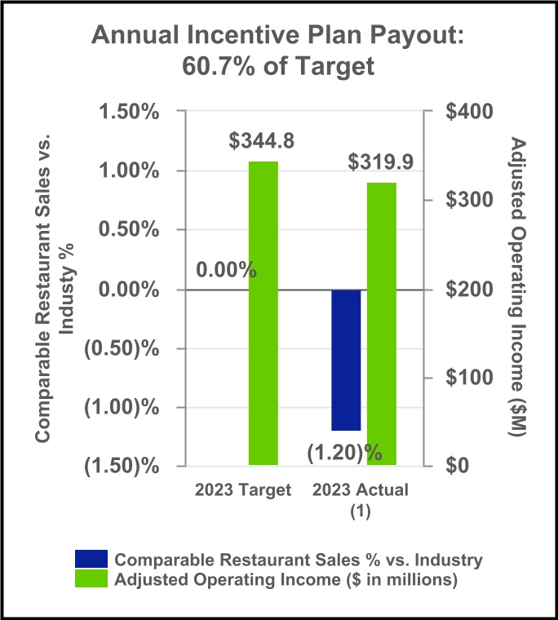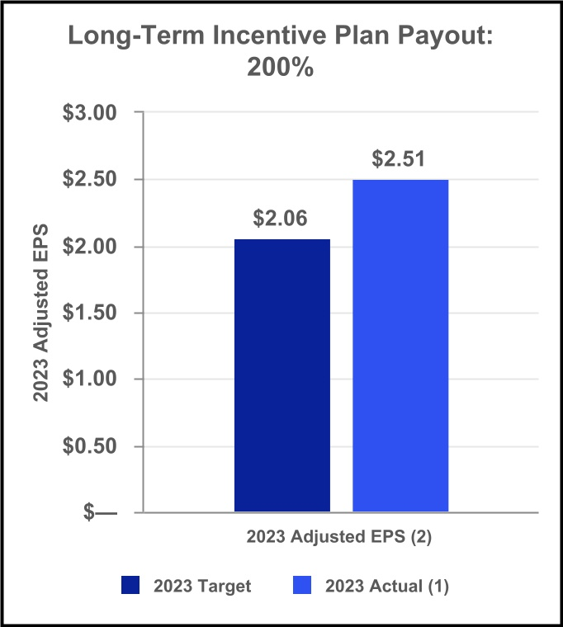
_______________
(1)See Appendix A for a reconciliation of the Adjusted Operating Income calculation for the 2023 STIP and a reconciliation of 2023 Adjusted EPS.
(2)See “Compensation Program Structure – Performance-Based Long-Term Incentive Program – Vesting of 2021 PSU Award” below.

2023 Say-On-Pay and Company Response:
At the 2023 Annual Meeting, the Company received 97.6% stockholder support for our Say-On-Pay proposal. We believe this strong support from our stockholders indicates satisfaction with our compensation programs. The Compensation Committee remains receptive to stockholder feedback as an integral part of administering compensation over time.

Overview of Key Executive Compensation Actions

Incentive Plan Design Changes to the Short-Term Incentive Plan (“STIP”):
At the beginning of the year, the Compensation Committee (the “Committee”) selected specific levels of relative same store sales compared to industry (50%) and adjusted operating income dollars (50%) as the performance objectives for the 2023 STIP. This reflects a change from the prior design of 40% revenue and 60% adjusted operating margin. The payout opportunity provides a range of 0% to 200% of target for the NEOs. No changes were made to the long-term incentive plan.

2024 Compensation Decisions:
The Compensation Committee reviews the NEO compensation arrangements annually and benchmarks executive compensation packages against the peer group market data each year to determine whether adjustments are needed to better align executive pay to our compensation philosophy. At the February 2024 meeting, the Compensation Committee did not recommend any changes to NEO Compensation for fiscal year 2024.

35
Table of Contents

Outback Steakhouse Organizational Change:
Mr. Patterson was promoted to Executive Vice President, President of Outback Steakhouse effective November 13, 2023 and received an annual target STIP increase to 85% of base salary (changed from 70%) and an annual target LTI grant increase to $500,000 (changed from $425,000). Mr. Patterson’s annual incentive opportunity for 2023 has been prorated according to his time in role. Mr. Patterson also received an appointment grant of $250,000 in RSU’s, which will vest ratably over the next three years.

Executive Compensation Program Philosophy & Principles

Compensation Program Objectives:
Our compensation program objectives and methods of achieving them are summarized below:
OBJECTIVES |  |  |  |  |  |  |  |  | HOW WE MEET OBJECTIVES
Attract and retain talented executives |  |  |  |  |  | • |  |  | Provide a competitive total compensation package by taking into account base salary, performance incentives and benefits
Motivate and reward executives |  |  |  |  |  | • |  |  | Provide a significant portion of each executive’s target total compensation in the form of equity compensation
 |  |  |  |  |  | • |  |  | Balance incentives between equity-based and cash-based compensation to support a high-performing culture
Provide a competitive compensation package |  |  |  |  |  | • |  |  | Benchmark our compensation against competitors and peer group
 |  |  |  |  |  | • |  |  | Target competitive positioning to align with industry
Ensure internal equity among executives |  |  |  |  |  | • |  |  | Adjust compensation based on review of job responsibilities and individual performance in addition to market data
Align management and stockholder interests |  |  |  |  |  | • |  |  | Provide compensation based on short-term and long-term performance objectives
Pay for performance |  |  |  |  |  | • |  |  | Provide the majority of executive pay in variable, “at-risk” incentive awards - approximately 86.5% and 69.6% of targeted compensation in 2023 for our CEO and other NEOs, respectively, to ensure that realized pay is tied to attainment of significant short-term and long-term operating goals

Governance Best Practices:
We seek to ensure that our executive compensation programs are closely aligned with the interests of our stockholders by following these executive compensation best practices:
 |  |  | WHAT WE DO |  |  |  |  |  |  |  |  | WHAT WE DO NOT DO
a |  |  | Design an executive compensation program to mitigate undue risk and conduct annual reviews to assess risk of our compensation programs |  |  |  |  |  | r |  |  | Permit executives and directors to hold our stock in a margin account, pledge our stock as collateral for loans or engage in speculative transactions involving our stock, including hedging
a |  |  | Award annual incentive compensation subject to achievement of objective and pre-established performance goals tied to operational and strategic objectives |  |  |  |  |  | r |  |  | Perform stock option re-pricing without stockholder approval
a |  |  | Benchmark executive officer compensation around the market median on all elements of target compensation against a relevant peer group |  |  |  |  |  | r |  |  | Provide cash buyouts for underwater stock options or stock appreciation rights without stockholder approval
a |  |  | Include double trigger change in control vesting provisions for equity awards |  |  |  |  |  | r |  |  | Provide cash compensation upon death or disability
a |  |  | Engage an independent compensation consultant that reports directly to the Compensation Committee |  |  |  |  |  | r |  |  | Pay dividends on any unvested stock options, stock appreciation rights, restricted stock units or unearned performance-based equity awards
a |  |  | Use a compensation recovery (“clawback”) policy for the CEO, certain officers and other key employees that applies to cash and equity compensation |  |  |  |  |  | r |  |  | Provide excise tax gross-ups upon change in control
a |  |  | Require stock ownership and retention values that align the interests of our executive officers and other key employees with the long-term interests of our stockholders |  |  |  |  |  | r |  |  | Provide excessive perquisites

36
Table of Contents

Compensation Program Structure

Performance-Based Overall Total Compensation Mix:
Our compensation program for 2023 consisted of three primary elements and other secondary benefits:
 |  |  | COMPENSATION ELEMENT |  |  | DESCRIPTION
Primary Elements |  |  | Base salary |  |  | Fixed cash compensation designed to provide appropriate, Competitive Market (defined below)-based predictable compensation
 |  |  |  |  |  | Determined and reviewed annually by the Compensation Committee with input from the compensation consultant, CEO (for other officers) and the Company’s human resources management
 |  |  | Performance-based cash incentives |  |  | Variable cash compensation based on pre-established performance goals measured against Compensation Committee-approved annual targets and individual performance
 |  |  |  |  |  | Target values informed by Competitive Market data
 |  |  | Long-term equity incentive awards |  |  | Variable compensation granted in the form of PSUs (two-thirds) and RSUs (one-third)
 |  |  |  |  |  | PSUs cliff vest after three years based on achievement of performance goals
 |  |  |  |  |  | RSUs vest ratably over three years
 |  |  |  |  |  | Target values informed by Competitive Market data
Secondary Benefits |  |  | Other benefits and perquisites |  |  | Medical, dental and vision insurance coverage, as well as life insurance and disability protection
 |  |  |  |  |  | Deferred compensation plan to allow efficient personal tax planning
 |  |  |  |  |  | Executive physicals
 |  |  |  |  |  | Relocation assistance for certain newly-hired executives
 |  |  | Change in control and termination benefits |  |  | Provides the CEO, NEOs and other Company executives benefits payable upon specified employment termination events as described in the Change in Control policy, employment agreement or offer of employment

Bloomin’ Brand’s provides equitable and competitive levels of fixed compensation (base salary and benefits) while emphasizing performance-based compensation that is dependent on the Company’s overall Company performance along with individual performance. Long-term equity incentives comprise the largest share of total compensation and provide an important connection to stockholder interests. We do not target a specific percentage for each element of compensation relative to total compensation. Our target compensation mix results from placing a greater emphasis on variable compensation and targeting around the market median on all elements of target compensation.

37
Table of Contents

Performance-Based Overall Total Compensation Mix:
The charts below show the annualized target compensation mix for the CEO and the average annualized target compensation mix for the other NEOs.
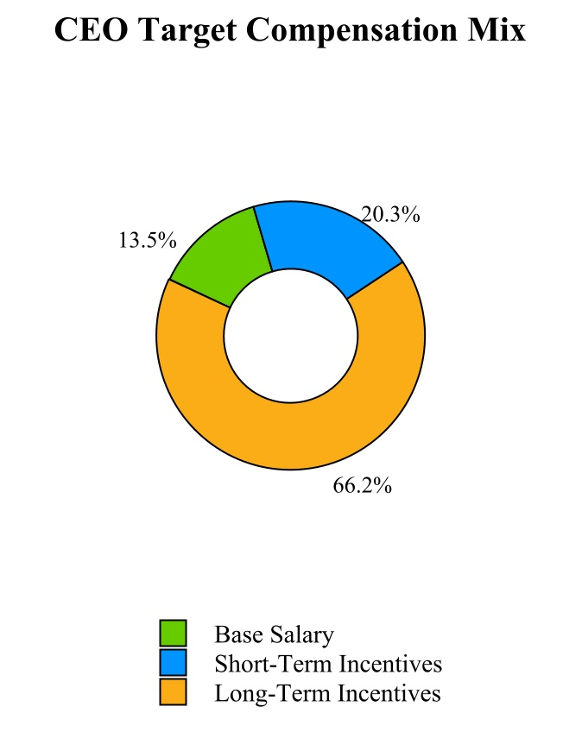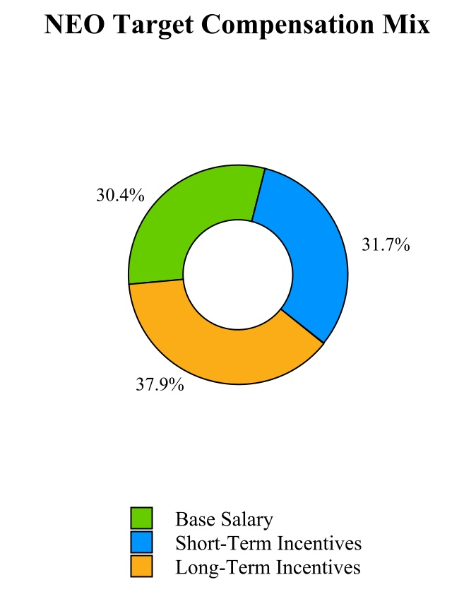
86.5% of CEO compensation is at-risk. 69.6% of average NEO compensation is at-risk.

Base Salary Design:
Base salary levels of our executive officers may be increased by the Compensation Committee as part of the annual performance review process, upon an executive officer’s promotion, change in job responsibilities or to address internal or external equity, as recommended by management.

Mr. Meyer and Ms. Lefferts received a base salary increase in 2023 to bring their total compensation closer to market median, which is aligned with the Company’s pay strategy. No other salaries were changed in 2023 from 2022.

Base salaries of the NEOs are listed in the table below:
NAMED EXECUTIVE OFFICER |  |  |  |  |  | ANNUAL BASE SALARY |  |  |  |  |  | MARKET ADJUSTMENT APPLIED IN 2023
David J. Deno |  |  |  |  |  | $ | 1,000,000 |  |  |  |  | $ | —
Christopher A. Meyer (1) |  |  |  |  |  | 600,000 |  |  |  |  |  | 75,000
Gregg D. Scarlett |  |  |  |  |  | 675,000 |  |  |  |  |  | —
Kelly M. Lefferts (1) |  |  |  |  |  | 520,000 |  |  |  |  |  | 20,000
Brett A. Patterson |  |  |  |  |  | 500,000 |  |  |  |  |  | —
__________________
(1)Mr. Meyer and Ms. Lefferts received a market adjustment in February 2023.

38
Table of Contents

Performance-Based Short-Term Incentive Plan:
Cash incentives are awarded to our executive officers under our performance-based STIP. The STIP is designed to place a significant portion of each NEO’s compensation at-risk, with payouts dependent on the Company’s and executive’s performance. These awards (the “2023 Corporate STIP”) are payable based on the achievement of the Company’s financial and the executive’s performance goals. The NEO’s annual STIP targets, measured as a percentage of base salary, are established in each executive officer’s employment agreement or offer of employment and may be increased by the Compensation Committee from time to time.

The 2023 Corporate STIP target payout amounts for each NEO, as a percentage of his or her base salary were as follows:
NAMED EXECUTIVE OFFICER |  |  |  |  |  | 2023 ANNUAL PERFORMANCE-BASED CASH INCENTIVE TARGET, AS A PERCENTAGE OF BASE SALARY |  |  |  |  |  | CHANGE FROM 2022 AS A PERCENTAGE OF BASE SALARY
Mr. Deno |  |  |  |  |  | 150% |  |  |  |  |  | —%
Mr. Meyer |  |  |  |  |  | 120% |  |  |  |  |  | —%
Mr. Scarlett |  |  |  |  |  | 120% |  |  |  |  |  | —%
Ms. Lefferts |  |  |  |  |  | 85% |  |  |  |  |  | —%
Mr. Patterson (1) |  |  |  |  |  | 85% |  |  |  |  |  | 15%
__________________
(1)Mr. Patterson’s STIP target changed from 70% to 85% effective November 13, 2023 in conjunction with his appointment to Executive Vice President.

2023 Metrics, Weightings, and Results:
The following chart summarizes the 2023 STIP metrics and weightings and the corresponding payout results:
PERFORMANCE PERIOD: DECEMBER 26, 2022 to DECEMBER 31, 2023
Financial Objective |  |  | Weighting |  |  | Threshold |  |  | Target |  |  | Max |  |  | Actual Results |  |  | Performance Factor |  |  | Funding Level
Relative Comparable Sales |  |  | 50% |  |  | (2.97)% |  |  | 0.00% |  |  | 3.00% |  |  | (1.20)% |  |  | 60.0% |  |  | 30.0%
Adjusted Operating Income (dollars in millions) (1) |  |  | 50% |  |  | $250.7 |  |  | $344.8 |  |  | $364.2 |  |  | $319.9 |  |  | 61.4% |  |  | 30.7%
 |  |  |  |  |  | 1% Payout |  |  | 100% Payout |  |  | 200% Payout |  |  |  |  |  |  |  |  | 60.7% Payout
__________________
(1)The Adjusted Operating Income calculation for STIP purposes is similar to the non-GAAP Adjusted Operating Income that we use in our presentations with stockholders, which is adjusted to exclude the impact of certain items that are not reflective of our business operations. The STIP Adjusted Operating Income calculation may include additional adjustments, for example an adjustment to remove the impact of the 53rd week, beneficial Brazil tax legislation and the impact of foreign currency translation. See Appendix A for a reconciliation of the Adjusted Operating Income calculation for the STIP.

The combined performance achieved under the 2023 Corporate STIP resulted in the following performance-based cash incentives:
NAMED EXECUTIVE OFFICER |  |  |  |  |  | STIP PERFORMANCE PAYOUT (1) |  |  |  |  |  | ACHIEVEMENT AS % OF STIP TARGET
Mr. Deno |  |  |  |  |  | $ | 910,500 |  |  |  |  | 60.7 |  | %
Mr. Meyer |  |  |  |  |  | 437,040 |  |  |  |  |  | 60.7 |  | %
Mr. Scarlett |  |  |  |  |  | 491,670 |  |  |  |  |  | 60.7 |  | %
Ms. Lefferts |  |  |  |  |  | 268,294 |  |  |  |  |  | 60.7 |  | %
Mr. Patterson (2) |  |  |  |  |  | 218,463 |  |  |  |  |  | 60.7 |  | %
__________________
(1)STIP payouts were modified by the following individual performance factors: Mr. Deno 100%, Mr. Meyer 100%, Mr. Scarlett 100%, Ms. Lefferts 100%, Mr. Patterson 100%.
(2)Payout amount for Mr. Patterson is prorated based on changes to his bonus target during the fiscal year.

39
Table of Contents

Performance-Based Long-Term Incentive Program:
LTI awards are designed to reward participants for achieving the Company’s long-term objectives and creating stockholder value. Additionally, LTI awards serve to retain participants and provide a continuity in leadership. Equity awards have generally been limited to our executive officers and other key employees who are in a position to contribute substantially to our growth and success.

2023 LTI Awards
Based on the recommendation of the Compensation Committee, the Board of Directors approved LTI grants in February 2023 to our executive officers under the 2020 Equity Plan consisting of two-thirds of PSUs and one-third of RSUs.
MEASURE |  |  |  |  |  | PERFORMANCE SHARE UNITS (PSUs) |  |  |  |  |  | RESTRICTED STOCK UNITS (RSUs)
WEIGHTING |  |  |  |  |  | 2/3 |  |  |  |  |  | 1/3
PURPOSE |  |  |  |  |  | PSUs align our executives with stockholders by encouraging executives to have a longer-term perspective with respect to driving sustainable performance, rather than taking risks for short-term pay-off. |  |  |  |  |  | RSUs provide our key executives with meaningful retentive value.
DESIGN |  |  |  |  |  | The 2023 PSUs provide for cliff vesting at the end of the three year performance period (2023-2025), contingent upon meeting performance objectives and continued employment. The number of units earned varies to the extent the performance targets are achieved over the period, ranging from 1% for threshold achievement to 200% for maximum achievement. The PSUs are distributed upon the Compensation Committee certifying that the performance metrics have been attained and making a recommendation of payment that is approved by the Board. |  |  |  |  |  | The 2023 RSUs vest one-third per year over three years.

For 2023, Annual Adjusted Diluted EPS (“Adjusted EPS”) performance over fiscal years 2023 through 2025 was chosen as the core PSU performance measure in order to continue to encourage executives to successfully balance profit maximization and the efficient use of capital. Additionally, there is a relative total stockholder return (“Relative TSR”) modifier, which can adjust final payouts downward or upward 75% to 125%. In no event can the award payout be above 200%. Relative TSR of the Company will be compared against the S&P 1500 Restaurant Index comprised of casual and fast dining companies.

Performance goals for the 2023 PSU award were approved by the Compensation Committee in February 2023. The 2023 PSU award may vest and pay out, if at all, in 2026 based on Adjusted EPS and Relative TSR performance over the three-year performance period. Any payout remains subject to the final certification of the Compensation Committee. Further details of these annual grants are provided below:
PERFORMANCE MEASURE |  |  |  |  |  | PERFORMANCE MEASURES AND TARGETS
 |  |  |  |  |  | THRESHOLD  (1% of shares are earned) |  |  |  |  |  | TARGET  (100% of shares are earned) |  |  |  |  |  | MAXIMUM  (200% of shares are earned)
2023-2025 Adjusted EPS Performance (1) |  |  |  |  |  | $2.68 |  |  |  |  |  | $3.00 |  |  |  |  |  | $3.35
__________________
(1)Adjusted EPS as defined for this grant is similar to the non-GAAP Adjusted EPS that we use in our presentations with stockholders, which excludes the impact of certain items that are not reflective of our ongoing business operations.
40
Table of Contents

PERFORMANCE MEASURE |  |  |  |  |  | PERFORMANCE MEASURES AND TARGETS
 |  |  |  |  |  | MINIMUM  (Bottom Third of Relative TSR Comparison Group) |  |  |  |  |  | TARGET  (Middle Third of Relative TSR Comparison Group) |  |  |  |  |  | MAXIMUM  (Top Third of Relative TSR Comparison Group)
Relative TSR Performance 2023-2025 |  |  |  |  |  | 75% |  |  |  |  |  | 100% |  |  |  |  |  | 125%

Vesting of 2021 PSU Award
LTI grants made in 2021 for the 2021-2023 performance period utilized a cumulative three-year performance period. Adjusted EPS performance, as defined under the Company’s 2021 award agreements was the performance metric for the 2021 PSU award. The Adjusted EPS calculation for LTI purposes is similar to the non-GAAP Adjusted EPS that we use in our presentations with stockholders, which is adjusted to exclude the impact of certain items that are not reflective of ongoing business operations. The following table shows the percentage of PSUs earned under the 2021 PSU award and the applicable performance measures:
PERFORMANCE MEASURE |  |  |  |  |  | PERFORMANCE MEASURES AND TARGETS |  |  |  |  |  |  |  |  |  |  |  |  |  |  |  |  |  | ACTUAL RESULTS |  |  |  |  |  | PERCENTAGE OF PSUs EARNED 2021-2023 (2)
 |  |  |  |  |  | THRESHOLD  (1% of shares are earned) |  |  |  |  |  | TARGET  (100% of shares are earned) |  |  |  |  |  | MAXIMUM  (200% of shares are earned)
2021-2023 Adjusted EPS Performance (1) |  |  |  |  |  | $1.97 |  |  |  |  |  | $2.06 |  |  |  |  |  | $2.20 |  |  |  |  |  | $2.51 |  |  |  |  |  | 200%
__________________
(1)The baseline Adjusted EPS used to measure such growth is $1.90, as disclosed in the 2022 Proxy Statement. See Appendix A for a reconciliation of 2023 Adjusted EPS.
(2)2021 Relative TSR delivered top third performance of the relative Comparison Group and resulted in a 125% modifier. However, Adjusted Diluted EPS performance delivered the maximum 200% payout.

Administering LTI Awards
In May 2020, the Company’s stockholders adopted the 2020 Omnibus Incentive Compensation Plan (the “2020 Plan”) to replace our 2016 Equity Incentive Plan (the “2016 Plan”). The purpose of the 2020 Plan is to promote the interests of our Company and its stockholders by (1) providing a means for our Company to attract and retain talented individuals; (2) encouraging the profitability and growth of our Company through annual and long-term incentives that are consistent with our goals and link a significant portion of compensation to the value of our common stock; and (3) providing incentives that will align the interests of our employees, consultants and directors with those of our stockholders. This plan was in effect for awards issued beginning in May 2020 and remains in effect.

The Company also has an Equity Award Policy that prohibits granting equity awards in anticipation of the release of material nonpublic information, and we do not time the release of material nonpublic information based on equity award grant dates. Because the Company believes equity awards are an important part of our compensation program, we grant equity awards on an annual basis to key employees, including our executive officers. Annual equity awards must be approved by the Compensation Committee (or the Board) and are expected to be granted following the second business day after the announcement of earnings for the fiscal year. The Company’s policy is that it will not purposely accelerate or delay the public release of material non-public information (“MNPI”) in consideration of any pending equity award grant in order to allow an award recipient to benefit from a more favorable stock price. The Company realizes that a release of MNPI by the Company in close proximity to an equity award could create the appearance of an effort by the Company to time the announcement to a recipient’s benefit, even if no such benefit was intended. The Compensation Committee approves new-hire, promotion and retention equity awards for NEOs, as well as other executive officers, and has delegated authority to our Chief Executive Officer and Chief Human Resources Officer, collectively or individually, to approve all other “off-cycle” new-hire, promotion and retention equity awards, subject to certain limitations.

41
Table of Contents

Program Governance

Compensation Peer Group and Competitive Market Information:
The Compensation Committee utilizes a compensation peer group of certain consumer discretionary companies to evaluate executive officer compensation levels and to benchmark our executive compensation design and governance features. The Compensation Committee reviews the peer group on an annual basis to ensure the peer group includes companies with certain attributes. These attributes include: companies with comparable size (based on revenue, market capitalization and other relevant metrics), companies that maintain strong consumer brands and/or have multiple consumer brands in their portfolios, companies that have an entrepreneurial culture, companies that are globally positioned and companies that compete with us for executive talent.

For 2023, the peer group data compiled by the independent compensation consultant, FW Cook, was used to establish market consensus information (the “Competitive Market”) against which the Compensation Committee assessed our compensation elements. The Compensation Committee also periodically reviews other benchmarking data as presented by FW Cook and the Company’s human resources management, such as peer equity vesting practices, the prevalence of performance metrics among peer companies, types of equity vehicles used by peer companies and equity burn rates and overhang.

The Compensation Committee reviewed the peer group to be used for 2023 and made no changes to the prior-year peer group. The peer group used for 2023 compensation benchmarking consisted of the following 18 companies:
2023 COMPENSATION PEER GROUP COMPANIES
Brinker International, Inc. |  |  |  |  |  | Foot Locker, Inc. |  |  |  |  |  | Texas Roadhouse, Inc.
Chipotle Mexican Grill, Inc. |  |  |  |  |  | Hyatt Hotels Corporation |  |  |  |  |  | The Cheesecake Factory Incorporated
Cracker Barrel Old Country Store, Inc. |  |  |  |  |  | Jack in the Box Inc. |  |  |  |  |  | The Wendy’s Company
Darden Restaurants, Inc. |  |  |  |  |  | MGM Resorts International |  |  |  |  |  | Williams-Sonoma Inc.
Dine Brands Global |  |  |  |  |  | Norwegian Cruise Line Holdings |  |  |  |  |  | Wyndham Hotels & Resorts, Inc.
Domino’s Pizza |  |  |  |  |  | Royal Caribbean Cruises Ltd. |  |  |  |  |  | YUM! Brands, Inc.

In July 2023, the Compensation Committee approved changes to the peer group to be used for 2024. The Committee believes these changes maintain a balance between company size, revenue, industry, industrial footprint and presence as a competitor for executive talent. The new peer group is comprised of the following companies:
2024 COMPENSATION PEER GROUP COMPANIES
Boot Barn Holdings, Inc. |  |  |  |  |  | Foot Locker, Inc. |  |  |  |  |  | Texas Roadhouse, Inc.
Brinker International, Inc. |  |  |  |  |  | Guess? Inc. |  |  |  |  |  | The Cheesecake Factory Incorporated
Caleres, Inc. |  |  |  |  |  | Jack in the Box Inc. |  |  |  |  |  | The Wendy’s Company
Cracker Barrel Old Country Store, Inc. |  |  |  |  |  | Kontoor Brands, Inc. |  |  |  |  |  | V.F. Corporation
Darden Restaurants, Inc. |  |  |  |  |  | Norwegian Cruise Line Holdings, Ltd. |  |  |  |  |  | Williams-Sonoma, Inc.
Dave & Buster's Entertainment, Inc. |  |  |  |  |  | PVH Corp. |  |  |  |  |  | Yum China Holdings, Inc.
Designer Brands Inc. |  |  |  |  |  | Royal Caribbean Cruises Ltd. |  |  |  |  |  | YUM! Brands, Inc.
Dine Brands Global Inc. |  |  |  |  |  | Shake Shack Inc.
Domino’s Pizza Inc. |  |  |  |  |  | Tapestry, Inc.

In assessing the target range for compensation relative to the market, the Compensation Committee targets around the Competitive Market Median for all elements of target direct compensation. Compensation for each individual may be below or above the targeted competitive positioning based on several factors, including performance of the business, the individual’s skill set relative to industry peers, overall experience and time in the position, critical nature of the individual’s role, difficulty of replacement, expected future contributions, readiness for promotion to a higher level and role relative to that of other executive officers and other business factors. The Compensation
42
Table of Contents

Committee does not set a specific position relative to the market for indirect compensation, such as benefits and perquisites.

Role of the Compensation Committee:
Our Compensation Committee oversees our executive compensation program and, in some cases, together with the Board of Directors:

•Approves the type and amount of compensation paid to our CEO and other executive officers

•Approves agreements with our executive officers

•Provides oversight to our equity compensation plan

•Meets periodically and monitors our compensation arrangements and objectives

The Compensation Committee considers the Competitive Market data provided by FW Cook and the Company’s human resources management team, as well as recommendations from broader management, to evaluate the appropriateness and competitive positioning of the CEO and each other NEO’s total compensation and compensation elements. The Compensation Committee reviews and approves the compensation of the CEO, based in part on the CEO’s performance review as assessed by the full Board of Directors.

Our executive officers have employment agreements or offers of employment that establish, among other things, the executive’s base salary, both target bonus and LTI amounts, as well as benefits upon a termination of employment and/or a change in control of the Company. Our Compensation Committee’s approval of equity awards to our executive officers qualifies these awards as exempt awards under Rule 16b-3 under the Exchange Act.

Role of Independent Compensation Consultant:
The Compensation Committee has engaged FW Cook to serve as its independent compensation consultant for 2023. FW Cook’s responsibilities include, but are not limited to, providing compensation market data, advising on trends and developments in executive compensation, periodically reviewing the design of the executive compensation program, providing independent analysis of CEO compensation and providing advice to the Compensation Committee and its Chair, as requested. The Compensation Committee has directly engaged and has the sole authority to hire and terminate the independent compensation consultant. FW Cook attends Compensation Committee meetings and, on occasion, obtains information and input from management to ensure that its recommendations are consistent with the Company’s strategy and culture. The Company does not engage FW Cook for any other unrelated consulting or services.

Role of Chief Executive Officer in Compensation Decisions:
The Compensation Committee considers the recommendations of the CEO with respect to salary adjustments, annual cash incentive bonus targets and awards and equity incentive awards for our other executive officers. In addition, the CEO provides input to the Compensation Committee on the design of incentive compensation and other employee benefit plans to ensure alignment with the Company’s business strategies and goals.

Our CEO reviews performance objectives with the Compensation Committee, including financial objectives and non-financial objectives for strategic business and human capital priorities. The Compensation Committee meets in executive session with and without its compensation consultant to review and discuss the performance and compensation of the CEO. The CEO does not participate in determinations or recommendations regarding his own compensation.

43
Table of Contents

Other Policies and Practices Related to Executive Compensation
Compensation Recovery (“Clawback”). In April 2023, the Company adopted an updated Compensation Recovery Policy in accordance with the final NASDAQ rules, which requires the Company’s executive officers and key employees designated by the Board to return incentive compensation paid to them if the financial results upon which the compensation was based are restated and republished under applicable securities laws, excluding any restatement required due to changes in accounting rules or standards or changes in applicable law (a “Material Financial Restatement”).

In the event of a Material Financial Restatement, the Company will recover the amount of incentive compensation received by the individual that exceeds the amount of such compensation that otherwise would have been received had it been determined based on the restated amounts if such compensation was received during the three years before the date the Company concludes that it must file a Material Financial Restatement or the date a governing authority directs the Company to file a Material Financial Restatement.

We believe our Compensation Recovery Policy is sufficiently broad to reduce the potential risk that the CEO and certain officers or key employees would intentionally misstate results in order to benefit under an incentive program by requiring recoupment of compensation in those circumstances.

Stock Ownership Guidelines. To further strengthen the link between executive and stockholder interests, we have a Stock Ownership Guidelines Policy for directors, executive officers and other executive leadership team members who are eligible to receive long-term incentive awards. The target level of ownership of our common stock is established as a multiple of base salary or annual cash retainer, as applicable.
POSITION |  |  |  |  |  | TARGET OWNERSHIP
Non-Employee Directors |  |  |  |  |  | 5x Annual Cash Retainer
Chief Executive Officer |  |  |  |  |  | 6x Base Salary
Executive Officers |  |  |  |  |  | 3x Base Salary
Other Executive Leadership Team Members Not Listed Above |  |  |  |  |  | 1x Base Salary

Each individual subject to the Stock Ownership Guidelines Policy is expected to achieve the ownership target within five years from the date on which the individual became subject to the guidelines. All executive officers have achieved their requirement or are on track to achieve their requirement prior to their respective deadline.

Shares that count towards ownership requirement are as follows:

•Stock Owned (either Directly or Indirectly)  •Estimated after-tax value of unvested, time-based RSUs |  |  |  |  |  | Beginning in 2023, estimated in-the-money value of vested stock options no longer count towards stock ownership requirement.

While the employee is not in compliance with his or her ownership requirement, the employee must retain 50% of the net after-tax shares received from the vesting or exercise of his or her LTI shares. Notwithstanding this restriction, employees may immediately sell Company stock acquired by exercising stock options for the limited purposes of paying the exercise price of the stock option and any applicable tax liability.

Insider Trading Policy - Prohibitions on Hedging and Pledging. Under our Insider Trading Policy, our directors and executive officers are prohibited from engaging in short sales or investing in other kinds of hedging transactions or financial instruments that are designed to hedge or offset any decrease in the market value of our securities. In addition, our directors and executive officers are prohibited from holding our securities in a margin account and from pledging our securities as collateral for a loan. Our policy is not intended to prohibit diversification transactions or broad-based index transactions.

44
Table of Contents

Other Benefits and Perquisites. The NEOs are each entitled to receive certain perquisites and benefits under the terms of their employment agreements and offers of employment. We believe these benefits are reasonable and consistent with our overall compensation program and better enable us to attract and retain qualified employees for key positions. Such benefits include life insurance, medical insurance and annual physical examinations. The Compensation Committee periodically reviews the levels of perquisites and other benefits provided to the NEOs.

We offer a deferred compensation plan for our highly compensated employees who are not eligible to participate in our 401(k) plan. The deferred compensation plan allows highly compensated employees to contribute from 5% to 90% of their base salary and from 5% to 100% of their cash bonus on a pre-tax basis to an investment account consisting of various investment fund options. The plan permits us to make a discretionary contribution to the plan on behalf of an eligible employee periodically; however, we have not made any discretionary contributions to date. In the event of the employee’s termination of employment, the employee is entitled to receive the full balance in the account in a single lump sum or in equal annual installments over a specified period of two to 15 years. If the employee becomes disabled or dies before any deferred amounts are paid out under the plan, we will pay to the employee (or the employee’s beneficiary if applicable) the full balance in the account in a single lump sum. If the employee’s employment terminates due to death or disability after he or she begins receiving payments, the remaining installment payments will be paid in installment payments as such payments come due.

The amounts attributable to perquisites and other benefits provided to the NEOs are reflected in the “—Summary Compensation Table” under the heading “All Other Compensation.”

Change in Control and Termination Benefits. Each employment agreement or offer of employment and our equity award plans and agreements establish, among other things, the executive’s benefits upon a termination of employment and/or a change in control. For a summary of these arrangements, see “—Potential Payments Upon Termination or Change in Control” below.

In addition, the Board of Directors adopted an Executive Change in Control Plan (the “Change in Control Plan”), which entitles executive officers and other key employees to certain severance payments and benefits in the event of a qualifying termination of employment upon or within the 24 months following certain change-in-control events. The payments and benefits will be reduced by the amount of any severance or similar payments or benefits under an employment agreement or other arrangement with us and are subject to the employee’s compliance with non-competition and other restrictive covenants, and the other terms and conditions of the Change in Control Plan. These benefits are described in more detail under “—Potential Payments Upon Termination or Change in Control” below.

The Compensation Committee considers these severance and change in control benefits to be an important part of the executive compensation program and consistent with Competitive Market practice. The Compensation Committee believes that providing appropriate severance benefits helps to attract and retain highly-qualified executives by mitigating the risks associated with leaving a previous employer and accepting a new position with the Company, and by providing income continuity following an unexpected termination. Furthermore, these severance benefits provide the executive officers with a reasonable range of income protection in the event of a qualifying employment termination and, following a change in control, support our executive retention goals and encourage their independence and objectivity in considering potential change-in-control transactions. These arrangements also allow the Company to protect its interests through corresponding confidentiality, non-competition and other restrictive covenants in the event of an executive’s termination.

Tax and Accounting Implications:
In making decisions about executive compensation, the Compensation Committee took into account certain tax and accounting considerations, including Sections 162(m), 409A and 280G of the Internal Revenue Code. Additionally, we account for stock-based payments in accordance with the requirements of FASB ASC Topic No. 718, “Compensation-Stock Compensation” (“ASC 718”). Until 2018, performance-based compensation was exempt from the $1 million tax deductibility limit for compensation paid to covered executives under Internal Revenue Code Section 162(m). Although the Compensation Committee will consider the tax impact of compensation to our
45
Table of Contents

covered executives and to the Company when designing our compensation programs, non-deductible compensation will be paid to covered executives when our Compensation Committee determines that providing such compensation is appropriate to attract and retain executive talent or is otherwise in the best interests of the Company.
Our Compensation Committee considers the accounting implications of significant compensation decisions, especially in connection with decisions that relate to our equity incentive award plans and programs. As accounting standards change, we may revise certain programs to appropriately align accounting expenses of our equity awards with our overall executive compensation philosophy and objectives.

Compensation Committee Report
The Compensation Committee has reviewed and discussed with management the foregoing Compensation Discussion and Analysis. Based on such review and discussions, the Compensation Committee recommended to the Board of Directors that the Compensation Discussion and Analysis be included in this proxy statement.
Submitted by the Compensation Committee
Tara Walpert Levy, Chair
David George
Melanie Marein-Efron
R. Michael Mohan

Compensation Committee Interlocks and Insider Participation
The Compensation Committee currently consists of Mses. Levy and Marein-Efron and Messrs. George and Mohan, each of whom are Independent Directors.

Compensation-Related Risk
As part of its oversight and administration of our compensation programs, the Compensation Committee considered the impact of our compensation policies and programs for our executive officers, to determine whether they present a significant risk to the Company or encourage excessive risk taking by our executive officers. Based on an assessment performed by its independent compensation consultant FW Cook, the Compensation Committee concluded that our compensation programs do not encourage excessive risk taking and are not reasonably likely to have a material adverse effect on the Company.

46
Table of Contents

Summary Compensation Table
The following table summarizes compensation earned by our NEOs for fiscal 2023:
NAMED EXECUTIVE OFFICER |  |  |  |  |  |  |  |  |  |  |  | SALARY |  |  |  |  |  |  |  | STOCK AWARDS |  |  |  |  |  | OPTION AWARDS |  |  |  |  |  | NON-EQUITY INCENTIVE PLAN COMPENSATION |  |  |  |  |  | ALL OTHER COMPENSATION
 |  |  |  |  |  | YEAR |  |  |  |  |  | (1) |  |  |  |  |  |  |  | (2) |  |  |  |  |  |  |  |  |  |  |  | (3) |  |  |  |  |  | (4) |  |  |  |  |  | TOTAL
David J. Deno |  |  |  |  |  | 2023 |  |  |  |  |  | $ | 1,000,000 |  |  |  |  |  |  | $ | 4,900,025 |  |  |  |  | $ | — |  |  |  |  | $ | 910,500 |  |  |  |  | $ | 14,478 |  |  |  |  | $ | 6,825,003
Chief Executive Officer |  |  |  |  |  | 2022 |  |  |  |  |  | 984,615 |  |  |  |  |  |  |  | 4,350,033 |  |  |  |  |  | — |  |  |  |  |  | 897,969 |  |  |  |  |  | 19,015 |  |  |  |  |  | 6,251,632
 |  |  |  |  |  | 2021 |  |  |  |  |  | 900,000 |  |  |  |  |  |  |  | 4,600,046 |  |  |  |  |  | — |  |  |  |  |  | 2,011,500 |  |  |  |  |  | 6,732 |  |  |  |  |  | 7,518,278
Christopher Meyer |  |  |  |  |  | 2023 |  |  |  |  |  | 588,461 |  |  |  |  |  |  |  | 800,031 |  |  |  |  |  |  |  |  |  |  |  | 437,040 |  |  |  |  |  | 5,510 |  |  |  |  |  | 1,831,042
Executive Vice President,  Chief Financial Officer |  |  |  |  |  | 2022 |  |  |  |  |  | 525,000 |  |  |  |  |  |  |  | 656,285 |  |  |  |  |  | — |  |  |  |  |  | 319,200 |  |  |  |  |  | 5,733 |  |  |  |  |  | 1,506,218
 |  |  |  |  |  | 2021 |  |  |  |  |  | 509,615 |  |  |  |  |  |  |  | 721,899 |  |  |  |  |  | — |  |  |  |  |  | 744,714 |  |  |  |  |  | 4,347 |  |  |  |  |  | 1,980,575
Gregg D. Scarlett |  |  |  |  |  | 2023 |  |  |  |  |  | 675,000 |  |  |  |  |  |  |  | 1,012,528 |  |  |  |  |  | — |  |  |  |  |  | 491,670 |  |  |  |  |  | 4,950 |  |  |  |  |  | 2,184,148
Executive Vice President,  Chief Operating Officer,  Casual Dining Restaurants |  |  |  |  |  | 2022 |  |  |  |  |  | 675,000 |  |  |  |  |  |  |  | 1,012,536 |  |  |  |  |  | — |  |  |  |  |  | 492,480 |  |  |  |  |  | 4,950 |  |  |  |  |  | 2,184,966
 |  |  |  |  |  | 2021 |  |  |  |  |  | 675,000 |  |  |  |  |  |  |  | 1,113,761 |  |  |  |  |  | — |  |  |  |  |  | 1,206,900 |  |  |  |  |  | 4,950 |  |  |  |  |  | 3,000,611
Kelly M. Lefferts |  |  |  |  |  | 2023 |  |  |  |  |  | 516,923 |  |  |  |  |  |  |  | 550,026 |  |  |  |  |  | — |  |  |  |  |  | 268,294 |  |  |  |  |  | 7,166 |  |  |  |  |  | 1,342,409
Executive Vice President,  Chief Legal Officer |  |  |  |  |  | 2022 |  |  |  |  |  | 500,000 |  |  |  |  |  |  |  | 500,028 |  |  |  |  |  | — |  |  |  |  |  | 284,240 |  |  |  |  |  | 6,955 |  |  |  |  |  | 1,291,223
 |  |  |  |  |  | 2021 |  |  |  |  |  | 488,462 |  |  |  |  |  |  |  | 550,042 |  |  |  |  |  | — |  |  |  |  |  | 618,636 |  |  |  |  |  | 6,099 |  |  |  |  |  | 1,663,239
Brett A. Patterson (5) |  |  |  |  |  | 2023 |  |  |  |  |  | 500,000 |  |  |  |  |  |  |  | 675,043 |  |  |  |  |  | — |  |  |  |  |  | 218,463 |  |  |  |  |  | 6,010 |  |  |  |  |  | 1,399,516
Executive Vice President,
President, Outback Steakhouse
_________________
(1)Salaries are paid on a bi-weekly basis. Mr. Meyer and Ms. Lefferts received a market adjustment on February 20, 2023.
(2)The amounts reported for stock awards represent the aggregate grant date fair value of RSUs and PSUs. The aggregate grant date value of the RSUs was computed in accordance with ASC 718, based on the market value of the underlying shares on the date of grant. PSU awards pay-out at a range of 0% to a maximum of 200% of their targets based on the following performance measures: 1% for threshold, 100% for target and 200% for maximum. For 2023, the PSU amounts reported represent the aggregate grant date fair value of the 2023 award based on the probable attainment of the performance measures as of the grant date (assumed to be 100% for target) in accordance with ASC 718. The aggregate grant date fair value of the 2023 PSUs assuming achievement of the maximum performance level of 200% would be: Mr. Deno, $6,533,342; Mr. Meyer, $1,066,698; Mr. Scarlett, $1,350,049; Ms. Lefferts, $733,373 and Mr. Patterson, $566,681. The other PSU amounts reported include the aggregate grant date fair value of the PSUs assuming achievement at Target performance level of 100%. See “—Compensation Discussion and Analysis” under the heading “Performance-Based Long-Term Incentive Program” for a description of the RSU and PSU terms. See also Note 6, “Stock-based and Deferred Compensation Plans,” of the notes to consolidated financial statements in Item 8 of our Annual Report on Form 10-K for additional information regarding these awards.
(3)Non-equity incentive plan compensation represents amounts earned under the performance-based cash incentive plans, or STIPs, established for such years. See “—Compensation Discussion and Analysis” under the heading “Performance-Based Short-Term Incentive Plan” for a description of the STIPs for 2023.
(4)The table set forth below titled “All Other Compensation” provides additional information regarding these amounts.
(5)Mr. Patterson’s stock awards include a one-time appointment grant of RSUs having a grant date value of $250,019.

All Other Compensation - The amounts shown for “All Other Compensation” for 2023 include the following:
 |  |  |  |  |  | LIFE
NAMED EXECUTIVE OFFICER |  |  |  |  |  | INSURANCE (1) |  |  |  |  |  | OTHER (2) |  |  |  |  |  | TOTAL
David J. Deno |  |  |  |  |  | $ | 14,478 |  |  |  |  | $ | — |  |  |  |  | $ | 14,478
Christopher A. Meyer |  |  |  |  |  | 1,486 |  |  |  |  |  | 4,024 |  |  |  |  |  | 5,510
Gregg D. Scarlett |  |  |  |  |  | 4,950 |  |  |  |  |  | — |  |  |  |  |  | 4,950
Kelly M. Lefferts |  |  |  |  |  | 2,409 |  |  |  |  |  | 4,757 |  |  |  |  |  | 7,166
Brett A. Patterson |  |  |  |  |  | 2,322 |  |  |  |  |  | 3,688 |  |  |  |  |  | 6,010
__________________
(1)The amounts shown reflect the imputed income for group term life insurance provided to our executive officers.
(2)The amounts shown in “Other” reflect executive physical fees and where applicable, wellness incentives paid in connection with our executive medical benefits.

47
Table of Contents

Grants of Plan-Based Awards for 2023
The following table summarizes the performance-based cash incentive awards (STIPs) and long-term stock incentive (LTI) awards made during 2023:
 |  |  |  |  |  |  |  |  |  |  |  |  |  |  |  |  |  |  |  |  |  |  |  |  |  |  |  |  |  |  |  |  |  |  |  |  |  |  |  |  |  |  |  |  |  |  |  |  |  |  |  |  |  |  |  |  |  |  |  |  |  |  |  |  |  | GRANT
 |  |  |  |  |  |  |  |  |  |  |  |  |  |  |  |  |  |  |  |  |  |  |  |  |  |  |  |  |  |  |  |  |  |  |  |  |  |  |  |  |  |  |  |  |  |  |  | ALL |  |  |  |  |  | ALL OTHER |  |  |  |  |  |  |  |  |  |  |  | DATE
 |  |  |  |  |  |  |  |  |  |  |  |  |  |  |  |  |  |  |  |  |  |  |  |  |  |  |  |  |  |  |  |  |  |  |  |  |  |  |  |  |  |  |  |  |  |  |  | OTHER |  |  |  |  |  | OPTION |  |  |  |  |  |  |  |  |  |  |  | FAIR
 |  |  |  |  |  |  |  |  |  |  |  | ESTIMATED FUTURE PAYOUTS |  |  |  |  |  |  |  |  |  |  |  |  |  |  |  |  |  | ESTIMATED FUTURE PAYOUTS |  |  |  |  |  |  |  |  |  |  |  |  |  |  |  |  |  | STOCK |  |  |  |  |  | AWARDS: |  |  |  |  |  | EXERCISE |  |  |  |  |  | VALUE
 |  |  |  |  |  |  |  |  |  |  |  | UNDER NON-EQUITY |  |  |  |  |  |  |  |  |  |  |  |  |  |  |  |  |  | UNDER EQUITY |  |  |  |  |  |  |  |  |  |  |  |  |  |  |  |  |  | AWARDS: |  |  |  |  |  | NUMBER OF |  |  |  |  |  | PRICE |  |  |  |  |  | OF
 |  |  |  |  |  |  |  |  |  |  |  | INCENTIVE |  |  |  |  |  |  |  |  |  |  |  |  |  |  |  |  |  | INCENTIVE |  |  |  |  |  |  |  |  |  |  |  |  |  |  |  |  |  | NUMBER |  |  |  |  |  | SECURITIES |  |  |  |  |  | OF |  |  |  |  |  | STOCK &
 |  |  |  |  |  |  |  |  |  |  |  | PLAN AWARDS (1) |  |  |  |  |  |  |  |  |  |  |  |  |  |  |  |  |  | PLAN AWARDS (2) |  |  |  |  |  |  |  |  |  |  |  |  |  |  |  |  |  | OF |  |  |  |  |  | UNDERLYING |  |  |  |  |  | OPTION |  |  |  |  |  | OPTION
 |  |  |  |  |  | GRANT |  |  |  |  |  | THRESHOLD |  |  |  |  |  | TARGET |  |  |  |  |  | MAXIMUM |  |  |  |  |  | THRESHOLD |  |  |  |  |  | TARGET |  |  |  |  |  | MAXIMUM |  |  |  |  |  | SHARES |  |  |  |  |  | OPTIONS |  |  |  |  |  | AWARDS |  |  |  |  |  | AWARDS
NAMED EXECUTIVE OFFICER |  |  |  |  |  | DATE |  |  |  |  |  | ($) |  |  |  |  |  | ($) |  |  |  |  |  | ($) |  |  |  |  |  | (#) |  |  |  |  |  | (#) |  |  |  |  |  | (#) |  |  |  |  |  | (#) (3) |  |  |  |  |  | (#) |  |  |  |  |  | ($/Sh) |  |  |  |  |  | ($) (3)
David J. Deno
Annual STIP Bonus |  |  |  |  |  |  |  |  |  |  |  | 15,000 |  |  |  |  |  | 1,500,000 |  |  |  |  |  | 3,000,000 |  |  |  |  |  | — |  |  |  |  |  | — |  |  |  |  |  | — |  |  |  |  |  | — |  |  |  |  |  | — |  |  |  |  |  | — |  |  |  |  |  | —
Annual PSU Grant |  |  |  |  |  | 2/22/2023 |  |  |  |  |  | — |  |  |  |  |  | — |  |  |  |  |  | — |  |  |  |  |  | 1,127 |  |  |  |  |  | 112,605 |  |  |  |  |  | 225,210 |  |  |  |  |  | — |  |  |  |  |  | — |  |  |  |  |  | — |  |  |  |  |  | 3,266,671
Annual RSU Grant (4) |  |  |  |  |  | 2/22/2023 |  |  |  |  |  | — |  |  |  |  |  | — |  |  |  |  |  | — |  |  |  |  |  | — |  |  |  |  |  | — |  |  |  |  |  | — |  |  |  |  |  | 64,028 |  |  |  |  |  | — |  |  |  |  |  | — |  |  |  |  |  | 1,633,354
Christopher A. Meyer
Annual STIP Bonus |  |  |  |  |  |  |  |  |  |  |  | 7,200 |  |  |  |  |  | 720,000 |  |  |  |  |  | 1,440,000 |  |  |  |  |  | — |  |  |  |  |  | — |  |  |  |  |  | — |  |  |  |  |  | — |  |  |  |  |  | — |  |  |  |  |  | — |  |  |  |  |  | —
Annual PSU Grant |  |  |  |  |  | 2/22/2023 |  |  |  |  |  | — |  |  |  |  |  | — |  |  |  |  |  | — |  |  |  |  |  | 184 |  |  |  |  |  | 18,385 |  |  |  |  |  | 36,770 |  |  |  |  |  | — |  |  |  |  |  | — |  |  |  |  |  | — |  |  |  |  |  | 533,349
Annual RSU Grant (4) |  |  |  |  |  | 2/22/2023 |  |  |  |  |  | — |  |  |  |  |  | — |  |  |  |  |  | — |  |  |  |  |  | — |  |  |  |  |  | — |  |  |  |  |  | — |  |  |  |  |  | 10,454 |  |  |  |  |  | — |  |  |  |  |  | — |  |  |  |  |  | 266,682
Gregg D. Scarlett
Annual STIP Bonus |  |  |  |  |  |  |  |  |  |  |  | 8,100 |  |  |  |  |  | 810,000 |  |  |  |  |  | 1,620,000 |  |  |  |  |  | — |  |  |  |  |  | — |  |  |  |  |  | — |  |  |  |  |  | — |  |  |  |  |  | — |  |  |  |  |  | — |  |  |  |  |  | —
Annual PSU Grant |  |  |  |  |  | 2/22/2023 |  |  |  |  |  | — |  |  |  |  |  | — |  |  |  |  |  | — |  |  |  |  |  | 233 |  |  |  |  |  | 23,268 |  |  |  |  |  | 46,536 |  |  |  |  |  | — |  |  |  |  |  | — |  |  |  |  |  | — |  |  |  |  |  | 675,005
Annual RSU Grant (4) |  |  |  |  |  | 2/22/2023 |  |  |  |  |  | — |  |  |  |  |  | — |  |  |  |  |  | — |  |  |  |  |  | — |  |  |  |  |  | — |  |  |  |  |  | — |  |  |  |  |  | 13,231 |  |  |  |  |  | — |  |  |  |  |  | — |  |  |  |  |  | 337,523
Kelly M. Lefferts
Annual STIP Bonus |  |  |  |  |  |  |  |  |  |  |  | 4,420 |  |  |  |  |  | 442,000 |  |  |  |  |  | 884,000 |  |  |  |  |  | — |  |  |  |  |  | — |  |  |  |  |  | — |  |  |  |  |  | — |  |  |  |  |  | — |  |  |  |  |  | — |  |  |  |  |  | —
Annual PSU Grant |  |  |  |  |  | 2/22/2023 |  |  |  |  |  | — |  |  |  |  |  | — |  |  |  |  |  | — |  |  |  |  |  | 127 |  |  |  |  |  | 12,640 |  |  |  |  |  | 25,280 |  |  |  |  |  | — |  |  |  |  |  | — |  |  |  |  |  | — |  |  |  |  |  | 366,686
Annual RSU Grant (4) |  |  |  |  |  | 2/22/2023 |  |  |  |  |  | — |  |  |  |  |  | — |  |  |  |  |  | — |  |  |  |  |  | — |  |  |  |  |  | — |  |  |  |  |  | — |  |  |  |  |  | 7,187 |  |  |  |  |  | — |  |  |  |  |  | — |  |  |  |  |  | 183,340
Brett A. Patterson
Annual STIP Bonus (5) |  |  |  |  |  |  |  |  |  |  |  | 3,599 |  |  |  |  |  | 359,906 |  |  |  |  |  | 719,812 |  |  |  |  |  | — |  |  |  |  |  | — |  |  |  |  |  | — |  |  |  |  |  | — |  |  |  |  |  | — |  |  |  |  |  | — |  |  |  |  |  | —
Annual PSU Grant |  |  |  |  |  | 2/22/2023 |  |  |  |  |  | — |  |  |  |  |  | — |  |  |  |  |  | — |  |  |  |  |  | 98 |  |  |  |  |  | 9,767 |  |  |  |  |  | 19,534 |  |  |  |  |  | — |  |  |  |  |  | — |  |  |  |  |  | — |  |  |  |  |  | 283,341
Annual RSU Grant (4) |  |  |  |  |  | 2/22/2023 |  |  |  |  |  | — |  |  |  |  |  | — |  |  |  |  |  | — |  |  |  |  |  | — |  |  |  |  |  | — |  |  |  |  |  | — |  |  |  |  |  | 5,554 |  |  |  |  |  | — |  |  |  |  |  | — |  |  |  |  |  | 141,683
Appointment RSU Grant (4)(6) |  |  |  |  |  | 12/1/2023 |  |  |  |  |  | — |  |  |  |  |  | — |  |  |  |  |  | — |  |  |  |  |  | — |  |  |  |  |  | — |  |  |  |  |  | — |  |  |  |  |  | 11,705 |  |  |  |  |  | — |  |  |  |  |  | — |  |  |  |  |  | 250,019
__________________
(1)Amounts represent potential performance-based cash incentive awards under the 2023 Corporate STIP for all NEOs. The minimum award level is 1% of target bonus, the target award level is 100% of target bonus, and the maximum award level for 2023 is 200% of target bonus. Actual payouts are derived using a non-linear scale between such points. Threshold is represented with minimum payout of stipulated plan, but zero payout is possible if threshold performance measures are not met. See “—Compensation Discussion and Analysis” under the heading “Performance-Based Short-Term Incentive Plan” for a description of the 2023 Corporate STIP.
(2)Amounts represent potential shares to be issued upon settlement of the aggregate number of PSUs granted in 2023, which vest as to 100% of the shares on the third anniversary of the grant date, contingent upon such executive’s continued employment. The number of shares earned ranges from 0% to 200% based upon the achievement of performance targets set at the beginning of the performance period as follows: 1% for threshold, 100% for target and 200% for maximum. Any portion of the award that is unvested upon termination is generally forfeited, unless the executive meets certain age and service criteria for retirement eligibility. See “—Compensation Discussion and Analysis” under the heading “Performance-Based Long-Term Incentive Program” for a description of the PSU terms. The executive generally forfeits any portion of the award for which the threshold performance is not achieved. Threshold is represented with minimum payout of stipulated financial plan, but zero payout is possible if threshold performance measure is not met.
(3)RSU and PSU awards are valued on the grant date in accordance with ASC 718. See Note 6, “Stock-based and Deferred Compensation Plans,” in the notes to consolidated financial statements in Item 8 of our Annual Report on Form 10-K for the fiscal year ended December 31, 2023.
(4)RSU grants each vest as to one-third of the shares on each anniversary of the grant date, contingent upon the individual’s continued employment.
(5)Mr. Patterson’s cash incentive award target is prorated due to a change in bonus target that occurred in November 2023 in concert with his appointment to Executive Vice President.
(6)Reflects appointment grant with three-year ratable vesting which was awarded to Mr. Patterson in November 2023 in concert with his appointment to Executive Vice President.

48
Table of Contents

Outstanding Equity Awards at 2023 Year-End
The following table summarizes outstanding stock options, unvested RSUs and PSU awards for each NEO as of December 31, 2023:
 |  |  |  |  |  | OPTION AWARDS |  |  |  |  |  |  |  |  |  |  |  |  |  |  |  |  |  |  |  |  |  |  |  | STOCK AWARDS (1)
 |  |  |  |  |  |  |  |  |  |  |  |  |  |  |  |  |  |  |  |  |  |  |  |  |  |  |  |  |  | EQUITY INCENTIVE
 |  |  |  |  |  |  |  |  |  |  |  |  |  |  |  |  |  |  |  |  |  |  |  |  |  |  |  |  |  | PLAN AWARDS:
 |  |  |  |  |  |  |  |  |  |  |  |  |  |  |  |  |  | OPTION |  |  |  |  |  |  |  |  |  |  |  | UNEARNED SHARES, UNITS,
 |  |  |  |  |  |  |  |  |  |  |  |  |  |  |  |  |  | EXERCISE |  |  |  |  |  |  |  |  |  |  |  | OR RIGHTS THAT HAVE
 |  |  |  |  |  | NUMBER OF |  |  |  |  |  |  |  |  |  |  |  | PRICE |  |  |  |  |  |  |  |  |  |  |  | NOT VESTED
 |  |  |  |  |  | SECURITIES UNDERLYING |  |  |  |  |  |  |  |  |  |  |  | PER |  |  |  |  |  | OPTION |  |  |  |  |  | NUMBER OF |  |  |  |  |  | MARKET
 |  |  |  |  |  | UNEXERCISED OPTIONS (#) |  |  |  |  |  |  |  |  |  |  |  | SHARE |  |  |  |  |  | EXPIRATION |  |  |  |  |  | SHARES |  |  |  |  |  | VALUE
NAMED EXECUTIVE OFFICER |  |  |  |  |  | EXERCISABLE |  |  |  |  |  | UNEXERCISABLE |  |  |  |  |  | $ |  |  |  |  |  | DATE |  |  |  |  |  | (#) (2) |  |  |  |  |  | $ (3)
David J. Deno
February 27, 2014 (4) |  |  |  |  |  | 58,800 |  |  |  |  |  | — |  |  |  |  |  | 25.32 |  |  |  |  |  | 2/27/2024 |  |  |  |  |  | — |  |  |  |  |  | —
February 26, 2015 (4) |  |  |  |  |  | 55,760 |  |  |  |  |  | — |  |  |  |  |  | 25.36 |  |  |  |  |  | 2/26/2025 |  |  |  |  |  | — |  |  |  |  |  | —
February 25, 2016 (4) |  |  |  |  |  | 56,577 |  |  |  |  |  | — |  |  |  |  |  | 17.15 |  |  |  |  |  | 2/25/2026 |  |  |  |  |  | — |  |  |  |  |  | —
February 24, 2017 (4) |  |  |  |  |  | 57,921 |  |  |  |  |  | — |  |  |  |  |  | 17.27 |  |  |  |  |  | 2/24/2027 |  |  |  |  |  | — |  |  |  |  |  | —
February 23, 2018 (4) |  |  |  |  |  | 42,917 |  |  |  |  |  | — |  |  |  |  |  | 24.10 |  |  |  |  |  | 2/23/2028 |  |  |  |  |  | — |  |  |  |  |  | —
February 19, 2019 (5) |  |  |  |  |  | 50,345 |  |  |  |  |  | — |  |  |  |  |  | 21.29 |  |  |  |  |  | 2/19/2029 |  |  |  |  |  | — |  |  |  |  |  | —
April 1, 2019 (5) |  |  |  |  |  | 270,758 |  |  |  |  |  | — |  |  |  |  |  | 20.62 |  |  |  |  |  | 4/1/2029 |  |  |  |  |  | — |  |  |  |  |  | —
February 22, 2021 (6)(7)(8) |  |  |  |  |  | — |  |  |  |  |  | — |  |  |  |  |  | — |  |  |  |  |  | — |  |  |  |  |  | 244,113 |  |  |  |  |  | 6,871,781
February 21, 2022 (6)(7)(9) |  |  |  |  |  | — |  |  |  |  |  | — |  |  |  |  |  | — |  |  |  |  |  | — |  |  |  |  |  | 153,942 |  |  |  |  |  | 4,333,467
February 22, 2023 (6)(7)(10) |  |  |  |  |  | — |  |  |  |  |  | — |  |  |  |  |  | — |  |  |  |  |  | — |  |  |  |  |  | 176,633 |  |  |  |  |  | 4,972,219
Christopher Meyer
February 27, 2014 (4) |  |  |  |  |  | 3,194 |  |  |  |  |  | — |  |  |  |  |  | 25.32 |  |  |  |  |  | 2/27/2024 |  |  |  |  |  | — |  |  |  |  |  | —
February 26, 2015 (4) |  |  |  |  |  | 6,251 |  |  |  |  |  | — |  |  |  |  |  | 25.36 |  |  |  |  |  | 2/26/2025 |  |  |  |  |  | — |  |  |  |  |  | —
February 25, 2016 (4) |  |  |  |  |  | 4,207 |  |  |  |  |  | — |  |  |  |  |  | 17.15 |  |  |  |  |  | 2/25/2026 |  |  |  |  |  | — |  |  |  |  |  | —
February 24, 2017 (4) |  |  |  |  |  | 6,591 |  |  |  |  |  | — |  |  |  |  |  | 17.27 |  |  |  |  |  | 2/24/2027 |  |  |  |  |  | — |  |  |  |  |  | —
February 23, 2018 (4) |  |  |  |  |  | 7,222 |  |  |  |  |  | — |  |  |  |  |  | 24.10 |  |  |  |  |  | 2/23/2028 |  |  |  |  |  | — |  |  |  |  |  | —
February 19, 2019 (5) |  |  |  |  |  | 9,682 |  |  |  |  |  | — |  |  |  |  |  | 21.29 |  |  |  |  |  | 2/19/2029 |  |  |  |  |  | — |  |  |  |  |  | —
April 1, 2019 (5) |  |  |  |  |  | 69,043 |  |  |  |  |  | — |  |  |  |  |  | 20.62 |  |  |  |  |  | 4/1/2029 |  |  |  |  |  | — |  |  |  |  |  | —
February 22, 2021 (6)(7)(8) |  |  |  |  |  | — |  |  |  |  |  | — |  |  |  |  |  | — |  |  |  |  |  | — |  |  |  |  |  | 35,461 |  |  |  |  |  | 998,227
February 21, 2022 (6)(7)(9) |  |  |  |  |  | — |  |  |  |  |  | — |  |  |  |  |  | — |  |  |  |  |  | — |  |  |  |  |  | 23,225 |  |  |  |  |  | 653,784
February 22, 2023 (6)(7)(10) |  |  |  |  |  | — |  |  |  |  |  | — |  |  |  |  |  | — |  |  |  |  |  | — |  |  |  |  |  | 28,839 |  |  |  |  |  | 811,818
Gregg D. Scarlett
February 27, 2014 (4) |  |  |  |  |  | 12,166 |  |  |  |  |  | — |  |  |  |  |  | 25.32 |  |  |  |  |  | 2/27/2024 |  |  |  |  |  | — |  |  |  |  |  | —
February 26, 2015 (4) |  |  |  |  |  | 14,706 |  |  |  |  |  | — |  |  |  |  |  | 25.36 |  |  |  |  |  | 2/26/2025 |  |  |  |  |  | — |  |  |  |  |  | —
April 1, 2015 (4) |  |  |  |  |  | 100,000 |  |  |  |  |  | — |  |  |  |  |  | 24.14 |  |  |  |  |  | 4/1/2025 |  |  |  |  |  | — |  |  |  |  |  | —
February 25, 2016 (4) |  |  |  |  |  | 16,973 |  |  |  |  |  | — |  |  |  |  |  | 17.15 |  |  |  |  |  | 2/25/2026 |  |  |  |  |  | — |  |  |  |  |  | —
August 1, 2016 (4) |  |  |  |  |  | 100,000 |  |  |  |  |  | — |  |  |  |  |  | 17.96 |  |  |  |  |  | 8/1/2026 |  |  |  |  |  | — |  |  |  |  |  | —
February 24, 2017 (4) |  |  |  |  |  | 36,090 |  |  |  |  |  | — |  |  |  |  |  | 17.27 |  |  |  |  |  | 2/24/2027 |  |  |  |  |  | — |  |  |  |  |  | —
February 23, 2018 (4) |  |  |  |  |  | 36,974 |  |  |  |  |  | — |  |  |  |  |  | 24.10 |  |  |  |  |  | 2/23/2028 |  |  |  |  |  | — |  |  |  |  |  | —
February 19, 2019 (5) |  |  |  |  |  | 46,472 |  |  |  |  |  | — |  |  |  |  |  | 21.29 |  |  |  |  |  | 2/19/2029 |  |  |  |  |  | — |  |  |  |  |  | —
March 2, 2020 (5) |  |  |  |  |  | 100,000 |  |  |  |  |  | — |  |  |  |  |  | 18.45 |  |  |  |  |  | 3/2/2030 |  |  |  |  |  | — |  |  |  |  |  | —
February 22, 2021 (6)(7)(8) |  |  |  |  |  | — |  |  |  |  |  | — |  |  |  |  |  | — |  |  |  |  |  | — |  |  |  |  |  | 54,710 |  |  |  |  |  | 1,540,087
February 21, 2022 (6)(7)(9) |  |  |  |  |  | — |  |  |  |  |  | — |  |  |  |  |  | — |  |  |  |  |  | — |  |  |  |  |  | 35,833 |  |  |  |  |  | 1,008,699
February 22, 2023 (6)(7)(10) |  |  |  |  |  | — |  |  |  |  |  | — |  |  |  |  |  | — |  |  |  |  |  | — |  |  |  |  |  | 36,499 |  |  |  |  |  | 1,027,447
Kelly M. Lefferts
February 27, 2014 (4) |  |  |  |  |  | 3,407 |  |  |  |  |  | — |  |  |  |  |  | 25.32 |  |  |  |  |  | 2/27/2024 |  |  |  |  |  | — |  |  |  |  |  | —
February 26, 2015 (4) |  |  |  |  |  | 4,200 |  |  |  |  |  | — |  |  |  |  |  | 25.36 |  |  |  |  |  | 2/26/2025 |  |  |  |  |  | — |  |  |  |  |  | —
February 23, 2018 (4) |  |  |  |  |  | 5,703 |  |  |  |  |  | — |  |  |  |  |  | 24.10 |  |  |  |  |  | 2/23/2028 |  |  |  |  |  | — |  |  |  |  |  | —
February 19, 2019 (5) |  |  |  |  |  | 7,281 |  |  |  |  |  | — |  |  |  |  |  | 21.29 |  |  |  |  |  | 2/19/2029 |  |  |  |  |  | — |  |  |  |  |  | —
February 22, 2021 (6)(7)(8) |  |  |  |  |  | — |  |  |  |  |  | — |  |  |  |  |  | — |  |  |  |  |  | — |  |  |  |  |  | 27,019 |  |  |  |  |  | 760,585
February 21, 2022 (6)(7)(9) |  |  |  |  |  | — |  |  |  |  |  | — |  |  |  |  |  | — |  |  |  |  |  | — |  |  |  |  |  | 17,696 |  |  |  |  |  | 498,142
February 22, 2023 (6)(7)(10) |  |  |  |  |  | — |  |  |  |  |  | — |  |  |  |  |  | — |  |  |  |  |  | — |  |  |  |  |  | 19,827 |  |  |  |  |  | 558,130
Brett A. Patterson
February 22, 2021 (6)(7)(8) |  |  |  |  |  | — |  |  |  |  |  | — |  |  |  |  |  | — |  |  |  |  |  | — |  |  |  |  |  | 18,237 |  |  |  |  |  | 513,372
February 21, 2022 (6)(7)(9) |  |  |  |  |  | — |  |  |  |  |  | — |  |  |  |  |  | — |  |  |  |  |  | — |  |  |  |  |  | 13,272 |  |  |  |  |  | 373,607
February 22, 2023 (6)(7)(10) |  |  |  |  |  | — |  |  |  |  |  | — |  |  |  |  |  | — |  |  |  |  |  | — |  |  |  |  |  | 15,321 |  |  |  |  |  | 431,286
December 1, 2023 (6) |  |  |  |  |  | — |  |  |  |  |  | — |  |  |  |  |  | — |  |  |  |  |  | — |  |  |  |  |  | 11,705 |  |  |  |  |  | 329,496
49
Table of Contents

_________________
(1)All stock options, RSUs and PSUs are granted under a stockholder-approved equity incentive plan.
(2)Unvested portions of awards are generally forfeited upon termination of employment, unless the executive meets certain age and service criteria for retirement eligibility. See “—Potential Payments Upon Termination or Change in Control” for additional information regarding accelerated vesting on certain terminations of employment.
(3)Market value is calculated by multiplying $28.15, which was the closing price per share of our common stock on the NASDAQ Global Select Market on December 29, 2023, the last market day of our fiscal year, by the number of shares subject to the award.
(4)Stock option grants vested 25% of the shares on each anniversary of the grant date, contingent on continued employment.
(5)Stock option grants vested one-third of the shares on each anniversary of the grant date, contingent on continued employment.
(6)RSU grants vest as to one-third of the shares on each anniversary of the grant date, contingent on continued employment.
(7)PSU grants vest as to 100% of the shares on the third anniversary of the grant date, contingent on continued employment assuming a payout at target performance. The actual number that may be earned ranges from 0% to 200% based upon the achievement of performance targets for the three-year period set on the grant date, as follows: 1% for threshold, 100% for target and 200% for maximum. See “Compensation Discussion and Analysis” under the heading “Performance-Based Short-Term Incentive Plan” for a description of the PSU terms.
(8)The Compensation Committee certified performance payout for PSUs granted in 2021 on February 12, 2024, based on Adjusted EPS growth over 2021-2023 at 200% of target. These PSUs are reflected at actual performance and vested on the third anniversary of the grant date.
(9)These PSUs are reflected at target performance and will vest, if at all, based on the Compensation Committee’s certification of Adjusted EPS Performance at the conclusion of fiscal year 2024, and Relative TSR performance as compared to a Relative TSR Comparison Group over the 2022-2024 performance period. The Compensation Committee retains the right to adjust payout outcomes negatively or positively for unusual, infrequently occurring, or non-operating items and performance is uncertain until the time of certification. At maximum performance (200%) executives would earn the following number of shares: Mr. Deno - 222,224; Mr. Meyer - 33,526; Mr. Scarlett - 51,726; Ms. Lefferts - 25,544 and Mr. Patterson - 19,158.
(10)These PSUs are reflected at target performance and will vest, if at all, based on the Compensation Committee’s certification of Adjusted EPS Performance at the conclusion of fiscal year 2025, and Relative TSR performance as compared to a Relative TSR Comparison Group over the 2023-2025 performance period. The Compensation Committee retains the right to adjust payout outcomes negatively or positively for unusual, infrequently occurring, or non-operating items and performance is uncertain until the time of certification. At maximum performance (200%), executives would earn the following number of shares: Mr. Deno - 225,210; Mr. Meyer - 36,770; Mr. Scarlett - 46,536; Ms. Lefferts - 25,280 and Mr. Patterson - 19,534.

Option Exercises and Stock Vested for Fiscal 2023
The following table summarizes the exercise of stock options and vesting of PSUs and RSUs held by the NEOs during fiscal 2023:
 |  |  |  |  |  | OPTION AWARDS |  |  |  |  |  |  |  |  |  |  |  | STOCK AWARDS
 |  |  |  |  |  | NUMBER OF |  |  |  |  |  |  |  |  |  |  |  | NUMBER OF
 |  |  |  |  |  | SHARES |  |  |  |  |  | VALUE |  |  |  |  |  | SHARES |  |  |  |  |  | VALUE
 |  |  |  |  |  | ACQUIRED |  |  |  |  |  | REALIZED |  |  |  |  |  | ACQUIRED |  |  |  |  |  | REALIZED
 |  |  |  |  |  | ON EXERCISE |  |  |  |  |  | ON EXERCISE |  |  |  |  |  | ON VESTING |  |  |  |  |  | ON VESTING
NAMED EXECUTIVE OFFICER |  |  |  |  |  | (#) |  |  |  |  |  | (1) |  |  |  |  |  | (#) |  |  |  |  |  | (2)
David J. Deno |  |  |  |  |  | — |  |  |  |  |  | $ | — |  |  |  |  | 227,905 |  |  |  |  |  | $ | 6,293,532
Christopher Meyer |  |  |  |  |  | — |  |  |  |  |  | — |  |  |  |  |  | 37,903 |  |  |  |  |  | 1,046,870
Gregg D. Scarlett |  |  |  |  |  | — |  |  |  |  |  | — |  |  |  |  |  | 115,373 |  |  |  |  |  | 3,154,309
Kelly M. Lefferts |  |  |  |  |  | — |  |  |  |  |  | — |  |  |  |  |  | 36,399 |  |  |  |  |  | 1,004,505
Brett A. Patterson |  |  |  |  |  | 16,305 |  |  |  |  |  | 89,113 |  |  |  |  |  | 58,107 |  |  |  |  |  | 1,583,544
_________________
(1)Represents amount realized upon exercise of stock options, based on the difference between the market value of the shares acquired at the time of exercise and the exercise price.
(2)Represents the value realized upon vesting of PSUs and RSUs, based on the market value of the shares on the vesting date. The Company withheld or netted for tax purposes the following number of shares from the distribution of shares upon vesting: Mr. Deno, 84,228; Mr. Meyer, 9,625; Mr. Scarlett, 40,049; Ms. Lefferts, 9,042 and Mr. Patterson, 19,213.

50
Table of Contents

Nonqualified Defined Contribution and Other Nonqualified Deferred Compensation Plans
We offer a Deferred Compensation Plan for our highly compensated employees who are not eligible to participate in the OSI Restaurant Partners, LLC Salaried Employees 401(k) Plan and Trust, as described in “—Compensation Discussion and Analysis” under the heading “—Other Benefits and Perquisites.” We do not sponsor any defined benefit pension plans.

The following table summarizes contributions during 2023 to our Deferred Compensation Plan along with aggregate earnings/losses for the year and the aggregate balance as of December 31, 2023. We did not make any contributions to the plan during 2023. Participants are fully vested in all contributions to the plan. The amounts listed as executive contributions are included as “Salary” in the “Summary Compensation Table.” The aggregate earnings are not reflected in “All Other Compensation” in the “Summary Compensation Table.”
NAMED EXECUTIVE OFFICER |  |  |  |  |  | AGGREGATE BALANCE AT DECEMBER 25, 2022 |  |  |  |  |  | EXECUTIVE CONTRIBUTIONS IN 2023 |  |  |  |  |  | AGGREGATE EARNINGS IN 2023 |  |  |  |  |  | AGGREGATE WITHDRAWALS/ DISTRIBUTIONS IN 2023 |  |  |  |  |  | AGGREGATE BALANCE AT DECEMBER 31, 2023
Kelly M. Lefferts |  |  |  |  |  | $ | 779,773 |  |  |  |  | $ | 50,996 |  |  |  |  | $ | 154,089 |  |  |  |  | $ | — |  |  |  |  | $ | 984,858
Brett A. Patterson |  |  |  |  |  | $ | 579,865 |  |  |  |  | $ | 106,085 |  |  |  |  | $ | 159,547 |  |  |  |  | $ | — |  |  |  |  | $ | 845,497

Potential Payments Upon Termination or Change in Control
Each of the NEOs is party to an employment agreement or offer of employment and other arrangements with us, which are summarized below, and may entitle him or her to payments or benefits upon a termination of employment and/or a change in control. See the table included under “Executive Benefits and Payments Upon Separation” below for the amount of compensation payable under these agreements and arrangements to the individuals serving as NEOs as of the end of fiscal 2023.

Change in Control Plan
The Change in Control Plan entitles executive officers and other key employees to certain severance payments and benefits in the event of a qualifying termination of employment upon or within the 24 months following certain change-in-control events. A qualifying termination is a termination by us for any reason other than cause, or by the employee for good reason, in each case as defined in the Change in Control Plan.

Under the Change in Control Plan, in the event of a qualifying termination within the 24 months following a change in control, the named executive officers are each entitled to receive the following benefits:

•A severance payment, payable in a lump sum 60 days after the termination, equal to (a) with respect to Mr. Deno, two times the sum of his base salary and his target annual cash bonus and (b) with respect to the other named executive officers, one and one-half times the sum of base salary and target annual cash bonus

•Accelerated vesting of all outstanding equity awards

•Continued eligibility to participate in group health benefits for 18 months following the termination

•Outplacement services for six months following the termination

•Certain other accrued benefits

The severance payments and other benefits described above will be reduced by the amount of any similar payments and benefits under any employment agreement or other arrangement with us and are subject to the employee’s compliance with non-competition and other restrictive covenants and the other terms and conditions of the Change in Control Plan.

51
Table of Contents

Rights and Potential Payments Upon Termination or Change in Control: Mr. Deno
On April 1, 2019, we entered into an amended and restated employment agreement, as amended April 6, 2020 and February 21, 2022, with Mr. Deno for a five-year term that automatically renews for successive one-year terms unless either party elects not to renew by giving written notice to the other party not less than 60 days prior to the start of any renewal term. The employment agreement is also subject to earlier termination under certain circumstances described below.

Mr. Deno’s employment may be terminated as follows:

•Upon his death or disability (as defined in the agreement)

•By us for Cause. “Cause” is defined to include: (i) willful failure to perform, or gross negligence or insubordination in the performance of, his duties and responsibilities to us or our affiliates (other than any such failure from incapacity due to physical or mental illness), subject to notice and cure periods; (ii) indictment or conviction (or plea of guilty or nolo contendere) of a felony or other crime involving moral turpitude; (iii) engaging in dishonesty, illegal misconduct or gross misconduct that is intentionally harmful to us or our affiliates; (iv) any material and knowing violation by him of any covenant or restriction contained in his employment agreement or any other agreement entered into with us or our affiliates; or (v) any material violation of any of our or our affiliates’ published policies (including with respect to discrimination and harassment, responsible alcohol policy, insider trading policy and security policy)

•By Mr. Deno for Good Reason. “Good Reason” is defined to include: (i) the assignment of duties inconsistent with his position as Chief Executive Officer or a material diminution in the nature or scope of his duties, authority or responsibilities; (ii) a reduction of his annual base salary, unless a similar reduction is made in salary of all similarly situated employees; (iii) requiring him to be based at a location in excess of 50 miles from the location of our principal executive offices in Tampa, Florida; or (iv) a material breach by us of our obligations under his employment agreement

•By us other than for Cause

•By Mr. Deno other than for Good Reason, upon ninety (90) days’ prior written notice to the Company

•By Mr. Deno by reason of retirement

Mr. Deno will be entitled to receive severance benefits if his employment is terminated by us other than for Cause or if he terminates employment for Good Reason. If his employment is terminated under these circumstances, he will be entitled to receive severance equal to two times the sum of his base salary at the rate in effect on the date of termination, payable in a lump sum within sixty days following the effective date of such termination, plus a pro rata portion of his target bonus for the year of termination and pro rata vesting of the RSUs, PSUs and stock options granted in connection with his appointment as Chief Executive Officer.

In the event Mr. Deno’s employment is terminated due to his death or disability, he will receive any base salary amount and any annual bonus amount for the preceding fiscal year earned but not paid as of the date of his employment termination, any accrued and payable travel or business expenses and benefits under the employee benefit plan, plus a pro rata portion of his target bonus for the year of termination and pro rata vesting of the RSUs, PSUs and stock options granted in connection with his appointment as Chief Executive Officer.

In the event Mr. Deno’s employment is terminated due to his retirement, he will receive any base salary amount and any annual bonus amount for the preceding fiscal year earned but not paid as of the date of his employment termination, plus pro rata vesting of the RSUs, PSUs and stock options granted in connection with his appointment as Chief Executive Officer.

52
Table of Contents

A change in control of the Company does not trigger any severance payments to him under the employment agreement. However, in the event of a qualifying termination within the 24 months following a change in control, Mr. Deno would be entitled to receive the benefits described above under “—Change in Control Plan.”

Separation Agreement: Mr. Scarlett
On October 2, 2023 the Company announced organizational design changes that will result in the elimination of the Executive Vice President, Chief Operating Officer of Casual Dining position following a transition period ending on March 15, 2024, as reported in the Company’s Form 8-K filed with the SEC on October 3, 2023. As a result, the Company and Mr. Scarlett entered into an agreement pursuant to which Mr. Scarlett will separate from the Company once his transitional duties are complete effective March 15, 2024. The agreement provides that Mr. Scarlett will receive a lump sum severance payment of $1,485,000 and $20,705 for COBRA premiums to extend health benefits for 12 months. All payments are subject to Mr. Scarlett’s execution of a separation agreement that includes a customary release of claims and certain other covenants.

All unvested equity and vested stock options held by Mr. Scarlett are subject to the retirement provisions set forth in his existing grant agreements and the applicable plans as described under “Equity Awards” below.

Equity Awards
As a general matter, unless otherwise provided in an individual’s award agreement or other agreement, and depending on the reason for termination, upon a termination of employment or other continuous service, all unvested equity awards will terminate and vested stock options must be exercised within certain limited time periods after the date of termination. If the individual’s employment is terminated for cause (as defined in the award or other applicable agreement), all stock options, whether vested or unvested, and all unvested PSUs and RSUs will terminate immediately. If the individual’s termination is due to death or disability, all stock options and RSUs that are not vested will become immediately vested in full upon such termination and a pro rata portion (based on the portion of the applicable performance period that passed prior to termination of the individual’s employment) of the target number of PSUs will immediately vest and become payable in shares of common stock upon such termination. Stock options accelerated due to death or disability become exercisable on the award’s original vesting schedule.

Awards under the 2012 Equity Plan, if unvested, will forfeit upon retirement. Under the 2016 Equity Plan, if the NEO retires on or after age 60 with five years of service with the Company or an affiliate (“Retirement under 2016 Plan”) prior to the vesting or forfeiture of the RSUs, then the number of RSUs that vest shall be determined as of the date of the Retirement under 2016 Plan on a pro rata basis, determined based on the number of full months of employment completed from the date of grant to the date of the Retirement under 2016 Plan divided by the number of full months of the original vesting period. If the NEO retires prior to the vesting or forfeiture of the option to purchase shares of our common stock, the NEO may exercise the option at any time within 12 months following the date of Retirement under 2016 Plan (but in no event later than ten years after the date of grant). Under the 2020 Equity Plan, if the NEO retires on or after age 60 with five years of service, or age 55 with ten years of service with the Company or an affiliate (“Retirement under 2020 Plan”) prior to the vesting or forfeiture of stock options, RSUs, or PSUs, then the number of stock options, RSUs or PSUs that vest shall be determined as of the date of the Retirement under 2020 Plan on a pro rata basis, determined based on the number of full months of employment completed from the date of grant to the date of the Retirement under 2020 Plan divided by the number of full months of the original vesting period and, in the case of PSUs, the PSUs earned shall be determined at the end of the performance period based on the actual performance levels achieved. If the NEO retires prior to the vesting or forfeiture of the option to purchase shares of our common stock, the NEO may exercise the option at any time following the date of Retirement under 2020 Plan (but in no event later than the original expiration date of the grant, generally the tenth anniversary of the date of grant).

The Compensation Committee may provide for accelerated vesting of an award upon, or as a result of events following, a change of control. This may be done in the award agreement or in connection with the change of
53
Table of Contents

control. In the event of a change of control, the Compensation Committee may also cause an award to be canceled in exchange for a cash payment to the participant or cause an award to be assumed by a successor corporation.

Our forms of award agreements under the 2012, 2016 and 2020 Equity Plans provide as follows:

•Restricted stock and RSU awards to our directors become fully vested upon a change of control

•Restricted stock awards for our employees and consultants provide that upon a change of control (a) restricted stock that remains outstanding or is exchanged or converted into securities of the acquiring or successor entity will continue to vest in accordance with the terms set forth in the award agreement and (b) if the restricted stock will be canceled in exchange for cash consideration, (x) in the case of awards held by our executive officers at the time of such change of control, the restricted stock will instead be converted into a right to receive such cash consideration upon satisfaction of the vesting and other terms and conditions of the award agreement in effect immediately prior to the change of control and (y) in the case of other award recipients, the award will fully vest and be exchanged for the cash consideration at the time of the change of control

•PSU awards provide that if the award recipient’s employment or other service status with us terminates, the award will terminate as to any units that are unvested at the time of such termination, unless (a) such termination is due to death or disability, in which case a pro rata portion of the award shall vest based on the portion of the performance period for which service was provided, or (b) the termination occurs before the vesting date but after the end of the performance period and is other than for cause (as defined in the agreement), in which case the applicable number of units will vest for that performance period as if such termination had not occurred

In addition, as described above under “—Change in Control Plan,” in the event of a qualifying termination within the 24 months following a change in control, each of our named executive officers will be entitled to accelerated vesting of all outstanding equity awards.

Restrictive Covenants
Mr. Deno is subject to certain restrictive covenants under his current employment agreement. This includes covenants covering noncompetition, nondisclosure, nonsolicitation and nonpiracy. Based on the terms of the agreement, Mr. Deno agreed to these restrictive covenants during employment for 24 months following a termination of employment for any reason. Continued compliance with these restrictive covenants is a condition to our obligation to pay any severance amount due to Mr. Deno under his employment agreement.

Messrs. Meyer, Scarlett, Patterson and Ms. Lefferts are subject to certain restrictive covenants as per their offers of employment. These include covenants covering noncompetition, nondisclosure, nonsolicitation and nonpiracy. Each has agreed to these restrictive covenants during employment and for 12 months following a voluntary separation or separation for Cause, or in the event of separation for any reason other than voluntary resignation, for a period equal to the period used for calculating the amount of severance paid upon termination, if any.

Executive Benefits and Payments Upon Separation
The table below reflects the amount of compensation payable under the arrangements described above to the individuals serving as NEOs following a termination of employment (i) by us without Cause or by the executive for good reason without a change in control, (ii) by us without Cause or by the executive for good reason, following a change in control assuming that such termination constitutes a qualifying termination under the Change in Control Plan, (iii) by the executive voluntarily, (iv) as a result of retirement, (v) as a result of disability or (vi) as a result of death, in each case, assuming that such termination of employment occurred on December 31, 2023.

54
Table of Contents

No payments or benefits are due to the NEOs following a termination of employment for Cause. The table assumes that the change in control transaction resulted in per share consideration of $28.15, which was the closing price per share of our common stock on the NASDAQ Global Select Market on December 29, 2023, the last market day of our fiscal year. The actual amounts to be paid upon a termination of employment or a change in control can only be determined at the time of such executive’s separation from us, or upon the occurrence of a change in control (if any).
NAMED EXECUTIVE OFFICER |  |  |  |  |  | EXECUTIVE PAYMENTS AND BENEFITS UPON SEPARATION |  |  |  |  |  | INVOLUNTARY TERMINATION WITHOUT CAUSE OR TERMINATION BY EXECUTIVE FOR GOOD REASON WITHOUT CHANGE IN CONTROL |  |  |  |  |  | INVOLUNTARY TERMINATION WITHOUT CAUSE OR TERMINATION BY EXECUTIVE FOR GOOD REASON WITH CHANGE IN CONTROL |  |  |  |  |  | VOLUNTARY TERMINATION |  |  |  |  |  | RETIREMENT |  |  |  |  |  | DISABILITY |  |  |  |  |  | DEATH
 |  |  |  |  |  | (1) |  |  |  |  |  | ($) |  |  |  |  |  | ($) |  |  |  |  |  | ($) |  |  |  |  |  | ($) (2) |  |  |  |  |  | ($) |  |  |  |  |  | ($)
David J. Deno |  |  |  |  |  | Severance |  |  |  |  |  | 3,500,000 |  |  |  |  |  | 5,000,000 |  |  |  |  |  | — |  |  |  |  |  | — |  |  |  |  |  | — |  |  |  |  |  | —
 |  |  |  |  |  | Equity Awards (3) |  |  |  |  |  | — |  |  |  |  |  | 12,958,120 |  |  |  |  |  | — |  |  |  |  |  | 7,479,033 |  |  |  |  |  | 9,802,299 |  |  |  |  |  | 9,802,299
 |  |  |  |  |  | Health Benefits |  |  |  |  |  | — |  |  |  |  |  | 22,562 |  |  |  |  |  | — |  |  |  |  |  | — |  |  |  |  |  | — |  |  |  |  |  | —
 |  |  |  |  |  | Total |  |  |  |  |  | 3,500,000 |  |  |  |  |  | 17,980,682 |  |  |  |  |  | — |  |  |  |  |  | 7,479.033 |  |  |  |  |  | 9,802,299 |  |  |  |  |  | 9,802,299
Christopher Meyer |  |  |  |  |  | Severance |  |  |  |  |  | — |  |  |  |  |  | 1,962,692 |  |  |  |  |  | — |  |  |  |  |  | — |  |  |  |  |  | — |  |  |  |  |  | —
 |  |  |  |  |  | Equity Awards (3) |  |  |  |  |  | — |  |  |  |  |  | 2,008,137 |  |  |  |  |  | — |  |  |  |  |  | — |  |  |  |  |  | 1,505,819 |  |  |  |  |  | 1,505,819
 |  |  |  |  |  | Health Benefits |  |  |  |  |  | — |  |  |  |  |  | 31,057 |  |  |  |  |  | — |  |  |  |  |  | — |  |  |  |  |  | — |  |  |  |  |  | —
 |  |  |  |  |  | Total |  |  |  |  |  | — |  |  |  |  |  | 4,001,886 |  |  |  |  |  | — |  |  |  |  |  | — |  |  |  |  |  | 1,505,819 |  |  |  |  |  | 1,505,819
Gregg D. Scarlett |  |  |  |  |  | Severance |  |  |  |  |  | — |  |  |  |  |  | 2,227,500 |  |  |  |  |  | — |  |  |  |  |  | — |  |  |  |  |  | — |  |  |  |  |  | —
 |  |  |  |  |  | Equity Awards (3) |  |  |  |  |  | — |  |  |  |  |  | 2,873,186 |  |  |  |  |  | — |  |  |  |  |  | 1,692,462 |  |  |  |  |  | 2,193,842 |  |  |  |  |  | 2,193,842
 |  |  |  |  |  | Health Benefits |  |  |  |  |  | — |  |  |  |  |  | 31,057 |  |  |  |  |  | — |  |  |  |  |  | — |  |  |  |  |  | — |  |  |  |  |  | —
 |  |  |  |  |  | Total |  |  |  |  |  | — |  |  |  |  |  | 5,131,743 |  |  |  |  |  | — |  |  |  |  |  | 1,692,462 |  |  |  |  |  | 2,193,842 |  |  |  |  |  | 2,193,842
Kelly M. Lefferts |  |  |  |  |  | Severance |  |  |  |  |  | — |  |  |  |  |  | 1,438,385 |  |  |  |  |  | — |  |  |  |  |  | — |  |  |  |  |  | — |  |  |  |  |  | —
 |  |  |  |  |  | Equity Awards (3) |  |  |  |  |  | — |  |  |  |  |  | 1,469,655 |  |  |  |  |  | — |  |  |  |  |  | 849,989 |  |  |  |  |  | 1,112,601 |  |  |  |  |  | 1,112,601
 |  |  |  |  |  | Health Benefits |  |  |  |  |  | — |  |  |  |  |  | 19,529 |  |  |  |  |  | — |  |  |  |  |  | — |  |  |  |  |  | — |  |  |  |  |  | —
 |  |  |  |  |  | Total |  |  |  |  |  | — |  |  |  |  |  | 2,927,569 |  |  |  |  |  | — |  |  |  |  |  | 849,989 |  |  |  |  |  | 1,112,601 |  |  |  |  |  | 1,112,601
Brett A. Patterson |  |  |  |  |  | Severance |  |  |  |  |  | — |  |  |  |  |  | 1,289,859 |  |  |  |  |  | — |  |  |  |  |  | — |  |  |  |  |  | — |  |  |  |  |  | —
 |  |  |  |  |  | Equity Awards (3) |  |  |  |  |  | — |  |  |  |  |  | 1,413,412 |  |  |  |  |  | — |  |  |  |  |  | — |  |  |  |  |  | 1,140,235 |  |  |  |  |  | 1,140,235
 |  |  |  |  |  | Health Benefits |  |  |  |  |  | — |  |  |  |  |  | 31,057 |  |  |  |  |  | — |  |  |  |  |  | — |  |  |  |  |  | — |  |  |  |  |  | —
 |  |  |  |  |  | Total |  |  |  |  |  | — |  |  |  |  |  | 2,734,328 |  |  |  |  |  | — |  |  |  |  |  | — |  |  |  |  |  | 1,140,235 |  |  |  |  |  | 1,140,235
__________________
(1)Amounts in the table do not include amounts for accrued but unpaid base salary, annual bonus or other expenses.
(2)The amount in the column represents prorated vesting of eligible equity awards as of December 31, 2023, calculated at target performance.
(3)Amounts exclude intrinsic value of vested in-the-money stock options. If termination is due to Death or Disability, then all RSUs that are not vested shall become immediately vested in full upon such termination and a pro rata portion (based on the portion of the Performance Period that passed prior to termination of Participant’s Continuous Service) of the Target Number of PSUs will immediately vest and become payable in shares upon such termination, as those terms are defined in the applicable plans. Under the applicable award agreements, upon retirement, the number of RSUs and PSUs that vest is determined as of the date of the Retirement on a pro rata basis based on the period employed from the grant date to the departure date and, in the case of PSUs, the PSUs earned shall be determined at the end of the performance period based on the actual performance levels achieved (which are assumed to be at target for purposes of the table). The dollar amounts are determined by multiplying the number of shares subject to the accelerated or pro rata vested RSUs and PSUs, as applicable, by $28.15, the closing price of the Company’s common stock on December 29, 2023.

55
Table of Contents

Pay vs. Performance

The following table summarizes compensation paid to our principal executive officer (“PEO”) as set forth in our Summary Compensation Table, compensation actually paid to our PEO, average compensation paid to our Non-PEO NEOs as set forth in our Summary Compensation Table, and average compensation actually paid to our Non-PEO NEOs, each as calculated in accordance with SEC rules, and certain Company and peer group performance measures for the periods indicated:
Fiscal Year |  |  |  |  |  | Summary Compensation Table Total for PEO (1) |  |  |  |  |  | Compensation Actually Paid to PEO (2) |  |  |  |  |  | Average Summary Compensation Table Total for Non-PEO NEOs (3) |  |  |  |  |  | Average Compensation Actually Paid to Non-PEO NEOs (2) |  |  |  |  |  | Value of Initial Fixed $100 |  |  |  |  |  |  |  |  |  |  |  | Net Income (Loss)  (dollars in millions) |  |  |  |  |  | Adjusted Diluted EPS (5)
 |  |  |  |  |  |  |  |  |  |  |  |  |  |  |  |  |  |  |  |  |  |  |  |  |  |  |  |  |  | Total Shareholder Return |  |  |  |  |  | Peer Group Total Shareholder Return (4)
2023 |  |  |  |  |  | $ | 6,825,003 |  |  |  |  | $ | 8,305,815 |  |  |  |  | $ | 1,689,279 |  |  |  |  | $ | 2,116,313 |  |  |  |  | $ | 139.94 |  |  |  |  | $ | 148.11 |  |  |  |  | $ | 254.4 |  |  |  |  | $ | 2.93
2022 |  |  |  |  |  | 6,251,632 |  |  |  |  |  | 5,068,922 |  |  |  |  |  | 1,561,981 |  |  |  |  |  | 1,339,269 |  |  |  |  |  | 100.18 |  |  |  |  |  | 106.39 |  |  |  |  |  | 109.2 |  |  |  |  |  | 2.52
2021 |  |  |  |  |  | 7,518,278 |  |  |  |  |  | 11,384,346 |  |  |  |  |  | 2,200,145 |  |  |  |  |  | 2,598,640 |  |  |  |  |  | 97.64 |  |  |  |  |  | 129.49 |  |  |  |  |  | 222.9 |  |  |  |  |  | 2.70
2020 |  |  |  |  |  | 5,576,984 |  |  |  |  |  | 6,261,185 |  |  |  |  |  | 1,945,655 |  |  |  |  |  | 1,701,174 |  |  |  |  |  | 88.32 |  |  |  |  |  | 102.95 |  |  |  |  |  | (158.8) |  |  |  |  |  | (0.69)
__________________
(1)Mr. Deno was the PEO for all four years (2020-2023).
(2)The charts below detail the additions to and deductions from the Summary Compensation Table Totals to calculate the Compensation Actually Paid amounts.
(3)The Non-PEO NEOs are comprised of: 2023 - Messrs. Meyer, Scarlett and Patterson and Ms. Lefferts; 2022 - Messrs. Meyer, Scarlett and Murtha and Ms. Lefferts; 2021 - Messrs. Meyer, Scarlett, Murtha and Stutts and Ms. Lefferts; 2020 - Messrs. Meyer, Scarlett, Stutts and Herlihy and Ms. Lefferts.
(4)The peer group is made up of the same 18 companies in our peer group used for executive compensation benchmarking as described on page 42.
(5)Adjusted Diluted EPS was selected as the third metric to be included in the disclosure (as the Company-Selected Measure). A detailed Adjusted Diluted EPS reconciliation can be found within Appendix B.

The following table reconciles the PEO Summary Compensation Table total to Compensation Actually Paid for the periods indicated:
Fiscal Year |  |  |  |  |  | Salary |  |  |  |  |  | Bonus and Non-Equity Incentive Compensation |  |  |  |  |  | Equity Compensation |  |  |  |  |  | All Other Compensation |  |  |  |  |  | Summary Compensation Table Total |  |  |  |  |  | Deductions from Summary Compensation Table Total (1) |  |  |  |  |  | Additions to Compensation Table Total (2) |  |  |  |  |  | Compensation Actually Paid
2023 |  |  |  |  |  | $ | 1,000,000 |  |  |  |  | $ | 910,500 |  |  |  |  | $ | 4,900,025 |  |  |  |  | $ | 14,478 |  |  |  |  | $ | 6,825,003 |  |  |  |  | $ | (4,900,025) |  |  |  |  | $ | 6,380,837 |  |  |  |  | $ | 8,305,815
2022 |  |  |  |  |  | 984,615 |  |  |  |  |  | 897,969 |  |  |  |  |  | 4,350,033 |  |  |  |  |  | 19,015 |  |  |  |  |  | 6,251,632 |  |  |  |  |  | (4,350,033) |  |  |  |  |  | 3,167,323 |  |  |  |  |  | 5,068,922
2021 |  |  |  |  |  | 900,000 |  |  |  |  |  | 2,011,500 |  |  |  |  |  | 4,600,046 |  |  |  |  |  | 6,732 |  |  |  |  |  | 7,518,278 |  |  |  |  |  | (4,600,046) |  |  |  |  |  | 8,466,114 |  |  |  |  |  | 11,384,346
2020 |  |  |  |  |  | 695,597 |  |  |  |  |  | 1,271,700 |  |  |  |  |  | 3,600,036 |  |  |  |  |  | 9,651 |  |  |  |  |  | 5,576,984 |  |  |  |  |  | (3,600,036) |  |  |  |  |  | 4,284,237 |  |  |  |  |  | 6,261,185
__________________
(1)Represents the grant date fair value of equity-based awards granted each year.
(2)Reflects the value of equity calculated in accordance with the SEC methodology for determining Compensation Actually Paid for each period presented. The equity component of compensation actually paid for fiscal year 2023 is further detailed in the supplemental table below.

56
Table of Contents

The following table reconciles the Non-PEO NEOs Average Summary Compensation Table total to Average Compensation Actually Paid for the periods indicated:
Fiscal Year |  |  |  |  |  | Average Salary |  |  |  |  |  | Average Bonus and Non-Equity Incentive Compensation |  |  |  |  |  | Average Equity Compensation |  |  |  |  |  | Average All Other Compensation |  |  |  |  |  | Average Summary Compensation Table Total |  |  |  |  |  | Deductions from Summary Compensation Table Total (1) |  |  |  |  |  | Additions to Compensation Table Total (2) |  |  |  |  |  | Average Compensation Actually Paid
2023 |  |  |  |  |  | $ | 570,096 |  |  |  |  | $ | 353,867 |  |  |  |  | $ | 759,407 |  |  |  |  | $ | 5,909 |  |  |  |  | $ | 1,689,279 |  |  |  |  | $ | (759,407) |  |  |  |  | $ | 1,186,441 |  |  |  |  | $ | 2,116,313
2022 |  |  |  |  |  | 550,000 |  |  |  |  |  | 338,580 |  |  |  |  |  | 667,219 |  |  |  |  |  | 6,182 |  |  |  |  |  | 1,561,981 |  |  |  |  |  | (667,219) |  |  |  |  |  | 444,507 |  |  |  |  |  | 1,339,269
2021 |  |  |  |  |  | 536,539 |  |  |  |  |  | 640,700 |  |  |  |  |  | 697,157 |  |  |  |  |  | 325,749 |  |  |  |  |  | 2,200,145 |  |  |  |  |  | (697,157) |  |  |  |  |  | 1,095,652 |  |  |  |  |  | 2,598,640
2020 |  |  |  |  |  | 410,300 |  |  |  |  |  | 360,564 |  |  |  |  |  | 865,989 |  |  |  |  |  | 308,802 |  |  |  |  |  | 1,945,655 |  |  |  |  |  | (865,989) |  |  |  |  |  | 621,508 |  |  |  |  |  | 1,701,174
__________________
(1)Represents the average grant date fair value of equity-based awards granted each year.
(2)Reflects the average value of equity calculated in accordance with the SEC methodology for determining average compensation actually paid for each period presented. The equity component of average compensation actually paid for fiscal year 2023 is further detailed in the supplemental table below.

The following table includes supplemental data for the additions and deductions resulting in the equity component of PEO Compensation Actually Paid for the periods indicated:
Fiscal Year |  |  |  |  |  | Addition of Fair Value of Current Year Equity Awards at Fiscal Year End |  |  |  |  |  | (Deductions) Additions for Change in Value of Prior Years’ Awards Unvested at Fiscal Year End (1) |  |  |  |  |  | Additions (Deductions) for Change in Value of Prior Years’ Awards That Vested in Fiscal Year |  |  |  |  |  | Equity Value Included in Compensation Actually Paid
2023 |  |  |  |  |  | $ | 5,194,051 |  |  |  |  | $ | (329,870) |  |  |  |  | $ | 1,516,656 |  |  |  |  | $ | 6,380,837
2022 |  |  |  |  |  | 3,910,236 |  |  |  |  |  | (1,252,356) |  |  |  |  |  | 509,443 |  |  |  |  |  | 3,167,323
2021 |  |  |  |  |  | 3,268,932 |  |  |  |  |  | 3,748,314 |  |  |  |  |  | 1,448,868 |  |  |  |  |  | 8,466,114
2020 |  |  |  |  |  | 3,298,873 |  |  |  |  |  | 1,895,458 |  |  |  |  |  | (910,094) |  |  |  |  |  | 4,284,237
__________________
(1)The valuation for PSUs granted in 2022 and vesting in 2025 decreased from 100% at the end of fiscal year 2022 to 0% at the end of fiscal year 2023. The valuation for PSUs granted in 2020 and vesting in 2023 decreased from 200% at the end of fiscal year 2021 to 148% at the end of fiscal year 2022.

The following table includes supplemental data for the additions and deductions resulting in equity component of Non-PEO NEOs Average Compensation Actually Paid for the periods indicated:
Fiscal Year |  |  |  |  |  | Addition of Average Fair Value of Current Year Equity Awards at Fiscal Year End |  |  |  |  |  | (Deductions) Additions for Average Change in Value of Prior Years’ Awards Unvested at Fiscal Year End (1) |  |  |  |  |  | Additions (Deductions) for Average Change in Value of Prior Years’ Awards That Vested in Fiscal Year |  |  |  |  |  | Average Equity Value Included in Compensation Actually Paid
2023 |  |  |  |  |  | $ | 821,094 |  |  |  |  | $ | (63,284) |  |  |  |  | $ | 428,631 |  |  |  |  | $ | 1,186,441
2022 |  |  |  |  |  | 599,763 |  |  |  |  |  | (278,452) |  |  |  |  |  | 123,196 |  |  |  |  |  | 444,507
2021 |  |  |  |  |  | 422,722 |  |  |  |  |  | 364,276 |  |  |  |  |  | 308,654 |  |  |  |  |  | 1,095,652
2020 |  |  |  |  |  | 975,526 |  |  |  |  |  | (57,273) |  |  |  |  |  | (296,745) |  |  |  |  |  | 621,508
__________________
(1)The valuation for PSUs granted in 2022 and vesting in 2025 decreased from 100% at the end of fiscal year 2022 to 0% at the end of fiscal year 2023. The valuation for PSUs granted in 2020 and vesting in 2023 decreased from 200% at the end of fiscal year 2021 to 148% at the end of fiscal year 2022.

Relationship between Compensation Paid and Performance Measures
As shown in the charts as discussed further below, the relationship between the Compensation Actually Paid to the PEO and the Average Compensation Actually Paid to the NEOs other than the PEO in fiscal 2020, 2021, 2022 and 2023 (collectively, “NEO Compensation Actually Paid”) to each of (1) Net income, (2) total shareholder return (“TSR”), and (3) Adjusted Diluted EPS demonstrates that such compensation fluctuates to the extent the Company is achieving its goals and increasing value for stockholders in line with the Company’s compensation philosophy and performance-based objectives.

57
Table of Contents

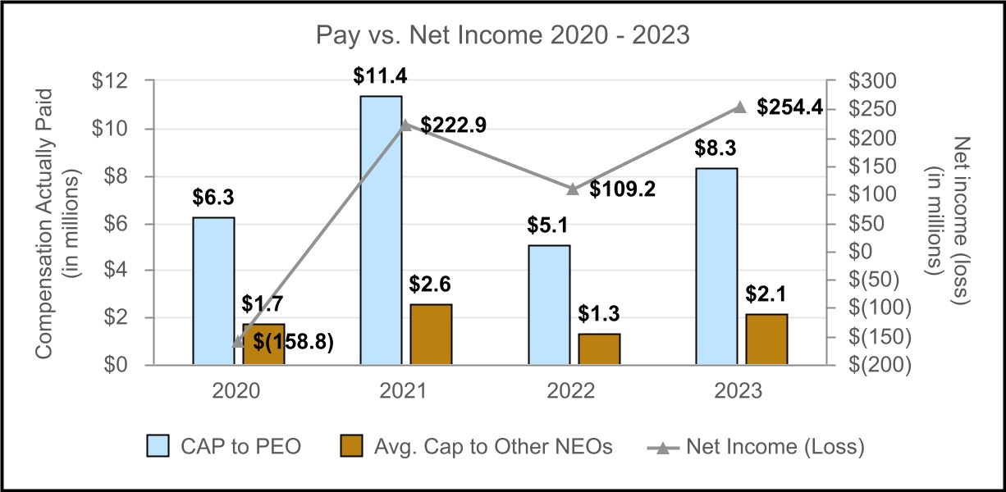
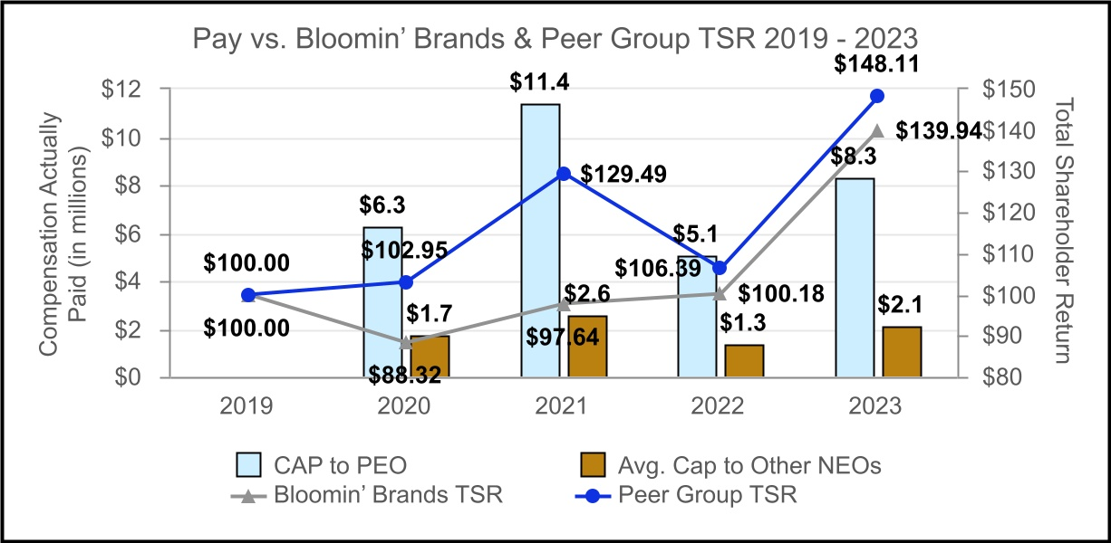
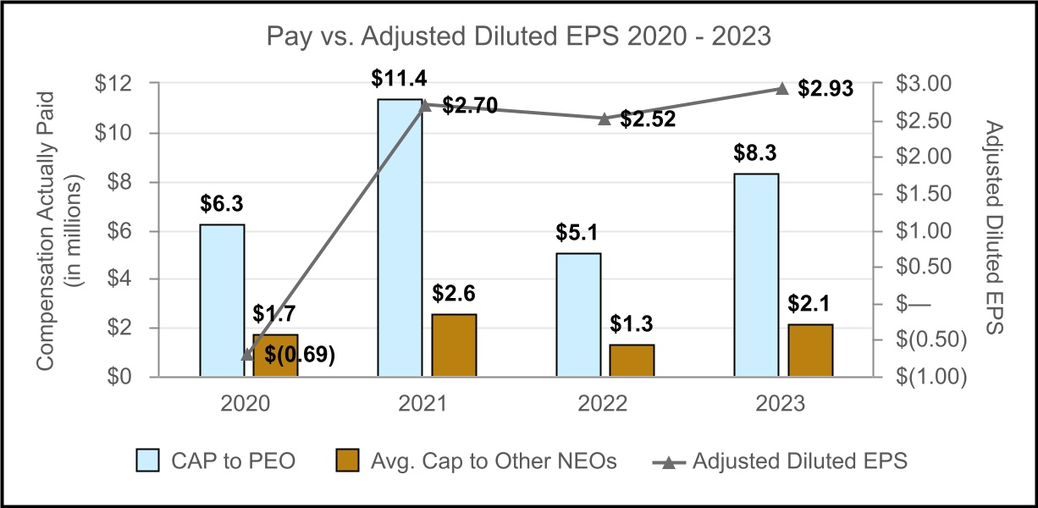

58
Table of Contents

The three items listed below represent the most important metrics we used to determine Compensation Actually Paid for fiscal year 2023 as further described in our CD&A within the sections titled “Performance-Based Short-Term Incentive Plan” and “Performance-Based Long-term Incentive Plan.” Most important performance measures:
1. |  |  | Adjusted Diluted Earnings Per Share
2. |  |  | Revenue
3. |  |  | Adjusted Operating Income Dollars

CEO Pay Ratio
We are providing the following disclosure about the relationship of the annual total compensation of our employees to the annual total compensation of our CEO, as required by Section 953(b) of the Dodd Frank Wall Street Reform and Consumer Protection Act, and Regulation 402(u) of Regulation S-K.
For fiscal year 2023,
•The median of the annual total compensation of all our employees, other than Mr. Deno, was $22,885.

•Mr. Deno’s annual total compensation was $6,825,003, as reported in the Total column of the Summary Compensation Table.

Based on this information, the ratio of the annual total compensation of Mr. Deno to the median of the annual total compensation of all employees is estimated to be 298 to 1.
To identify the median of the annual total compensation of all employees, as well as to determine the annual total compensation of our median employee and our CEO, we took the following steps:
1)We selected October 1, 2021 as the date on which to determine our median employee. As of that date, we had 75,263 employees, with 63,453 employees based in the United States and 11,810 employees located outside of the United States. The pay ratio disclosure rules provide an exemption for companies to exclude non-U.S. employees from the median employee calculation if non-U.S. employees in a particular jurisdiction account for five percent (5%) or less of the Company’s total number of employees. We applied this de minimis exemption when identifying the median employee by excluding 32 employees in China and 937 employees in Hong Kong. After considering the de minimis exemption, 63,453 employees in the United States and 10,841 employees located outside of the United States were considered for identifying the median employee.
2)For purposes of identifying the median employee from our employee population base, we considered total cash compensation, as compiled from our payroll records. We selected total cash compensation as it represents the principal form of compensation delivered to all our employees and this information is readily available in each country. In addition, we measured compensation for purposes of determining the median employee using the year-to-date period ended October 1, 2021. Compensation paid in foreign currencies was converted to U.S. dollars based on exchange rates in effect on October 1, 2021.
3)The median employee referenced above is the same median employee identified in the 2023 Proxy Statement because there have not been changes in our employee population or employee compensation arrangements that we believe would significantly impact the pay ratio disclosure. As permitted by the SEC rules, the same median employee may be used for up to three years provided that such employee is still an active employee.
4)Using this methodology, we determined that our median employee was a part-time employee. In determining the annual total compensation of the median employee, such employee’s compensation was calculated in accordance with Item 402(c)(2)(x) of Regulation S-K, as required pursuant to the SEC executive compensation disclosure rules.

Our CEO pay ratio information is a reasonable good faith estimate calculated in a manner consistent with the SEC pay ratio rules and methods for disclosure. The SEC’s rules for identifying the median compensated employee and calculating the pay ratio based on that employee’s annual total compensation allow companies to adopt a variety of
59
Table of Contents

methodologies, to apply certain exclusions, and to make reasonable estimates and assumptions that reflect their employee populations and compensation practices. As a result, the pay ratio reported by other companies may not be comparable to the pay ratio reported above, as other companies have different employee populations, geographic footprints and compensation practices and may utilize different methodologies, exclusions, estimates and assumptions in calculating their own pay ratios. With regard to restaurant, hospitality and retail companies, comparability may further be impacted by additional factors including the mix of company-owned to franchised units.

CERTAIN RELATIONSHIPS AND RELATED PARTY TRANSACTIONS

Our Board has adopted a written Code of Conduct and a Related Party Transactions Policy, which supplements the Code of Conduct. The Code of Conduct applies to our directors, officers, and employees, and the Related Party Policy applies to our executive officers. These policies require disclosure of the material terms of any applicable related person transaction, including the approximate dollar value of the amount involved in the transaction, and all the material facts as to the related person’s direct or indirect interest in, or relationship to, the related person transaction. The policies require that all related person transactions must be reported to the Chief Legal Officer and are subject to the approval or ratification by the Audit Committee. The Audit Committee may approve or ratify the transaction if it determines that the transaction is in the best interests of the Company and its stockholders.

There are no related party transactions or relationships required to be reported in this Proxy Statement under Item 404 of the SEC’s Regulation S-K.

AUDIT COMMITTEE REPORT

The Audit Committee is composed solely of independent directors meeting the requirements of applicable SEC and NASDAQ rules. The Audit Committee has the duties and powers described in its written charter adopted by the Board. A copy of the charter is available on the Company’s website at: https://investors.bloominbrands.com/corporate-governance.

The Audit Committee is responsible for the engagement, compensation, retention and oversight of the work performed by the Company’s independent registered public accounting firm, PricewaterhouseCoopers LLP. In fulfilling its oversight responsibility, the Audit Committee carefully reviews and considers the engagement of the independent registered public accounting firm, including the scope of the audit, audit fees, auditor independence matters, performance of the independent auditors and the extent to which the independent registered public accounting firm may be retained to perform non-audit services.

The Audit Committee reviewed and discussed the audited consolidated financial statements of Bloomin’ Brands, Inc. to be included in its Annual Report on Form 10-K for the 2023 fiscal year with the Company’s management and PricewaterhouseCoopers LLP. The Audit Committee has also discussed with PricewaterhouseCoopers LLP the matters required to be discussed by Auditing Standard No. 1301, Communications with Audit Committees, as adopted by the Public Company Accounting Oversight Board (“PCAOB”) in Rule 3200.

The Audit Committee received and reviewed the written disclosures and the letter from PricewaterhouseCoopers LLP required by applicable requirements of the PCAOB regarding PricewaterhouseCoopers LLP’s communications with the Audit Committee concerning independence and has discussed with PricewaterhouseCoopers LLP its independence from the Company.

60
Table of Contents

Based on the review and discussions referred to above, the Audit Committee recommended to the Board of Directors that the audited consolidated financial statements referred to above be included in Bloomin’ Brands, Inc.’s Annual Report on Form 10-K for its 2023 fiscal year for filing with the SEC.

Submitted by the Audit Committee
John J. Mahoney, Chair
Lawrence V. Jackson
Julie Kunkel
Rohit Lal

STOCKHOLDER PROPOSALS FOR 2025 ANNUAL MEETING OF STOCKHOLDERS

Stockholders may submit proposals for inclusion in our proxy materials in accordance with Rule 14a-8 promulgated under the Exchange Act. For such proposals to be included in our proxy materials relating to our 2025 annual meeting of stockholders, all applicable requirements of Rule 14a-8 must be satisfied and such proposals must be received by us no later than November 4, 2024. Such proposals should be delivered to Bloomin’ Brands, Inc., Attn: Corporate Secretary, 2202 North West Shore Boulevard, Suite 500, Tampa, Florida 33607 (and we encourage you to send a copy via email to CorporateSecretary@bloominbrands.com).

Stockholders who intend to submit nominations to the Board of Directors or present other proposals for consideration at our 2025 annual meeting (other than proposals submitted in accordance with Rule 14a-8 for inclusion in our proxy materials) must comply with all provisions of our bylaws with respect to such nominations and proposals and provide timely written notice thereof. To be timely for our 2025 annual meeting, notice must be delivered to our Corporate Secretary at our principal executive offices no earlier than December 24, 2024 and no later than January 23, 2025. However, in the event that our 2025 annual meeting is to be held on a date that is not within 30 calendar days before or after April 23, 2025, to be timely, notice must be so delivered not later than the tenth calendar day following the date on which public announcement of the date of the 2025 annual meeting is first made.

In addition to satisfying the requirements under our bylaws, to comply with the universal proxy rules, stockholders who intend to solicit proxies in support of director nominees other than the Company’s nominees must provide notice to the Company that sets forth the information required by Rule 14a-19 under the Exchange Act, which notice must be postmarked or transmitted electronically to us at our principal executive offices no later than 60 days prior to the one-year anniversary date of the annual meeting (for the 2025 annual meeting, no later than February 22, 2025). Such notice should be delivered to our Corporate Secretary at our principal executive offices and/or sent via email to CorporateSecretary@bloominbrands.com. If the date of the 2025 annual meeting is changed by more than 30 days from such anniversary date, however, then the stockholder must provide notice by the later of 60 days prior to the date of the 2025 annual meeting and the 10th day following the date on which public announcement of the date of the 2025 annual meeting is first made.

PROXY SOLICITATION AND COSTS

We will bear the entire cost of this solicitation of proxies, including the preparation, assembly, printing, and mailing of the Notice of Internet Availability of Proxy Materials, this proxy statement, the proxy and any additional solicitation material that we may provide to stockholders. Copies of solicitation material will be provided to brokerage firms, fiduciaries, custodians and other nominees holding shares in their names that are beneficially owned by others so that they may forward the solicitation material to such beneficial owners. Further, the original solicitation of proxies by mail may be supplemented by solicitation by telephone and other means by our directors, officers and employees. No additional compensation will be paid to these individuals for any such services.

STOCKHOLDERS SHARING THE SAME ADDRESS

The SEC has adopted rules that permit companies and intermediaries (such as brokers) to implement a delivery procedure called “householding.” Under this procedure, multiple stockholders who reside at the same address may
61
Table of Contents

receive a single copy of our annual report and proxy materials, including the Notice of Internet Availability of Proxy Materials, unless the affected stockholder has provided contrary instructions. This procedure reduces printing costs and postage fees.

A number of brokers with account holders who beneficially own our common stock will be “householding” our annual report and proxy materials, including the Notice of Internet Availability of Proxy Materials. A single Notice of Internet Availability of Proxy Materials and, if applicable, a single set of annual report and other proxy materials will be delivered to multiple stockholders sharing an address unless contrary instructions have been received from the affected stockholders. Once you have received notice from your broker that it will be “householding” communications to your address, “householding” will continue until you are notified otherwise or until you revoke your consent. Stockholders may revoke their consent at any time by contacting Broadridge Financial Solutions, either by calling toll-free (866) 540-7095, or by writing to Broadridge Financial Solutions, Householding Department, 51 Mercedes Way, Edgewood, New York, 11717.

Upon written or oral request, Bloomin’ Brands will promptly deliver a separate copy of the Notice of Internet Availability of Proxy Materials and, if applicable, a separate set of our annual report and proxy materials to any beneficial owner at a shared address to which a single copy of any of those documents was delivered. To receive a separate copy of the Notice of Internet Availability of Proxy Materials and, if applicable, a separate set of our annual report and proxy materials, you may write or call the Bloomin’ Brands Investor Relations Department at Bloomin’ Brands, Inc., 2202 North West Shore Boulevard, Suite 500, Tampa, Florida 33607, Attention: Investor Relations, telephone (813) 830-5323.

Any stockholders who share the same address and currently receive multiple copies of our Notice of Internet Availability of Proxy Materials or annual report and other proxy materials, who wish to receive only one copy in the future, are asked to contact Computershare (if a registered holder) or their bank, broker or other nominee (if a beneficial holder) to request information about householding.

FORM 10-K

We will mail without charge, upon written request, a copy of the Bloomin’ Brands Annual Report on Form 10-K for the fiscal year ended December 31, 2023, including the consolidated financial statements, list of exhibits, and any particular exhibit specifically requested. Requests should be sent to: Bloomin’ Brands Investor Relations Department at Bloomin’ Brands, Inc., 2202 North West Shore Boulevard, Suite 500, Tampa, Florida 33607, Attention: Investor Relations, telephone (813) 830-5323. The Annual Report on Form 10-K is also available in the Investors section at www.bloominbrands.com.

62
Table of Contents

OTHER MATTERS

The Board does not know of any other matters to be presented for stockholder action at the annual meeting. However, if other matters do properly come before the annual meeting or any adjournments or postponements thereof, the Board intends that the persons named in the proxies will vote upon such matter in accordance with their best judgment.

BY ORDER OF THE BOARD OF DIRECTORS
Kelly Lefferts
Secretary
Dated: March 4, 2024

63
Table of Contents

Appendix A
BLOOMIN’ BRANDS, INC.
INCENTIVE COMPENSATION ADJUSTED INCOME FROM OPERATIONS NON-GAAP RECONCILIATION
(UNAUDITED)
 |  |  | FISCAL YEAR
(dollars in thousands) |  |  | 2023
Income from operations |  |  | $ | 325,144
Income from operations adjustments (1) |  |  | 31,576
Adjusted income from operations |  |  | 356,720
Less: benefit of 53rd week (2) |  |  | (19,801)
Less: benefit of Brazil tax legislation (3) |  |  | (12,754)
Less: impact of foreign currency translation (4) |  |  | (4,254)
Adjusted income from operations, as defined in the STIP |  |  | $ | 319,911
_________________
(1)See Appendix B for a description of non-GAAP adjustments. For 2023, all non-GAAP adjustments were included in adjusted operating income.
(2)We utilize a 52-53-week year ending on the last Sunday in December. Fiscal year 2023 consisted of 53 weeks with December 25, 2023 through December 31, 2023 representing the 53rd week. Adjusted income from operations as defined for the 2023 STIP excludes the benefit of this additional 53rd week.
(3)During 2023, the Company benefited from Brazil tax legislation that provided exemptions from Brazil federal value added taxes. Adjusted income from operations as defined by the 2023 STIP excludes the benefit of these exemptions.
(4)Adjusted income from operations as defined by the 2023 STIP excludes the impact of foreign currency translation.

BLOOMIN’ BRANDS, INC.
INCENTIVE COMPENSATION DILUTED EARNINGS PER SHARE NON-GAAP RECONCILIATIONS
(UNAUDITED)
 |  |  | FISCAL YEAR
(in thousands, except per share data) |  |  | 2023
Net income attributable to Bloomin’ Brands |  |  | $ | 247,386
Net income adjustments (1) |  |  | 20,775
Adjusted net income attributable to Bloomin’ Brands (1) |  |  | 268,161
Less: benefit of 53rd week (2) |  |  | (14,893)
Less: benefit of Brazil tax legislation (3) |  |  | (23,643)
Adjusted net income attributable to Bloomin’ Brands, as defined in the LTI plan |  |  | $ | 229,625
Adjusted diluted earnings per share, as defined in the LTI plan |  |  | $ | 2.51
Adjusted diluted weighted average common shares outstanding (1) |  |  | 91,386
_________________
(1)See Appendix B for reconciliation of adjusted net income attributable to Bloomin’ Brands.
(2)We utilize a 52-53-week year ending on the last Sunday in December. Fiscal year 2023 consisted of 53 weeks with December 25, 2023 through December 31, 2023 representing the 53rd week. Adjusted diluted earnings per share as defined by the 2021 LTI grant agreement excludes the benefit of this additional 53rd week.
(3)During 2023, the Company benefited from Brazil tax legislation that provided exemptions from Brazil income tax and federal value added taxes. Adjusted diluted earnings per share as defined by the 2021 LTI grant agreement excludes the benefit of these exemptions.

64
Table of Contents

Appendix B
BLOOMIN’ BRANDS, INC.
ADJUSTED NET INCOME AND DILUTED EARNINGS PER SHARE NON-GAAP RECONCILIATIONS
(UNAUDITED)
 |  |  | FISCAL YEAR
(in thousands, except per share data) |  |  | 2023 |  |  |  |  |  | 2022 |  |  |  |  |  | 2021 |  |  |  |  |  | 2020
Diluted net income attributable to common stockholders |  |  | $ | 247,386 |  |  |  |  | $ | 101,907 |  |  |  |  | $ | 215,900 |  |  |  |  | $ | (162,211)
Convertible senior notes if-converted method interest adjustment, net of tax (1) |  |  | — |  |  |  |  |  | — |  |  |  |  |  | 345 |  |  |  |  |  | —
Net income attributable to common stockholders |  |  | 247,386 |  |  |  |  |  | 101,907 |  |  |  |  |  | 215,555 |  |  |  |  |  | (162,211)
Adjustments:
Asset impairments and closure costs (2) |  |  | 25,786 |  |  |  |  |  | — |  |  |  |  |  | — |  |  |  |  |  | (2,205)
Partner compensation (3) |  |  | 1,894 |  |  |  |  |  | — |  |  |  |  |  | — |  |  |  |  |  | —
Legal and other matters (4) |  |  | (3,650) |  |  |  |  |  | 5,900 |  |  |  |  |  | (372) |  |  |  |  |  | 178
Royalty termination expense (5) |  |  | — |  |  |  |  |  | — |  |  |  |  |  | 61,880 |  |  |  |  |  | —
Severance and other transformational costs (6) |  |  | — |  |  |  |  |  | — |  |  |  |  |  | 2,764 |  |  |  |  |  | 32,404
COVID-19-related costs (7) |  |  | — |  |  |  |  |  | — |  |  |  |  |  | — |  |  |  |  |  | 93,811
Loss on extinguishment and modification of debt (8) |  |  | — |  |  |  |  |  | 107,630 |  |  |  |  |  | 2,073 |  |  |  |  |  | —
Loss on fair value adjustment of derivatives, net (8) |  |  | — |  |  |  |  |  | 17,685 |  |  |  |  |  | — |  |  |  |  |  | —
Amortization of debt discount (9) |  |  | — |  |  |  |  |  | — |  |  |  |  |  | — |  |  |  |  |  | 6,275
Other (10) |  |  | 7,546 |  |  |  |  |  | — |  |  |  |  |  | — |  |  |  |  |  | —
Total adjustments, before income taxes |  |  | 31,576 |  |  |  |  |  | 131,215 |  |  |  |  |  | 66,345 |  |  |  |  |  | 130,463
Adjustment to provision for income taxes (11) |  |  | (10,801) |  |  |  |  |  | (263) |  |  |  |  |  | (21,222) |  |  |  |  |  | (32,526)
Redemption of preferred stock in excess of carrying value (12) |  |  | — |  |  |  |  |  | — |  |  |  |  |  | — |  |  |  |  |  | 3,496
Net adjustments |  |  | 20,775 |  |  |  |  |  | 130,952 |  |  |  |  |  | 45,123 |  |  |  |  |  | 101,433
Adjusted net income (loss) |  |  | $ | 268,161 |  |  |  |  | $ | 232,859 |  |  |  |  | $ | 260,678 |  |  |  |  | $ | (60,778)
Diluted earnings (loss) per share attributable to common stockholders (13) |  |  | $ | 2.56 |  |  |  |  | $ | 1.03 |  |  |  |  | $ | 2.00 |  |  |  |  | $ | (1.85)
Adjusted diluted earnings (loss) per share (14) |  |  | $ | 2.93 |  |  |  |  | $ | 2.52 |  |  |  |  | $ | 2.70 |  |  |  |  | $ | (0.69)
Diluted weighted average common shares outstanding (13) |  |  | 96,453 |  |  |  |  |  | 98,512 |  |  |  |  |  | 107,803 |  |  |  |  |  | 87,468
Adjusted diluted weighted average common shares outstanding (14) |  |  | 91,386 |  |  |  |  |  | 92,423 |  |  |  |  |  | 96,426 |  |  |  |  |  | 87,468
_________________
(1)Adjustment for interest expense related to the convertible senior notes due in 2025 (the “2025 Notes”) weighted for the portion of the period prior to our election under the 2025 Notes indenture to settle the principal portion of the 2025 Notes in cash.
(2)For 2023, primarily includes asset impairment, closure costs and severance in connection with the decision to close 41 underperforming restaurants. For 2023 and 2020, includes lease termination gains of $6.7 million and $2.8 million, respectively, net of related impairments.
(3)Costs incurred in connection with the transition to a new partner compensation program.
(4)For 2023 and 2022, reflects changes in legal reserves in connection with certain collective action wage and hour lawsuits. For 2021, includes: (i) a $3.1 million benefit from the recognition of recoverable Program of Social Integration and Contribution for the Financing of Social Security taxes, including accrued interest, within other revenues as a result of favorable court rulings and (ii) an accrual of $2.7 million for Imposto sobre Serviços, a Brazilian municipal service tax, in connection with royalties from our Brazilian subsidiary over the prior five years, including related penalties and interest, as a result of an unfavorable Brazilian Supreme Court ruling.
(5)Payment made to the Carrabba’s Italian Grill founders in connection with the Purchase and Sale of Royalty Payment Stream and Termination of Royalty Agreement.
(6)Severance, professional fees and other costs incurred as a result of transformational and restructuring activities.
(7)Costs incurred in connection with the COVID-19 pandemic, primarily consisting of fixed asset and right-of-use asset impairments, restructuring charges, inventory obsolescence and spoilage, contingent lease liabilities and current expected credit losses.
(8)For 2022, primarily includes losses in connection with the repurchase of $125 million of our outstanding 2025 Notes, as well as settlement of the related convertible senior note hedges and warrants (the “2025 Notes Partial Repurchase”).
(9)Amortization of debt discount related to the issuance of the 2025 Notes.
(10)Primarily includes professional fees, severance and other costs not correlated to our core operating performance during the period.
(11)The tax effect of non-GAAP adjustments was determined based on the nature of the underlying non-GAAP adjustments and their relevant jurisdictional tax rates. For 2023, also includes a $2.9 million adjustment related to a Brazil federal income tax exemption on certain state value added tax benefits. For 2022, the primary difference between GAAP and adjusted effective income tax rates relates to certain non-deductible losses and other tax costs associated with the 2025 Notes Partial Repurchase. For 2021, also
65
Table of Contents

includes a $4.2 million adjustment for the reduction of certain unrecognized tax benefits related to tax positions taken during a prior period.
(12)Consideration paid in excess of the carrying value for the redemption of preferred stock of our Abbraccio concept.
(13)Due to the GAAP net loss, the effect of dilutive securities was excluded from the calculation of GAAP diluted loss per share for 2020.
(14)Adjusted diluted weighted average common shares outstanding was calculated excluding the dilutive effect of 5,067, 6,089 and 9,992 shares for 2023, 2022 and 2021, respectively, to be issued upon conversion of the 2025 Notes to satisfy the amount in excess of the principal since our convertible note hedge offsets the dilutive impact of the shares underlying the 2025 Notes. For 2021, adjusted diluted weighted average common shares outstanding was also calculated assuming our February 2021 election to settle the principal portion of the 2025 Notes in cash was in effect for the entire period.

66
Table of Contents

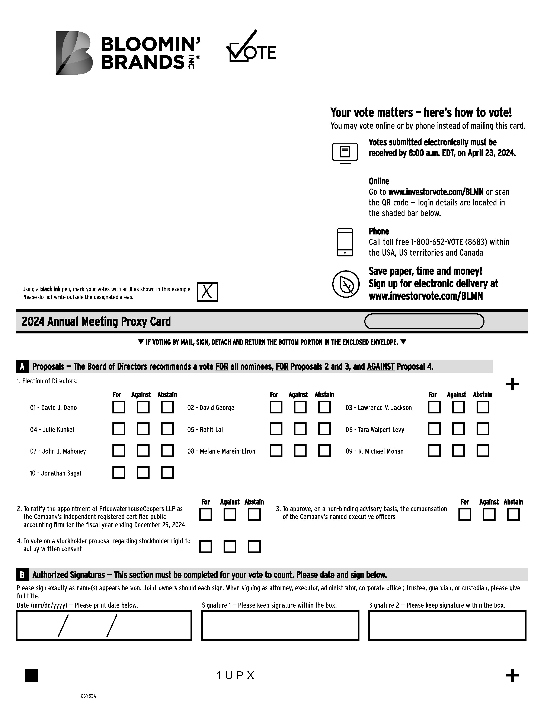

Table of Contents



